****ML079Som

A new support group offering information, advice and support

**Somali Parents and Carers!**

For more information or to book a place please contact **Hussein Ibrahim Hussein**

**Email:** Hussein.hussein@towerhamlets.gov.uk

**Telephone:** 07983 921741 Monday –Wednesday 9.00am to 5.00pm

Delivered by LBTH Parental Engagement Team: [Parenting@towerhamlets.gov.uk](mailto:Parenting@towerhamlets.gov.uk)

A new support group is being set up to offer information, advice and support to parents about school life and education

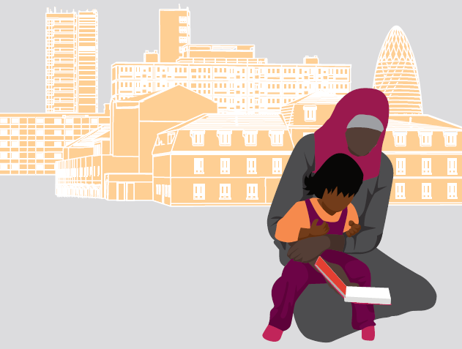

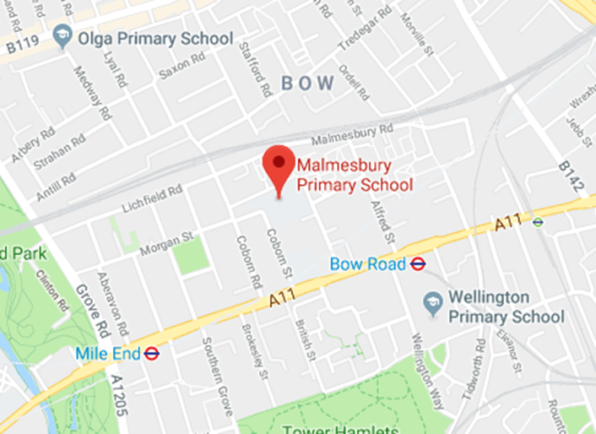

**Last Tuesday of the Month**

**Tuesday 26th February 2019 9.30am – 11.30pm**

**Malmesbury Primary school Coborn Street London E3 2AB**

**Future dates: 26th March**

**21st May**

**25th June**

**23rd July**

* Share your experiences with other parents
* Discuss any issues that you need help to resolve
* Obtain information and hear from guest speakers
* Find out about services and community resources