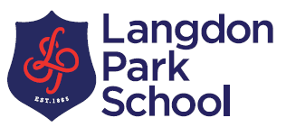
LANGDON PARK
SIXTH FORM
6th Form Foundation Learning Course
Open Afternoon
March 19th 2019 (10-11:30am).

Does your child have Special Educational Needs (EHCP)?
Are they in Year 11 now?
Would they like a course which offers a mixture of:

• Life Skills catering course – a Learn to Cook course
• Maths, English and ICT at a level which suits them (Entry Level to Level 1)
• Employability Options at Tower Project
• Sports Coaching
• Learning Independent Living Skills
• Fashion Design course
• Link course at Tower Hamlets College: Motor Mechanics.
All delivered in a small group setting (no more than 10 students).
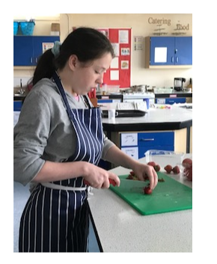
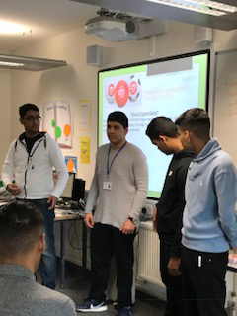

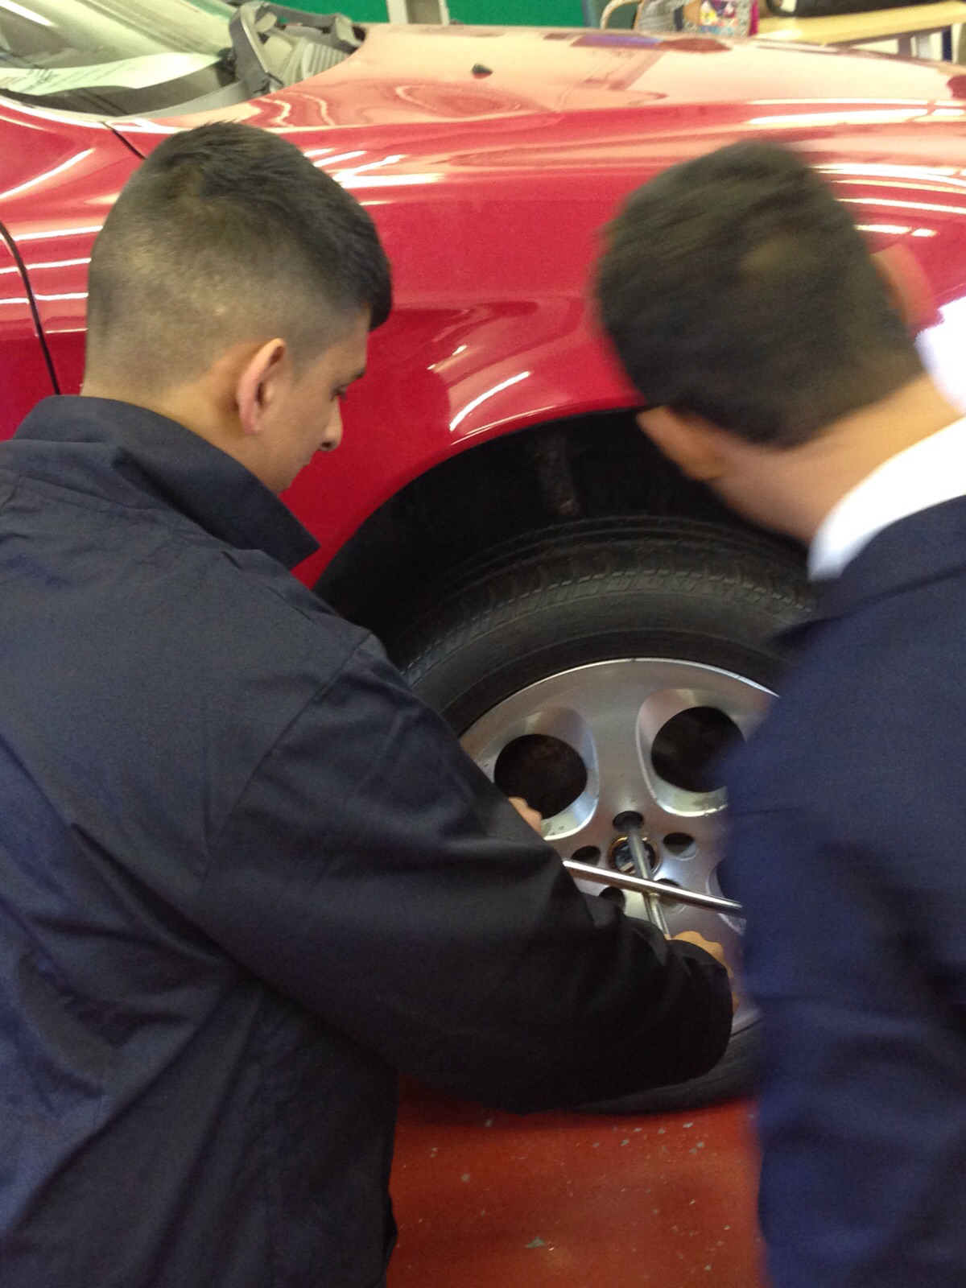
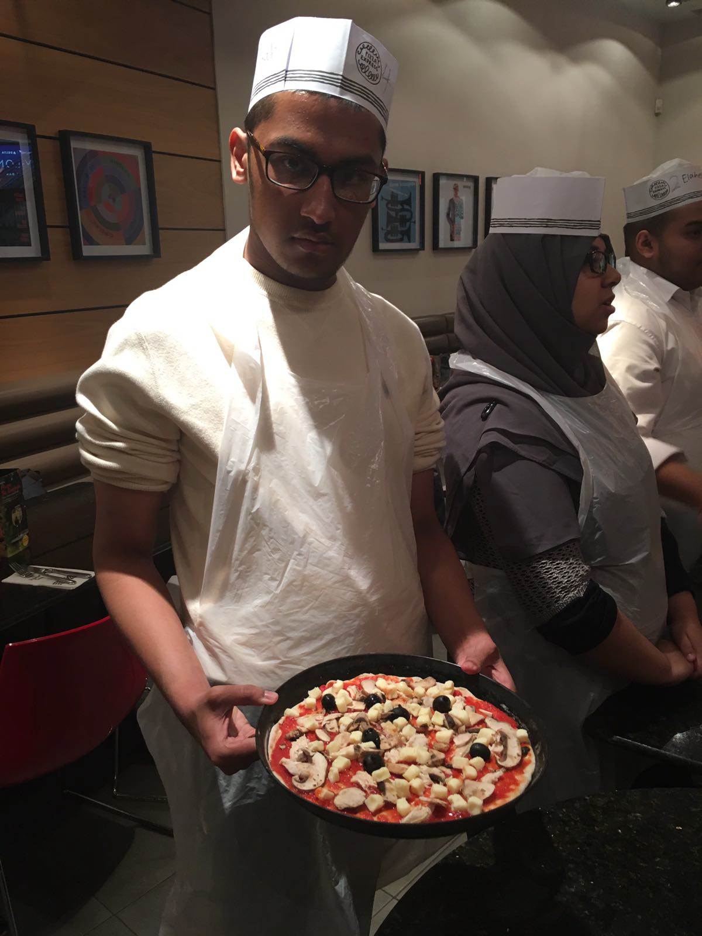
For more information contact Shannon Malavase (6th Form Foundation Co-ordinator) malavases@langdonpark.org or at 02079874811 ext. 219

The course will be based at Langdon Park School but will take advantage of outside organisations (eg Tower Project, ONEbyme, New City College) which the students will travel to with their Teaching Assistants.

This is for students to visit us with their Teachers/TA’s/Parents. Please arrive at 10am. We will go over the details of the course, tour the school, meet other students. Please let us know if you can make the Open Afternoon.

