

Tower Hamlets & City

SEND Parents Network

**An opportunity for parent representatives of groups that support local parents who have children with a Special Education Need and/or Disability (SEND) to come together discuss issues that may affect families locally**

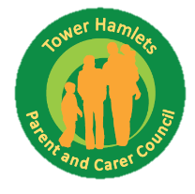

**Friday 9th November 2018 10:00am – 12:00pm** (Registration & refreshments from 9:30am)

**Parents Advice Centre** **30 Greatorex Street, E1 5NP**

For further information please contact Abdul Razak

Email: abdul.razak@towerhamlets.gov.uk

Tel: 020 7364 6481

Website: [www.towerhamlets.gov.uk/localoffer](http://www.towerhamlets.gov.uk/localoffer)

Tower Hamlets SEND Parents Network is supported by the Parent & Family Support Service

Join us to find out more and have your voice heard

**Would you like to develop confidence in working with professionals?**

**What is true participation and co-production?**

**How do Local Authority (LA) and health services work together?**

**Have you thought about developing or joining an active parent/carer forum?**