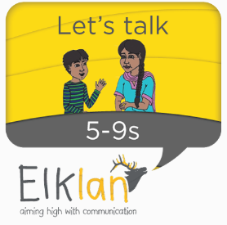 | Course for parents and carers of children with speech and language difficulties  Autumn and Winter 2018-2019
 | 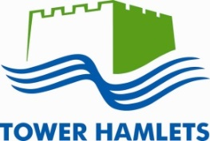

This course covers:
- How to encourage children to talk more. Please note that this course is not aimed at parents of children who aren’t talking at all yet.
- Helping children to learn new words
- Helping children to make sentences
- Helping children with unclear speech
The sessions will include lots of discussion and practical activities. You will get a book to go with the course so you can try out the ideas at home.
You can find more details about the course at: https://www.elklan.co.uk/courses/parents-and-carers/lets-talk-with-5-to-11s
Friday mornings from 09:45 to 12:00 starting on Friday 23rd November 2018 and finishing on Friday 1st Feb 2019.
We will have coffee and tea from 09:45; the course will start at 10:00.
The course will run for 8 weeks. We will meet for 4 weeks in November and December 2018. We will then start again on Friday 11th January 2019 and finish on 1st February 2019.
The course will be at:
Parents Advice Centre, 30 Greatorex St, London E1 5NP.
The course will be run by a specialist teacher and a speech and language therapist.
We only have space for 12 people on the course, so register as soon as you can.
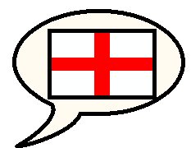 | The course will be taught in English only.
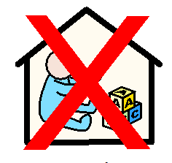 | Unfortunately we are not able to offer any crèche facilities.
If you want to do the homework, you can get a Level 1, three credit Ascentis award based on this course.
This qualification could help you with employment opportunities. You will be given support and encouragement to achieve this goal.

What to do if you want to come on the course:
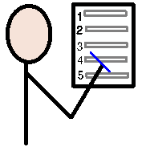 | To register on the course, contact James Dodd by email, phone or text.  Please tell us your name, address, email address and phone number so we can contact you.  James’s contact details are shown below.  James will check that you will benefit from the course before adding your name to the list of parents attending.
 | If you have any questions, then contact James, using the details below.
07970 956977 (mobile)
020 8223 8943 (office)
 | james.dodd@nhs.net
James Dodd, Speech and Language Therapy Children’s Service,
Hastings Ward, Mile End Hospital,
Bancroft Road, London. E1 4DG

