

This booklet is designed to help you think about and plan your goals, dreams and aspirations for the future – you can add extra pages if you wish!

**This is me!**

**My Future My Choice**



**What do other people say that you are good at and what do they like and admire about you?**

**What People Like and Admire About Me**

**My Family, Friends and Supporters**

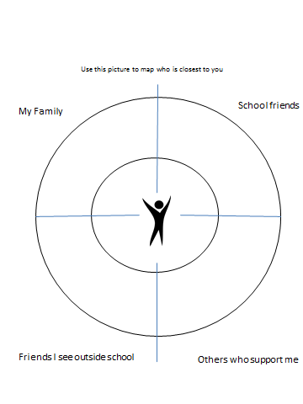



**Places I go to and people I see /having fun**

**Where I go when I’m not at school in the evenings and weekends? What I have fun doing? New things I would like to try?**

**My Gifts and Skills**

**Gifts (The unique qualities a person has. For example: makes people laugh, calmness, and generosity)**



**Interests (Hobbies or specific interests for example Star Trek, gardening, football)**

**Skills (Specific skills for example typing, sewing, cooking, speaking in public)**



**Communication**

**How do I communicate? How do I like people to communicate with me? Do I need any support with my communication? What does this support look like?**



**How I learn**

**What conditions do I learn best in e.g. quiet environments, 1:1, in a group, with tasks broken into smaller steps with repetition, written instructions, pictures, verbal instructions, or by doing things/hands on?**



**My Independence Skills**

**Money and budgeting**

**Transport and travel**

**How I care for myself/washing, dressing**

**My independence skills like cooking and shopping**

**Good Day/Bad Day**



**It’s a good day for me when ….**

**It’s a bad day for me when…….**

**What’s working?**

**What’s not working?**

**Things that are working and not working so well for me**





**School**

**Home**



**Other**



**My Future / Preparing for Adulthood**

**In this section write about the things you would like to happen in your life in the future …**

**Employment**

**I would like a job doing:**

**I would like to do this because:**

**Community Inclusion**

**I would like to take part in the following activities as an adult:**

**Independence and Housing**

**(Where I would like to live, who I want to live with)**

**I want to learn the following new skills so that I can be as independent as possible**



**Keeping Healthy**

**To stay healthy as an adult I will need to:**

**To discuss at my review meeting**

**Where I want to go when I am 16**

* **Stay at 6th Form**
* **Go to College**
* **A job with training**
* **Other**

**Other things I want to say at my meeting**

My consent

I am happy for the information in this document to be used in my One Page Profile /my Education Health and Care Plan

Signed ………………………………………………………………………………………………………………………………………………….