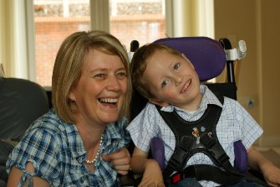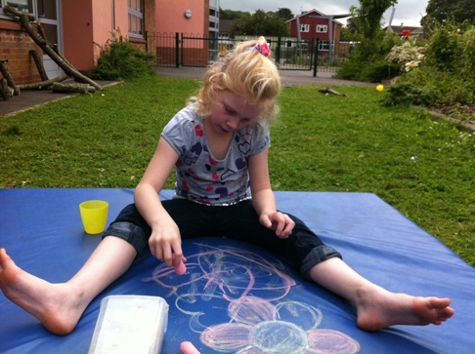

Short Breaks Statement and how to access short breaks and activities for Children and Young People with Disabilities in Bath and North East Somerset

Bath and North East Somerset -
Improving People’s Lives

Revised October 2020
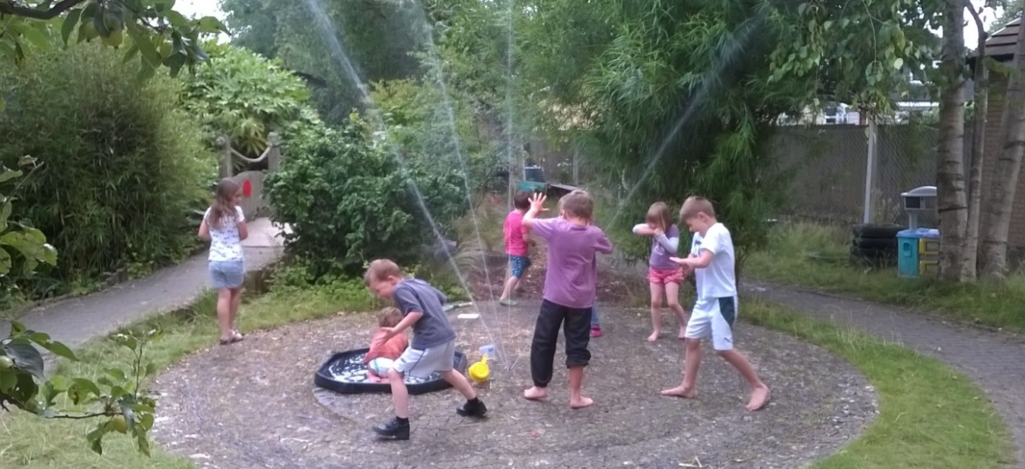
Revised Oct 2020

Introduction 2
Results of the consultation July 2018 3
Range of Short Breaks 4
What is a short Break? 5
Who is entitled to a short break? 5
How to access Short Breaks and activities for disabled children 6
Universal services 6
Targeted Services 7
Specialist Service 8
Transport 9
Transitions for disabled young people/ Preparing for Adulthood 10
Workforce development 11
Where do you go to access information? 11
Future plans for Short Break Services 13
Appendix 1 14
Definitions 14
Contacts 16

Introduction
This document specifically focuses on short break provision for children and young people with a disability aged 0-21 years in Bath and North East Somerset, however the legislation refers to young people aged 0-25 years. This document has been put together with the views and support of key partners and stake holders including the Parent Carer Voice group and the SEND Steering group.
In recent years access to short breaks for disabled children has significantly improved as the volume and range of short breaks has increased. The short breaks that are commissioned by the Council; parent carer groups report that this has led to improved outcomes for disabled children, young people and their families and has also provided evidence for those planning and providing services. Examples of improved outcomes include young people forming friendships with peers in their community and being supported to develop independent skills.
Since October 2011 there is a duty for local authorities to provide a range of short breaks for disabled children under the Breaks for Carers of Disabled Children's Regulation 2011. These regulations require each local authority to produce a short break statement. The needs of disabled children and their families are evaluated through timely consultations with children, young people and their families which last took place in July 2018. The results of the consultation are detailed below and have shaped the short break provision that is currently being delivered.

Results of the consultation July 2018
Parent/carers report they
- Are happy with the quality of Short Break provision that is on offer
- Want more holiday provision (especially last 2 weeks of the summer holiday)
- Want Short Break provision for whole family
- Want overnight provision to develop independent skills for teenagers

Children and young people
- Like trained staff at provision
- Like the opportunity to meet up with friends/ socialise
- Want to visit new places/day trips
- Want overnight trips with friends

Providers would like
- To develop independence skills for teenagers.
- Activities for whole family (especially pre-school children)

A range of data is available such as attendance sheets, performance levels and levels of satisfaction of services commissioned by the Council as well as demographic data and reach data. By collecting data in this way the Council can demonstrate value for money and set out clear outcomes when developing strategic plans and commissioning of short breaks.
Age
Age | Number of Pupils
0 to 4 | 44
5 to 9 | 453
10 to 14 | 600
15 to 19 | 533
20 to 24+ | 363
Total: | 1993
Gender
Gender | Number of Pupils
Male | 1329
Female | 664
Total: | 1993
Source 0-24+ years: Liquid Logic and EHCP database January 2020

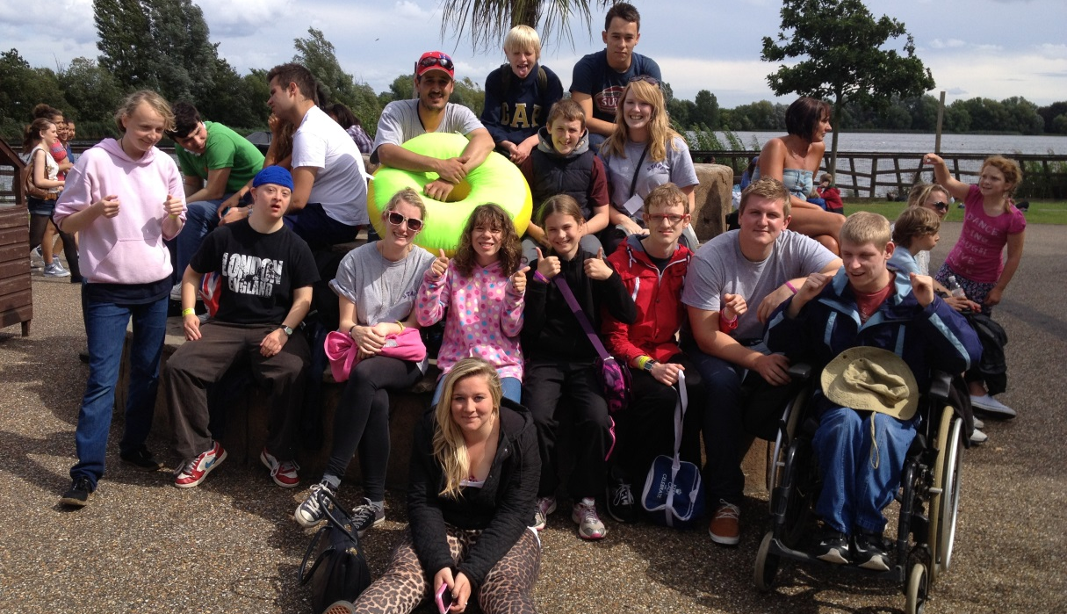
Specialised
Universal
Targeted

Range of Short Breaks
The aim of offering a range of short breaks is to ensure children and young people with disabilities have the necessary support to access and participate in society. Mainstream services and specialised agencies should work alongside each other to offer fair access and offer the same opportunities to children with disabilities including those with a sustainable and permanent disability so that disabled children and young people can make positive connections and develop friendship with their disabled and non-disabled peers. Short breaks also provide the opportunity for young people to go out to places in their local community and develop independence skills.
A short break can last a few hours to an overnight in or away from the home. They can take place in a community setting; the child’s own home; the home of an approved carer or in a residential setting. They can take place during the day, in the evening, during the weekend or during school holidays. Short Breaks also provide parents and families with a necessary and valuable break from caring responsibilities.

What is a short Break?
Short Breaks were previously known as 'respite care'. A short break takes place to allow families to spend time together, with or without their disabled child, doing ordinary family things. As well as providing a break from caring, short breaks offer disabled children and young people the opportunity to go places, have fun, spend time with friends, develop independence skills and increased self confidence in a range of activities both indoor and outdoor and in the wider environment.
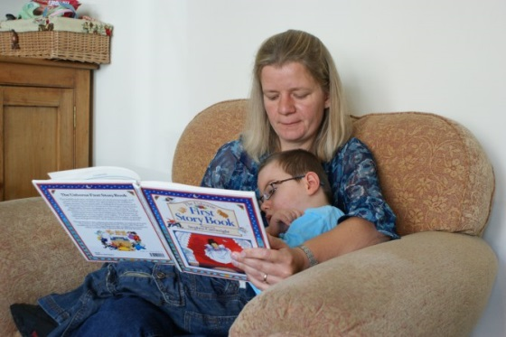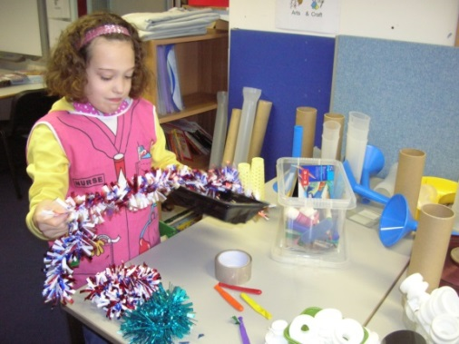

Who is entitled to a short break?
Children and young people are eligible for short breaks if they have a “physical or mental impairment, which has a substantial and long-term effect on their ability to carry out day-to-day activities.” (Source: The Equality Act 2010). This may include:
- Physical or mental impairment
- Sensory impairment
- Autistic Spectrum Disorder
- Children who may have challenging behaviour as a result of their disability
    - Children who have complex healthcare needs and who may have palliative, life limiting or life-threatening conditions
    - Children/young people with a statement of Special Educational Needs or Educational Health and Care Plan (EHCP) where the plan has been issued in recognition of the child’s disability.
Other requirements include
- Child who is a resident in Bath and North East Somerset
- Is of the age range of the provision taking pace.

How to access Short Breaks and activities for disabled children
Bath and North East Somerset believe that in order for services to be provided fairly and within an equality framework there must be consistency throughout all of Children's Services. Some services can be accessed by contacting the provider directly e.g. school holiday play schemes whereas other services such as short-term overnight care will require an assessment. The level of support a child would need to access provision depends on the severity of the child's disability and the needs of the rest of the family. This support is categorised into three levels

Specialised

Targeted

Universal

Many children will access a mixture of services, some specialised ones that are provided through an assessment and some that are accessed through universal and targeted activities, which have been commissioned from voluntary or independent sector groups.

Universal services
These are services available to all children and young people and cover educational or leisure activities for disabled children outside their home. They include activities at youth clubs, sports and leisure centres and after school clubs. Universal services will be the first point of contact for many families. Providers of short breaks services and of children's and young people's universal play and leisure services, take active steps to make reasonable adjustments to ensure that access for disabled children and young people is possible.
Disabled children would not need an assessment to access universal services. Parent/carers should contact the provider of the provision directly. A youth worker may wish to contact the family to ask questions about the individual needs of your child.
The SEND Partnership Service (SPS) provides impartial, confidential information, advice and support for children and young people with SEND aged 0-25 and their families in Bath and North East Somerset in matters relating to education, health and social care. SPS can signpost families to activities and other relevant organisations in the area.

To talk to one of the SEND Partnership Service Information and Advice Officers please call the SEND Partnership Service on 01225 394382 or email send_partnershipservice@bathnes.gov.uk

The Rainbow Resource is a searchable database providing information about a range of services, organisations and activities in the local area for families of children and young people with SEND. It also has a dedicated page on autism and can be found here. Rainbow Resource Autism Information

Families can apply for a Rainbow Resource Card which gives the card holder concessions to some activities, some organisations and events. Full details, including the online application form, can be found on the Rainbow Resource website.

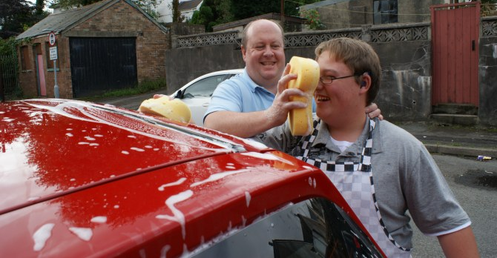

Targeted Services
The Council recognises that families may have additional needs if they are bringing up a disabled child and the children or young people may need extra support, either short or long term, to be able to take part in activities. Targeted services aim to offer support to prevent difficulties building up and to encourage children and young people to try new things. Examples of targeted services include youth clubs, Saturday clubs and school holiday clubs that are specifically run to support the individual needs of disabled young people. Other targeted services include daytime care in the homes or in the local community of disabled children as well as services available to assist carers in the evening, at weekends and during school holidays.
Access is not necessarily dependant on a formal assessment although each service may operate their own criteria. Some providers request that application forms for school holiday schemes are returned up to 6 weeks before the provision is to take place.
Some services will be available for children assessed as needing a short break through a multi-agency integrated or Early Help assessment process. This is a voluntary process where a lead professional such as a health visitor, school teacher or youth work professional supports the family to identify what interventions and services can be offered. The aim is to offer earlier interventions to prevent difficulties escalating and to increase the likelihood of positive outcomes for disabled children and their families. Bath and North East Somerset Council have developed an Early Help toolkit and App which can be found here: Early Help Toolkit.

The Council commissions’ family support services through the Southside Project. They work directly with families to support them with many complex issues including issues around disability. You can find more information about Southside on their website: Southside website.
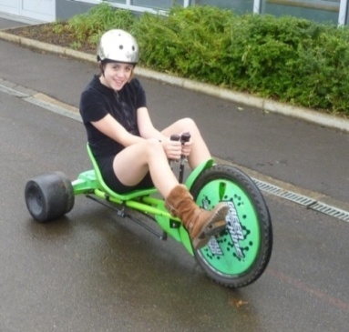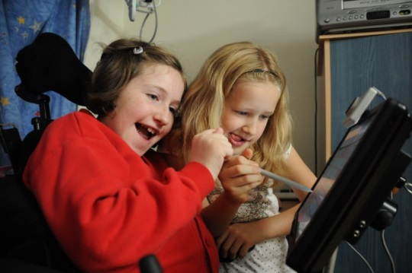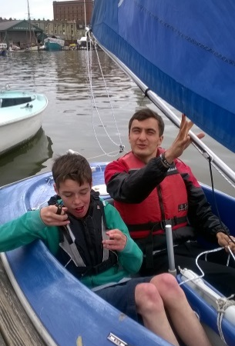

Specialist Service
Specialist services are available to children and families who have carried out an assessment through the Disabled Children's Team. To access specialised services, eligibility criteria are used to determine the level of service required for each family. To find out more information about the assessment process for children aged up to 18 years, please follow this link: https://www.bathnes.gov.uk/sites/default/files/threshold_for_assessment_of_cyp2.pdf

For those young people aged 18 or over please follow the Adult Social Care eligibility criteria to Fair Access to Care (FACS) here: Fair access to carer services guide

In order to access an assessment, parent carers can contact the Disabled Children’s Team on 01225 396967 and ask for an initial assessment. This assessment will look at the needs and circumstances of the family and recommend what support, if any, is needed. A core assessment is undertaken, and specialised services provided to children and families with the most complex needs. These include overnight short breaks in or away from the family home and could take place with family carers or individual support workers who will facilitate the use of community facilities. Services are also available to assist carers in the evenings, at weekends and during school holidays.
Specialist palliative care health services for children and young people with life limiting conditions are commissioned. These include short breaks at a children's hospice as well as an overnight service in the child's home. To receive these types of services an assessment from a health professional is required.
Some families choose to source their own services through direct payments which enable them to employ their own carers or contract with an agency for the care from a provider. Support is available for families who decide to take this option. To access direct payments families will need to go through a formal assessment. The Council commissions a service to support families with their direct payments and can provide advice on how this might work. Please contact the Disabled Children’s Team for more information about Direct Payments.
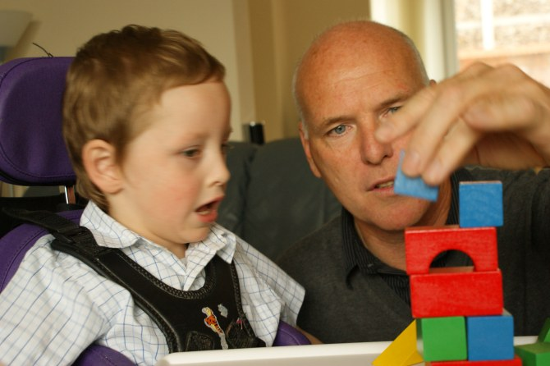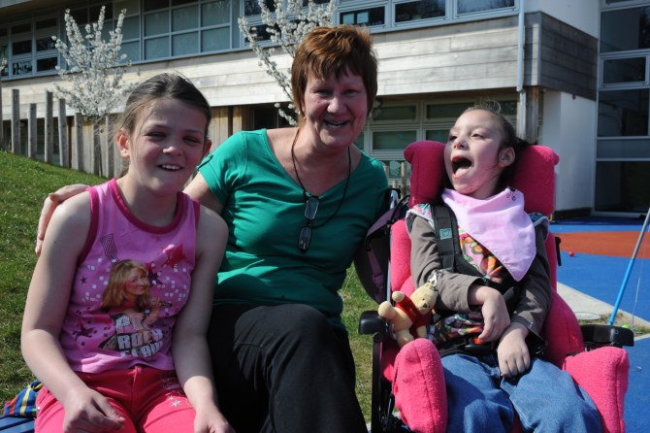
Feedback from families using short break services
Think about creating two groups to cater for wide ranging age group (5-19 all in one room is not appropriate)

The staff were really fun to talk to and be around.

The Diamond Bus Pass has given us the chance to travel and improve confidence when travelling on the buses
Despite the fact that my son does not have the ability to form a ‘traditional’ friendship, the idea to meet a group of friends at TR has increased his social skills and his ability to be sociable with others

The best thing about club is being able to meet friends on a weekly basis
Locations being inaccessible (we don't have a car)

Transport
Other feedback received from families relates to the low levels of accessible transportation getting to and from Short Breaks which can be an issue for some children, young people and their families. The Diamond Travel card offers free off-peak bus travel for older people and those with disabilities who live in Bath & North East Somerset. To access more information about the Diamond Travel card please follow this link: Diamond Travel Card information
There is also a Community Transport schemes in Bath & North East Somerset which is aimed at providing members of the public, who are unable to use conventional public transport due to disability or age, with fully accessible transport in order to help solve their mobility problems, or because of a lack of availability of adequate and safe public passenger services. There are three types of community transport schemes operating in most parts of Bath & North East Somerset:
- Dial-a-ride
- Mini Bus Schemes
- Voluntary Car Schemes
To find out more about the community transport scheme, please follow the link here: Community Transport
Organisations that offer short breaks to disabled children may be able to offer a solution to particular issues around transportation.

Transitions for disabled young people/ Preparing for Adulthood
Bath and North East Somerset Council have developed a transition pathway to support young people and their families through the transition process using person centred approaches. Transition to adulthood is about helping young people and their families to prepare for the changes in services that they may receive. The transition process also takes into account that sometimes a lot more planning is needed to ensure the transition to adulthood is a smooth as possible for young people with additional needs. In B&NES we recognise that good transition planning needs to be based around four specific areas (Pathways)
- Employment, Education and Training
- Independence and Housing
- Health
- Friendships, Relationships and Community

Further information about the Transitions process can be found on the Transitions information section of Rainbow Resource.

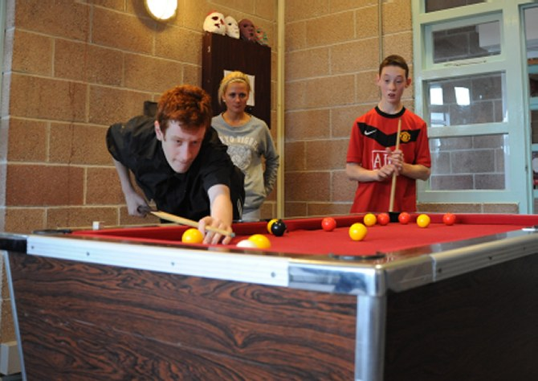

Workforce development
There are a number of ways professionals can receive additional training to support a disabled child who they are working with. All new council employees undertake induction training, where a section of training looks at communication techniques with children with disabilities. Specific courses around children and disabilities are accessed through the two special schools in the area and include:
- ASD enabling effective inclusion
- How adult empathy supports children’s emotional development
- Supporting Children with physical disabilities in School.
The family placement team also carries out a number of courses relating to understanding and supporting disabled children in the home environment for foster carers. The Council also offers training for professionals that covers sexual health training and include strategies to support the sexual health needs of young people with learning disabilities and supporting parents and carers to talk to their children about sex and relationships.
There are also plans through The Care Pathway Transformation programme to offer training to professionals in upskilling them around sensory issues. Bristol Autism Support Service (BASS) will be delivering additional Autism Awareness training to employers so to encourage and support them to create opportunities for disabled people to gain paid employment.

Where do you go to access information?
Specific information about short break services can be found here: https://5f2fe3253cd1dfa0d089-bf8b2cdb6a1dc2999fecbc372702016c.ssl.cf3.rackcdn.com/uploads/rainbowresource2/document/file/1017/List_of_Short_Breaks_2019.pdf

As part of the Children and Families Act 2014, all Local Authorities are required to publish a Local Offer of the support and services we expect to be available for children and young people aged 0 – 25, from children and young people with a low level of special educational need or disability, through to the most complex needs. The intention of the Local Offer is to improve choice and transparency for families. To find out more information about the Local Offer please follow the Rainbow Resource website. It also has a dedicated page on autism and can be found here: Rainbow Resource autism information.

There are specific services that can support families through the statutory Education Health and Care Needs Assessment for their child or young person. The B&NES SEND Partnership Service provides confidential and impartial information, advice and support to children and young people aged 0-25 with SEND and their parent carers to make informed decisions about matters relating to special educational needs or disabilities including health and social care.
The Shout Out advocacy service at Off the Record currently provides an advocacy service for disabled children and young people and also provide an independent advocacy service for young people with SEND for their year 11 reviews. To ensure you are directed to the right organisation for the support you require please contact the send_partnershipservice@bathnes.gov.uk or 01225 394382 who will direct you accordingly. Off the Record also offer other advocacy services to disabled children and young people and you can contact them directly to find out more.
Parent carers and, where appropriate, young people are fully involved in all aspects of short breaks development. They are involved in making key decisions about short break provision. As a result, the development of the range of short break services has grown reflecting the needs of families in the area. If you would like to have your say and get involved, please contact Parent Carer Voice (PCV) group. They can be contacted at the Carers Centre in Radstock on 01761 431388 or through the Parent Carer Voice website or the Parent Carers Voice Facebook page.
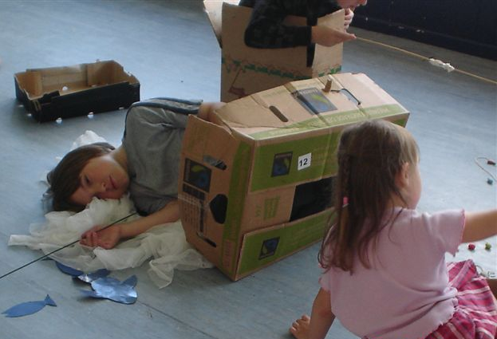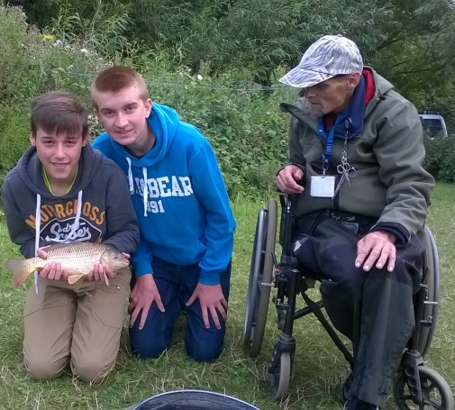

Future plans for Short Break Services
In order to sustain lasting change within Bath and North East Somerset the Council needs to be able to demonstrate which services and interventions are effective and where further improvement and/or growth is needed. That is why the Council works closely with providers of short breaks and families of disabled children to regularly review practice; systematically collect and analyse data.
Parent/carers have actively been involved in shaping this short break statement. The Council have also worked with children and young people who have created their version of the short break guide and can be found here: Short Breaks Summary.
Through timely consultations, the views of parent carers and their disabled children and young people using short breaks and providers of these services will continue to be heard and will influence decision making about commissioning to sustain and develop short breaks in the future.
The Council are actively advertising short breaks to students attending mainstream schools by sending them correspondence about short breaks provision directly. This is to ensure that all families that are entitled to short breaks are aware of when they are taking place. The Council are planning on carrying out this practice on a yearly basis.
We will continue to develop short break opportunities for families in conjunction with legislation such as the Equality Act 2010, the Children’s and Families Act 2014 and SEND to ensure that the Council comply with current legislation as well as developing seamless, high quality services for disabled children. This statement will be reviewed yearly.
Next Revision: October 2021
For more information about this statement, contact:
Kay Sibley, Specialist Commissioning Officer, Bath and North East Somerset Council, Keynsham Civic Centre, Market Walk, Keynsham, BS31 1FS 01225 39 5437, kay_sibley@bathnes.gov.uk

Appendix 1
Additional Information

Definitions
The Children Act 1989 sets out legal framework for how services for children and their families are provided.
This policy and procedure relate to children and their families who are in need. As such the definition is taken from the Childrens Act 1989. Section 17(1) states that “it shall be the general duty of every local authority:
To safeguard and promote the welfare of children within their area who are in need; and so far as is consistent with that duty, to promote the upbringing of such children by their families by providing a range and level of services appropriate to those children's needs”.

Child in Need definition
The Childrens Act 1989 section 17(10) states that a child shall be taken as in need if: A 'child in need' may be:
- disabled
- unlikely to have, or have the opportunity to have, a reasonable standard of health or development without services from the local authority; or
- unlikely to progress in terms of health or development; or
- unlikely to progress in terms of health or development; without services from the local authority

Disability Definition
The Childrens Act 1989 section 17(11) states that a child is disabled if:
“he is blind, deaf or dumb or suffers from mental disorder of any kind or is substantially and permanently handicapped by illness, injury or congenital deformity or such other disability as may be prescribed”
'Development' means physical, intellectual, emotional, social or behavioural development; and 'health' means physical or mental health.
The Equality Act 2010 defines disability as:
“A physical or mental impairment which has a substantial and long term adverse effect on a person's ability to carry out normal day to day activities”
Those covered by this definition would include anyone who permanently unable to use a limb, see or hear. Children or young people with a learning disability or with a long lasting clinically well – recognised mental illness.
The meaning of long term is lasting, or being likely to last, at least 12 months.

Short Breaks Definition
The Short Break Implementation Guidance 2008 defines short breaks as:
“Short breaks provide opportunities for disabled children and young people to spend time away from their primary carers. These include day, evening, overnight or weekend activities and take place in the child's home, the home of an approved carer, a residential or community setting. Provision of short breaks should be based on an assessment of the whole family addressing both their personal and social needs. Short breaks occur on a regular and planned basis and should be part of an integrated programme of support which is regularly reviewed”.

Special Educational Needs and Disability (SEND)
The Children and Families Act 2014 transformed the way support is provided for children and young people with SEN and/or disabilities up to the age of 25. Support focuses on enabling children, young people and their families to achieve their long term aspirations. The new laws and Code of Practice have been in force since 1st Sept 2014.
The main changes for SEND as part of the reforms are:
- Statements of Special Educational Needs are to be replaced with joined-up, holistic Education, Health and Care (EHC) plans from 1st September 2014
- EHC plans will come with the option of a Personal Budget
- All Local Authorities are required to publish a Local Offer of the support and services we expect to be available for children and young people aged 0 – 25, from children and young people with a low level of special educational need or disability, through to the most complex needs. The Local Offer is a continuing piece of work and will be reviewed and updated as it develops.

SENCo (Special Educational Needs Co-Ordinator)
The SENCo coordinates the provision made for individual children with a Special Educational Need (SEN) working closely with staff, parents and carers, and other agencies. The SENCo also provides related professional guidance to colleagues with the aim of securing high quality teaching for children with SEN.

Direct Payments
If you qualify for help through an assessment you can choose to receive a 'direct payment' to buy services you need to meet your needs as a family. On the whole this is instead of receiving services direct from the council.

Contacts
- Disabled Children's Team (DCT) 01225 396967
- Southside Project Tel: 01225 331243

- SEND Partnership Tel: 01225 394382 or email send_partnershipservice@bathnes.gov.uk

- Off the Record – 01225312481, Text 07753891745, email office@offtherecord-banes.co.uk

- Rainbow Resource - www.rainbowresource.org.uk.

- Parent Carers Voice (PCV) website: www.banesparentcarersvoice.co.uk
Tel: 07985765749 / 07985766750 or email parentcarersvoice@gmail.com

