

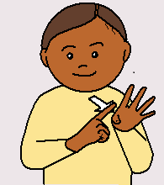

**Happy New Year**

**What’s on at Hartlepool Deaf Centre - One77, 177 York Road**

**JANUARY to MARCH 2020**

**Contact Rachel Austin 07751 974834**

**All welcome…**

Monday Afternoon Club with BSL interpreter – **every Monday 12.30pm - 2.30pm.** Cost £2 (free tea/coffee and biscuits). We chat, make things, knit, play board games/bingo.

NRASS Drop-in every Monday 10am – 12noon. Help with benefits, housing issues, letters, appointments and phone calls. **Text Fahmi Syeda on 07850766926** to bookappointment.

FREE 2 course meal at Lunch Club one Friday each month 11.30am – 1.30pm.

Next dates are **Friday 17th January, Friday 14th February** and **Friday 20th March**.

New people welcome but you must join first – please text Rachel.

Indoor Bowls with instructor (with BSL interpreter) one Saturday each month 12.30pm – 2pm, costs £2.50 to pay for instructor. Good exercise and good fun.

At Hartlepool Indoor Bowls Club, Raby Road, TS2 8AR. Text Rachel for more information.

Problems with NHS appointments or interpreters for GP? Please contact Rachel who can help. Text 07751 974834 or send a video message on WhatsApp.

USEFUL INFORMATION – **remember to ask for interpreter**

EXTENDED HOURS GP and NURSE APPOINTMENTS – Chadwick Practice, One Life, Park Road, TS24 7PW (open to all patients in Hartlepool).

Monday – Friday 6.30pm – 8pm, Saturday 10am – 1pm, Sunday 11am – 1pm.

To book contact your GP or use NHS111 BSL Service [www.interpreternow.co.uk/nhs111](http://www.interpreternow.co.uk/nhs111)

BSL Interpreters

North Tees or Hartlepool hospital text Everyday Language Solutions (ELS) on 07831 356809. James Cook Hospital text CJ Interpreting 07916 536176

**Give your name, appointment date, time and place.**

To contact Hartlepool Borough Council text 60006, start with HBC then add message.

Emergency Out of Hours Social Services (5pm – 8.30am – all night) Text 07826 903165.

See over…

Find us on Facebook  or contact Rachel at One77 on 07751 974834 or come see her on Mondays or Tuesdays or book an appointment to see her another time.

SignHealth has formed a partnership with Shout to make the service more accessible to Deaf people, it is available 24/7 just text 85258 to get started.

For more information type this link into google: <https://www.crisistextline.uk/how-it-works>

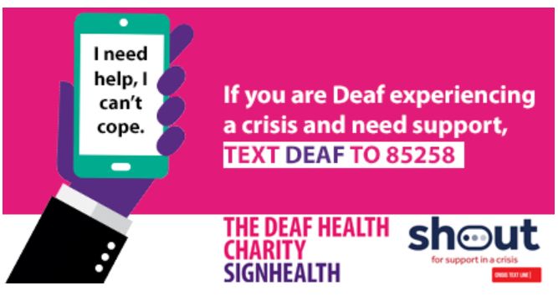

**VIRTUAL DROP-IN by CJ Interpreting**

Every **Wednesday from 10:00 - 1:00pm**

CJ Interpreting are meeting the needs for Deaf people who are unable to attend local drop-in sessions / see their local advocate / Social workers.

Free access to Trainee BSL/English Interpreters for Deaf people.

Making telephone calls on your behalf to sort out Hospital, Doctors appointment / and any other issues.

15 minute slot available per booking, must be booked in advance contact: 07926 109916 (Text / FaceTime / WhatsApp)

This service is free and will of course, be treated in the strictest confidence.

*The service is not an advisory service*