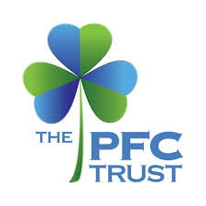



Community Wellbeing Champion Awards 2026
Nomination Form
Q1. Your contact details (contact details of the person making the nomination).
Full Name:

Address:

Phone Number:

Email Address:

Q2. Contact details of the person or group you are nominating.

Full name of person or group:

Address:

Phone Number:

Email Address:

Confirmation that nominee is happy to be nominated:

Q3. Award Category: Please select one of the following categories:

Young person (aged upto 18)
Adult champion (aged over 18)
Community group champion
Dementia champion

Q4. Why are you nominating this person or group?
Please tell us about what they have done to make a difference in their community, with examples and details about their impact.
(maximum 200 words)

Q5. Is there anything else about the person or group you feel should be considered?
(maximum 150 words)

Please send completed nominations to –
CommunityWellbeingChampions@hartlepool.gov.uk
Paper Copies to –
Stephen Thomas
Healthwatch Hartlepool
Greenbank
Waldon Street
Hartlepool TS24 7QS
The closing date for nominations is 1pm on Friday 21st August
Awards will be presented at the Annual World Mental Health Day Celebration at 1pm on Friday 9th October at the Centre for Independent Living, Burbank Street, TS24 7NY

Disclaimer – The World Mental Health Day Planning Group will always make sure that any information you provide is protected and treated securely and only used for the purpose for which it has been supplied. All information provided will be held in accordance with the Data Protection Regulation (GDPR) and Data Protection Act (2018).

