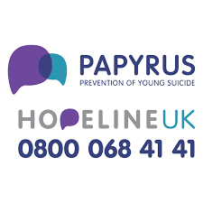
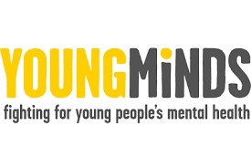
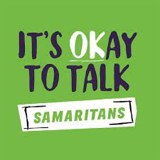

List of organisations for Mental Health Support
BEAM Sandwell
An emotional health and well-being drop-in service for young people aged 5-18 (or up to 25 if you're a care leaver) who are registered with a GP in Sandwell.

KOOTH
An online service which provides free, safe and anonymous support.

YoungMinds
Provides free, 24/7 text support for young people across the UK experiencing a mental health crisis. Text YM to 85258

HOPELINE
A confidential support and advice service for:
Children and young people under the age of 35 who are experiencing thoughts of suicide.
Call 0800 068 4141 any day 9 am -12 am(midnight)

Samaritans
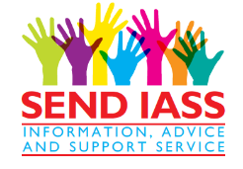
You can access confidential emotional support at any time from Samaritans either by emailing or by calling 116 123

