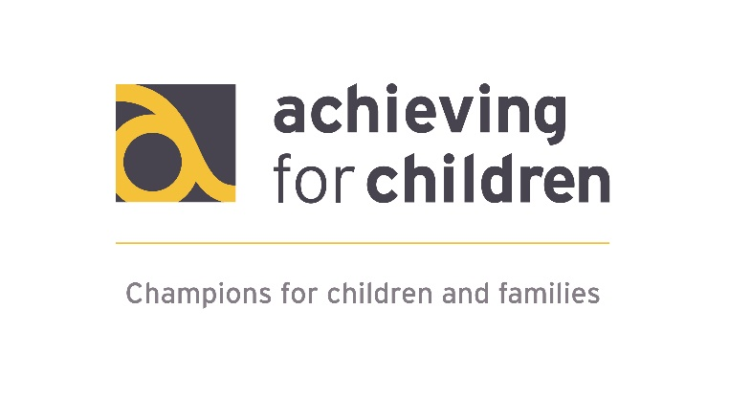

Early Years
Special Educational Needs
& Disability (SEND)
Inclusion Service

September 2019
Updated October 2020

Index

 |  | Page
 | Introduction | 3
 | How to access the service
 | 2.1 Telephone consultation | 3
 | 2.2 SEND Support to educational settings | 3
 | 2.3 Individual support for a child | 3
 | When we become involved | 3 - 4
 | Our team
 | 4.1 Who is in the service? | 4
 | 4.2 Early Years Area SENCO | 4
 | 4.3 Early Years Support Worker (Social Communication) | 4
 | 4.4 Early Years Educational Psychologists/Assistant Psychologists | 5
 | 4.5 Early Years Communication and Language Consultant | 5
 | SENCO/staff support
 | - Early Years Inclusion Network meetings | 5
 | - Centrally organised training courses | 5
 | Early Years SEND Inclusion Fund – EYSIF
 | 6.1 What is the Early Years SEND Inclusion Fund Discretionary Grant? | 6
 | 6.2 Early Years Inclusion Fund Background and Rationale | 6
 | 6.3 Who it is for? | 7
 | 6.4 Effective and appropriate use of the funding | 7
 | 6.5 How funding can be requested | 8
 | 6.6 How funding is allocated | 8
 | 6.7 How the impact of support is monitored | 8
 | Glossary | 8
 | Useful links | 9
 | Early Years SEND Inclusion Fund Request Form | 10 - 13
 | Appendices
 | 9.1 Roles and responsibilities | 14
 | 9.2 EY SEND Team Contact details | 15
 | 9.2 AfC (RBWM) Early Years SEND Pathway | 15 - 17

Introduction

The Early Years SEND inclusion service supports the successful inclusion of children with special educational needs and disabilities in Early Years settings or Childminders who are in receipt of funding for 3- and 4-year olds early educational entitlement. This is done through helping practitioners to facilitate access to the Early Years Foundation Stage Curriculum for children with additional needs and ensuring they receive the best possible start to their education and achieve the best possible outcomes.

Support can be offered to settings at a general level e.g. developing policies and practices to support inclusion or to offer advice about an individual child or group of children who have additional learning, physical, emotional or social needs.

How to access the service

Support can be accessed by:

Telephone consultation
For a telephone consultation and problem solving regarding a concern, please contact the Educational Psychology Service Telephone consultation line (01628 796688).

SEND Support for educational settings
Support can also be offered to Early Years settings by contacting the Early Years Area SENCo (helen.mchale@achievingforchildren.org.uk). Advice can be requested regarding aspects of inclusive practice or an individual concern.

Individual support for a child
For individual support for a child please complete the ‘Request for additional Support’ form (titled ‘Early help Part 1 Family Assessment requirement’) on the RBWM LSCB website: https://rbwmsafeguardingpartnership.org.uk/p/safeguarding-children/concerned-about-a-child#:~:text=All%20referrals%20for%20children%20or,can%20call%20on%2001628%20683150.&text=You%20can%20also%20phone%20the,child%20or%20young%20person%20lives

Any professional making a referral must have gained parental consent.

When we become involved

The Early Years SEND team becomes involved following a referral via the Single Point of Access (SPA) to the Early Help Hub (‘Request for additional Support’ form, as above) made by, for example a:
- Paediatrician
- Health Visitor
- Speech and Language Therapist
- Parent/Guardian
- Childminder
- Early Years setting.

The Early Help Hub meet once per week and if appropriate the referral will be passed onto the Early Years SEND team. The Early Help Hub will notify you regarding the outcome and the Early Years SEND team, if allocated, will contact the Early Years setting to discuss and clarify concerns to establish the next steps.

If the referral is not thought to be relevant to the Early Years SEND team, the referrer will be directed to another service. There is a range of provision available including:
- Inclusion/SEND Co-ordinator within the educational setting
- Health Visitor (AfC)
- Local Children’s Centres (AfC)
- Information, Advice & Support Service (RBWM) Email: ias-rbwm.co.uk
- Children and Young People’s Integrated Therapy Service (BHFT)
- A range of charitable organisations e.g. Autism Berkshire, Parenting Special Children.

All contact details are available on the Local Offer: http://directory.rbwm.gov.uk/kb5/rbwm/directory/localoffer.page

Our team

4.1 Who is in the service?

The service comprises of:
- Early Years Area SENCO
- Family Support Worker Early Years (Social Communication)
- Early Years Senior Practitioner Educational Psychologists
- Assistant Psychologist
- Early Years Speech and Language Development Consultant

4.2 Early Years Area SENCO

The Early Years Area SENCO role includes:
- Providing support and practical advice to settings on the assess, plan, do, review cycle
- Helping settings develop policies to support inclusion
- Assisting with observation, monitoring tools and record keeping systems for evidencing children’s progress to inform requests and referrals
- Developing and disseminating good practice
- Supporting the development and delivery of training
- Leading Inclusion/SEND Co-ordinator Network meetings.

4.3 Early Years Support Worker (Social Communication)

The Family Support Worker advises pre-school staff and parents to develop practical approaches to meet the needs of children in their setting with a diagnosis of an autistic spectrum disorder or other social communication needs.
This can be done through:
- Input to the child in the setting
- Modelling approaches to the setting so that input can be ongoing
- Giving advice about suitable approaches and adjustments within the setting and to the curriculum
- Offering advice to parents.

The Family Support Worker also takes part in the Multi-Agency Assessment Group (MAAG) run by the Child Development Centre, for the assessment of children with significant social communication disorders.

4.4 Early Years Educational Psychologists/Assistant Psychologists

The Educational Psychologist and the Assistant Psychologist (under the supervision of the Educational Psychologist), will give advice to the setting and to parents about how to meet the needs of a child. This may be done through advice, assessment, planning of intervention and review and may include:
- Discussion with staff and parents
- Observations of the child
- Assessment through play
- Support and modelling in the setting
- Recommendations for staff and the nursery or pre-school
- Reviews of the child’s progress, involving parents and other people working with the child.

4.5 Early Years Communication and Language Consultant

The Early Years Communication and Language Development role involves:
- Offering advice on strategies to support children with speech, language, and communication needs
- Modelling strategies to support children with SLCN
- Signposting settings to relevant training and resources
- Offering telephone/email advice on individual anonymous children.

- SENCO/staff support

  - Early Years Inclusion Network meetings
The SENCO in each early years setting will be invited to attend a termly Early Years network meeting, within their local area. The purpose of the meetings will be; to discuss aspects of Early Years education including special education needs; problem solving for shared concerns; share approaches and ideas for resources, disseminate knowledge and information about specific areas of SEND which are of concern to the group.

  - Centrally organised training courses
The team will organise training which will be open for all settings to attend. Examples of topics are Early Years Emotional Well-being Practitioner training; Attention Autism approaches; Lego therapy.

- Early Years SEND Inclusion Fund – EYSIF (Early Years SEND Inclusion Fund Discretionary Grant)

6.1 What is the Early Years SEND Inclusion Fund Discretionary Grant?

A fund for Early Years settings to facilitate:
- Access to the Early Years Foundation Stage curriculum, inclusion and participation within the setting of children, age 2 to school entry, with significant additional needs
- Early intervention within the setting, to improve outcomes for the child.

6.2 Early Years Inclusion Fund Background and Rationale

Early Education and Childcare Statutory Guidance for Local Authorities placed a requirement on Local Authorities from April 2017 to establish an Early Years Inclusion Fund to support 3- and 4-year olds with emerging Special Educational Needs (SEN) or disabilities.

By law all providers must have arrangements in place to support children with SEN or disabilities. The Early Years Foundation Stage framework (2017) states that: ‘Every child deserves the best possible start in life and the support that enables them to fulfil their potential.'

In response to identified SEND settings are required to adopt a graduated assess, plan, do, review to support the child's needs. Providers must also have regard to the SEND Code of Practice (2014) and the Equality Act (2010). The SEND Code of Practice outlines four areas of special educational need that include a range of difficulties and conditions: communication and interaction, cognition and learning, social, emotional and mental health and sensory and/or physical.

The majority of children with additional or special educational needs will not require special resources or enhanced staffing to be successfully included in settings; most settings meet the additional needs of their children very well. However, some children with complex needs may benefit from inclusion funding for a time limited period, or from the provision of additional resources or equipment.

A research report to the DfE in 2015 (Funding for young people with Special Educational Needs 2015; https://www.gov.uk/government/publications/funding-for-young-people-with-special-educational-needs) presented an evaluation of an early years inclusion fund that had been established in York.

Evaluation of the impact of this funding showed that benefits were:

- Young children’s additional needs were identified earlier
- Young children were referred earlier for assessment and advice
- Children were more likely to stay in their own local early years settings
- There was an improvement in tracking of children’s progress
- There was an improvement in children’s progress and better outcomes for children
- More comprehensive information was available about the children’s skills and needs which smoothed transition into school.

The report highlighted that support services played an important part in recommending interventions and identifying approaches to maximise learning and development in young children who were identified as having additional needs.

6.3 Who it is for?

The EYSIF can be used to support children aged two, three and four years old, who attend a Private, Voluntary or Independent setting, maintained nursery or childminder in RBWM. It cannot be used to support children who are in the Reception class of a maintained school. The purpose of this fund is to:

- Improve the outcomes for children with additional needs
- Enable children with significant and/or complex additional needs access targeted support to overcome barriers to inclusion.
- Enable Early Years providers who are eligible to receive funding for the 3- and 4-year olds early educational entitlement to help children with additional needs access the Early Years Foundation Stage curriculum.

6.4 Effective and appropriate use of the funding

We anticipate that where interventions are effective, that funding for one or two terms should be sufficient for most children to make progress. For some children with complex on-going needs settings should consider making a request for an Education Health Care Plan https://rbwm.afcinfo.org.uk/pages/local-offer/information-and-advice/assessment-and-education-health-and-care-planning/needs-assessment-ehc-plans
EYSIF is designed to support settings working with children in the short term as part of a cycle of targeted support and coordinated interventions. Applications must evidence a graduated response of assessment, plan, do and review. Targeted interventions must be implemented with full consent of parents and ongoing co-production.

Funding for one to one support is not available and settings should not make staffing decisions made on assumptions on or the possibility of funding. It cannot be used to support children who are in the Reception class of a maintained school or within specialist nursery provisions or units.
Examples of the way in which the EYSIF has been used effectively to implement strategies to enable a child or group of children to access the Early Years Foundation Stage curriculum have included:
- Specialist or one-off extra training, or to upskill a team or staff member
- Providing targeted training to the setting
- Opportunities for professionals to model interventions
- Extra staff time to implement specific interventions for individual children over a short period of time
- Targeted speech and language intervention delivered by a Speech and Language Therapist and modelled to staff in the setting with a view to ongoing intervention by the pre-school setting.
- Supporting children who are transitioning to school. This could be by spending time at the school and releasing key workers to support the process
- To release staff to have time to produce resources for specific children
- Purchasing specific specialised equipment requests or specific resources to support interventions.

6.5 How funding can be requested

- The child should be known to the Early Years SEND team (via a request to the Early Help Hub, please see Section 3).
- Discuss the request for funding with a member of the Early Years SEND team to establish the need for additional funding and how this will be used.
- Fill in the Early Years SEND Inclusion Fund Discretionary Grant application form with the consent of parents for individual children and the supporting officer agreement (a member of the Early Years SEND team). See Section 8 for application form.

6.6 How funding is allocated

- Requests will be considered at a weekly meeting of members of the Early Years SEND Team.
- The setting will be contacted about the outcome of the request. We aim to respond to requests within 2 weeks.

6.7 How the impact of support is monitored

- At the end of the specified intervention period an early help review, or similar meeting should be held to review the impact of the intervention. This should be summarised on the original funding form and submitted as directed. Further funding can be applied for as part of the next steps (see form).

- Glossary

AfC – Achieving for Children

BHFT - Berkshire Healthcare NHS Foundation Trust

DfE – Department for Education

EYSIF – Early Years SEND Inclusion Fund

INCo – Inclusion Co-ordinator

LSCB – Local Safeguarding Children Board

MAAG – Multi-Agency Assessment Group

RBWM – Royal Borough of Windsor and Maidenhead

SENCo – Special Educational Needs Co-ordinator

SEND – Special Educational Needs and Disabilities

- Useful Forms – and links

RBWM/AFC Local offer
https://rbwm.afcinfo.org.uk/local_offer

Early Years SEND team – Local Offer
https://rbwm.afcinfo.org.uk/pages/local-offer/information-and-advice/early-years-and-childcare

Request for Additional Support – Early Help Part 1 Family Assessment requirement
https://rbwmsafeguardingpartnership.org.uk/p/safeguarding-children/concerned-about-a-child#:~:text=All%20referrals%20for%20children%20or,can%20call%20on%2001628%20683150.&text=You%20can%20also%20phone%20the,child%20or%20young%20person%20lives

Privacy Notice (please email)
dpo@achievingforchildren.org.uk.

Education Health Care plan request form
https://rbwm.afcinfo.org.uk/pages/local-offer/information-and-advice/assessment-and-education-health-and-care-planning/needs-assessment-ehc-plans

RBWM/AFC Disability Register
https://rbwm.afcinfo.org.uk/pages/local-offer/information-and-advice/social-care/register-for-children-and-young-people-with-disabilities
Max card
https://mymaxcard.co.uk/

Providing Children’s Services for the Royal Borough of Windsor and Maidenhead
Early Years SEND Inclusion Fund
Request for Discretionary Grant 2020 - 2021
Child’s details
Child’s name:
Date of Birth:
Home Address (including postcode):

Parental consent/details
Name: |  |  | Relationship to child:
Telephone: |  |  | Email:
Signed: |  |  | Date:
Early Years Provider details
Early Years Provider (name and address):

Child’s start date:
Is child in receipt of 2, 3 or 4-year-old Early Education Entitlement Funding? |  |  | Yes/No
Days attends/ session time:
Has Disability Access Fund (DAF) been claimed? |  |  | Yes/No
If Yes, how is it being used?

Name of Professional applying for EYSIF:
Role:
Contact telephone number:
Email contact:
Child’s needs
Other Professionals involved
(please note the child should be known to the early years SEN team via a request to the early help hub)

Does child have an individual education plan/play plan? |  | Yes/No
If Yes, please attach
If No, please provide a brief summary of the child’s additional needs:

Interventions/Resources/ Training to be funded
Please identify interventions/resources/ training |  |  |  | Timescales and cost
What is the expected impact of the above?
Impact Review
Review: (to be submitted to rbwm.earlyyears-childcare@achievingforchildren.org.uk
by end of each half term)
Please attach review of individual education plan/play plan or summarise impact on the child’s progress:
Reviewed by: |  |  |  |  | Date:
Is further funding being applied for? |  |  |  |  | Yes / No
If Yes, please fill in and attach a new page 2 of this form to indicate how the funding will be used

For help in completing the form please contact: helen.mchale@achievingforchildren.org.uk

Please password protect form and return to:
rbwm.earlyyears-childcare@achievingforchildren.org.uk

Data Protection Privacy Statement to be shared with parents/carers
The information you supply is stored electronically and in paper file format in filing cabinets which are locked outside office hours and overseen by staff during office hours. It is accessed by professionals assigned to your case within the Early Years Service working with you and your child. Files will only be saved electronically after a period of non-involvement.
To enable us to deliver tailored solutions to meet your child’s needs we share appropriate information (e.g. details of the difficulties your child is experiencing) with other services already involved with your child. If other services need to be involved we will seek your permission before contacting them, unless we are required to disclose information to third parties where it is lawful to do so e.g. for child protection matters or criminal investigations. Through our secure online system, other teams within Children’s Services have access to our reports unless you request otherwise.

- Appendices

9.1 Roles and responsibilities

Anna Walsh and Fiona Hewin – Early Years Educational Psychologists
Fiona and Anna are Senior Practitioner Educational Psychologists in AfC for RBWM Psychology and Well-being team. Fiona and Anna have a special interest in early years and both work 1¼ days a week with the Early Years SEND team supporting early years settings through training, advice and work with individual children. The rest of their working week is spent as part of the wider Psychology and Well-being team as link Educational Psychologists for nursery, first, primary, middle and secondary schools across RBWM.

Helen McHale – Early Years Area SENCo
Helen works 2 days per week as the Early Years Area SENCO. This role involves supporting Early Years settings with inclusive practice and advising on strategies to assist individual children in accessing the Early Years Foundation Stage curriculum. The rest of Helen's working week is spent in her role as Co-Headteacher and SENCO of Cookham, Maidenhead and The Lawns Nursery School Federation.

Barbara Hetherington – Support Worker Early Years, Social and Communication
Barbara is part of the multi-agency team assessing pre-five children for diagnosis of Autism Spectrum. Post diagnosis, her role goes on to provide support and advice to parents and pre-school settings around all aspects of autism and facilitates links to local support service.

Bethan Beaney – Communication and Language Development Consultant
Bethan is a Speech and Language Therapist with 20 years’ experience. She has worked mainly for the NHS in Child Development teams and Special Schools. Her role is to support settings at the universal and targeted level with children with speech, language, and communication needs. Telephone and email advice can be given for individual anonymous children.

Saya Dunford – Assistant Psychologist
Saya is an Assistant Psychologist at AfC for RBWM Psychology and Well-being team. Saya works 1 day a week with the Early Years SEND team supporting early years settings through training, advice and support with individual children, under the supervision of an Educational Psychologist. Settings are able to use Inclusion Funding to buy-in some extended involvement with Saya, for example, to model interventions/approaches to staff and to work with individual children.

9.2 AfC (RBWM) Early Years SEND Pathway

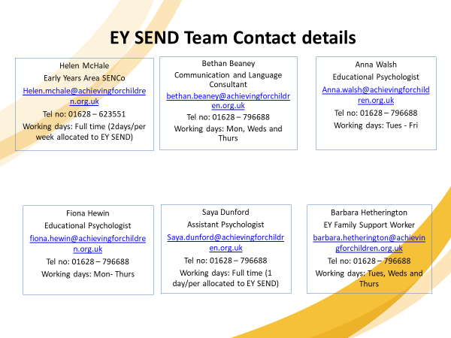
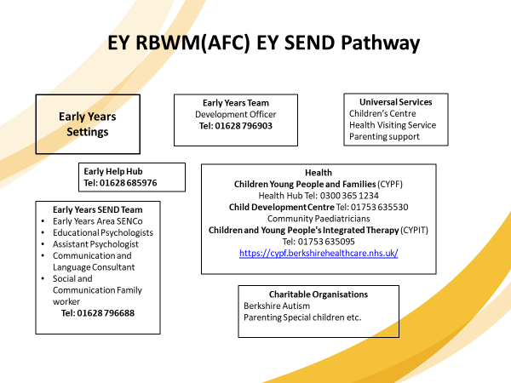

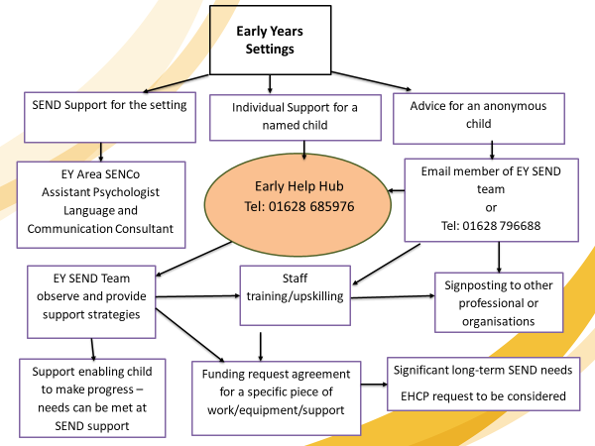
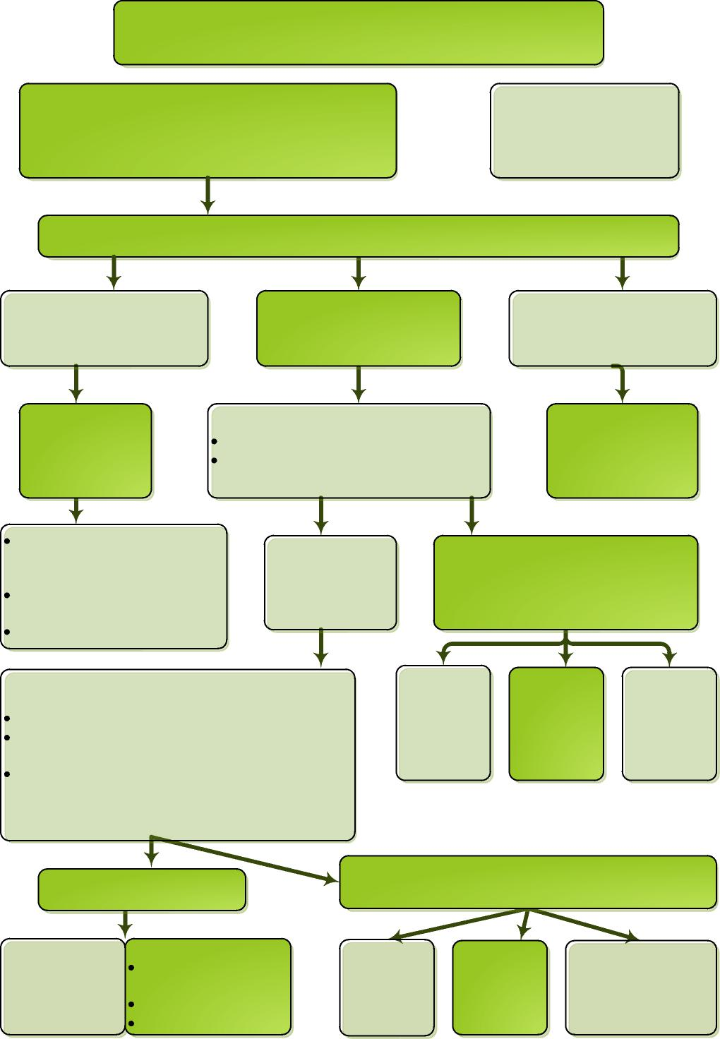
0 – 5 Referrals to Community Paediatricians
Children registered with Berkshire East GPs up to age 5 who
would benefit from a holistic paediatric assessment referred to
Community Paediatrician at CDC by any professional
(e.g. HV, GP, SaLT, EP, SENCo)
5+ with possible ASD refer to CAMHS
CDC hold weekly meeting to discuss way forward for each referral
Evident severe
neurodisability requiring
multiple input
‘General’ difficulties,
possible social communication
difficulties
Specific area of difficulty not
needing paediatrician
e.g. stammering
Joint Assessment
SaLT/ OT assessment
Clinic (JAC)
Paediatric clinic assessment
Baseline developmental assessment General physical assessment plus medical investigations arranged if indicated
Ongoing review/input from Paediatrician and relevant medical professionals Sensory Consortium Service support if needed
Early Help Hub referral?
Not ASD features
Features of ASD present
Possible outcomes include:
Early Help Hub referral
Advice and
review by
paediatrician
Signpost to
other services
e.g. parenting
courses
Not ASD, but other developmental issues
ASD diagnosis
possible outcomes include:
Notification to
CYPDS for Early
Help Hub referral
Early Help Hub referral
Signpost e.g.
parenting
course
Refer to SaLT
Post diagnosis workshop x3 for parent’s home visit
ongoing SaLT
If indicated,
medical investigations/
referral to SaLT/OT/
Physio
Multi-Agency Assessment Group (MAAG)
generally, age 2 ¹/₂ -3. (runs at least every half term) 3x2 hr sessions, free flow and structured activity Final session is individual meeting with parents to formulate plan
If younger with obvious diagnosis may not attend group but Paediatrician may discuss with other professionals e.g. SaLT and offer diagnosis and support without MAAG

