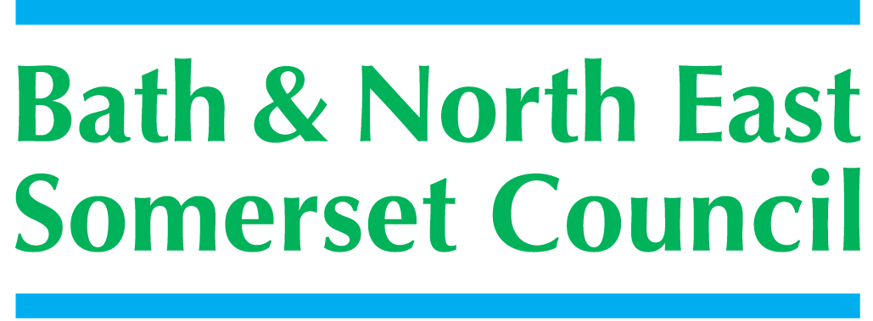

EDUCATIONAL PSYCHOLOGY SERVICE
Consultation Request for a Child or Young Person who has an Education, Health and Care Plan (EHCP) January 2021

Guidance Notes:
- The Educational Psychology Service is now working through a consultation process when working with children and young people who have an EHCP. This form is to be used for all requests for work that will involve an educational psychologist. Previous forms (e.g. Annual Review, Enhanced Support) are now obsolete [February 2019]. Please also read EPS and Annual Reviews – Protocols [December 2019] at the end of this request form.

- The focus of the work will be to ensure the successful implementation of the EHCP where there are concerns or difficulties in doing this.

- The educational psychologist’s work might be through consultation and review meetings, systemic training, supervision or coaching of staff. There will be follow-up reviews to ensure that progress or changes made have been maintained.

- This form is to be completed by a member of the educational setting which the child or young person attends.

- The consultation process provides a structure which helps use time effectively and productively. It aims to work preventatively and creatively, rather than working reactively. It draws on the skills and expertise of those involved and takes into account the complexity of different learning environments

- The consultation process involves the following:
- Joint investigation and exploration - this might involve school staff and/or the parent/carer.
- Developing a shared understanding of the situation
- Joint planning and exploration of solutions
- Developing jointly agreed actions to improve outcomes for the child or young person
- Reviewing progress made and planning for next steps

- The educational psychologist brings the following to the consultation process: his/her experience and knowledge of child and adolescent development, the psychology of teaching and learning and organisational processes, an understanding of the psychosocial processes that interact to effect children’s development, a range of psychological assessments and techniques and solution focused techniques.

Once fully completed, please send this request with signatures and any relevant supporting paperwork to:
Bath and North East Somerset Council, Educational Psychology Service, Lewis House
Manvers Street, Bath, BA1 1JG
Or email to psychology_service@bathnes.gov.uk
Or upload to Globalscape

Bath & North East Somerset
- the place to live, work and visit.

Making Bath & North East Somerset
an even better place to live, work and visit.

REQUEST FOR A CONSULTATION
WITH AN EDUCATIONAL PSYCHOLOGIST

Request from:
(Setting name)
Contact Person:
Phone Number and Email Address:
(include best day/s and time/s to make contact)
Position Held:

Child/Young Person |  |  | Date of Birth |  | Year Group  (If relevant)
Forename(s) |  | Family Name
Male |  | Female |  | Other

Ethnicity:

Address(es): |  | Telephone Nos:
Name of Parents/Carers including relationship: (and address if different from above): |  | Who has parental responsibility?

Desired outcomes from consultation:
1) child or young person | 2) parent/carer | 3) key educational setting staff
Please answer all of the following questions to help us understand what will be helpful in terms of EPS involvement

What are the current concerns?

Who is most concerned?

What is working well?

What is not working so well?

What has already been tried?

How well has this worked?

What other information will be helpful to know?

Please ensure the form is fully completed and signed. Consent does not guarantee direct individual work with a child or young person (see possible outcomes of request – below).

Request made by: |  | Date:
Signature of person making the request: | I have explained the consultation request form and process to the child/young person and parent/carers.
Signature of child/young person if possible: | The consultation request form has been explained to me and any questions I had have been answered.
Signature of parent/carer or young person if over 16 years of age: | The consultation request form has been explained to me and I understand that if a consultation is agreed, information about my child may be shared with professionals and between professionals involved to support the consultation process.

What will happen once the EPS receives the fully completed form?
- Once the fully completed request form has been received, an EP will contact the person who has made the request to clarify how an EP can become involved. This contact will be made within 10 working days of allocation to an EP - allocation meetings occur on a weekly basis.
- Outcomes of the initial contact might include the following:
  - No EPS involvement, signposted to another service
  - A consultation meeting with those most concerned, including parent/carers and educational setting staff. Where appropriate the child / young person will be involved in a consultation meeting. The meeting would be an opportunity to establish a shared understanding of the situation and jointly plan agreed actions.
  - Observation of the child / young person in the educational setting followed by a consultation meeting to establish a shared understanding of the situation and jointly plan agreed actions.
  - Individual work with the child / young person might be carried out to help provide additional perspectives during the consultation process.
  - Systemic training in the educational setting.
  - Supervision or coaching of educational staff around a specific issue or issues.
- A consultation review will take place after an appropriate amount of time. This will involve all involved in the initial consultation meeting. The date of the review meeting will be set at the end of the initial consultation meeting.
- The EP will provide a written record following the initial consultation and then after the review meeting.
- If a record is needed for the SEN Panel to consider a change in provision or a change in placement within the context of an Annual Review, the EP will establish when this will be completed when they initially make contact with the educational setting.
- The consultation process is time-limited. This can be discussed with the EP once the remit of the work is established.

Educational Psychology Service and Annual Reviews – Protocols
Jane De Ste Croix, Lead EP, December 2019

Rationale for Protocols

Historically, educational psychologists (EPs) in Bath and North East Somerset have been asked to contribute to a child/young person’s Annual Review if there is to be a change in provision or a change in type of placement. For an Annual Review and Key Stage transfers, the SEND Code of Practice (January 2015) requires educational settings to document the voice of the child/young person and submit a report from the educational setting. It does not specify which other professionals have to be involved.

EPs are frequently asked to carry out a cognitive assessment to identify a child/young person’s cognitive functioning. In some cases, the evidence of the complexity and severity of a child’s SEND may be available from an educational setting or from other professionals who have been involved over a period of time.

When a change of the type of provision is being considered, EPs are frequently asked to carry out an assessment to assist the SEN Panel in their decision around the appropriateness of a specialist provision. There are many instances where the educational setting has gathered a range of evidence and proposed an amended EHCP which clearly indicates that a consultation with a specialist provision would not be inappropriate as long as parent/carers are in agreement or if they are making the request.

The Educational Psychology Service (EPS) is committed to ensuring that high quality advice is provided for EHCNAs and that we can support educational settings to implement EHCPs and maintain placements where issues arise. If there is clear evidence to support a change in provision or type of placement which has been submitted by educational staff (including standardised tests) then an EP assessment may not be needed.

The aim of these protocols is to provide a clear system for educational settings and the SEND Team on when to involve an EP for changes in provision and type of placement. This will allow more time for the EPS to spend on providing high quality advice and assessments as well as supporting educational settings through a problem-solving/solution-finding consultation approach to maintain placements and implement EHCPs.

Protocols for Educational Settings
If a change of provision or type of placement is to be considered, relevant information is to be gathered.

Key question:
Is there enough robust evident to enable a recommendation for a change in provision or for the SEND Team to make a decision around the appropriateness of a specialist provision?

Robust evidence would include standardised tests and other assessments carried out by educational staff, assessments by outside professionals and recent reports (under a year old) from relevant professionals

YES | NO | NOT SURE
Carry out the Annual Review meeting process as set out in the SEND Code of Practice and in line with SEND Team checklist.  Submit paperwork to the SEND Team. | Consider where evidence can come from.  Which assessments can be carried out by educational staff?  Which relevant professionals have recently been involved who can submit evidence? | Talk to the SEND Team about whether up-to-date evidence is sufficient.  If EP involvement is being considered, talk to the EPS and SEND Team to see what would be helpful.  Please note – the EPS would not get involved solely to carry out a cognitive assessment for the reasons outlined above.  The EPS and SEND Team will discuss potential involvement. If an EP is going to become involved, the educational setting will be informed and can then complete an EPS Consultation Request form to be returned to the EPS for allocation.

Protocols for the SEN Team
If a request for a change of provision or type of placement comes from an educational setting to the SEND Team, the following will be considered:

- The SEND Lead Practitioner can consult with the EPS to consider the request and available evidence.
- If the SEND Lead practitioner is uncertain whether there is sufficient evidence, they will discuss the case in their POD meetings. Further discussion with the EPS can be sought.
- The EPS would not get involved solely to carry out a cognitive assessment for the reasons outlined above i.e. evidence of a child/young person’s cognitive functioning can be gained through other formal assessments, including those carried out by educational staff.
- If the outcome of the consultation between a Senior Inclusion Officer, SEND Lead Practitioner and the EPS is that EP involvement is needed, the SEND Lead Practitioner will ask educational staff to complete a Request for Consultation form indicating which area of need would be helpful to have EP advice about.

Protocols for the EPS - as above plus:

Through consultation with either the educational setting or the SEND Lead Practitioner or Senior Inclusion Officer, the EPS will decide whether to attend the Annual Review meeting if they feel it is appropriate. The purpose would be to gather information and support those present with problem-solving/solution-finding. This stage can form a key part of an EP’s assessment.

