Attention building activities
The following programme is based on the principles of Moody, Cooper and Reynell’s developmental stages. It is credited in full by Gina Davies.
It is very visual and attention grabbing
But most of all it is FUN! (For both the children and adults)
There are four stages to Attention building:
Stage One | THE BUCKET
Stage Two | Extending attention
Stage Three | Learning to shift attention
Stage Four | Transitioning with attention
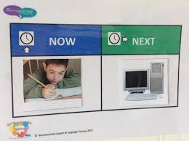
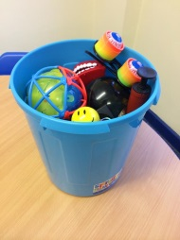
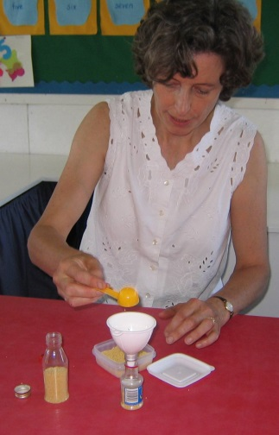
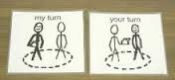

What to do – Stage one
Stage one is THE BUCKET.
What are the aims? To build attention that can be sustained. We are offering an activity that follows a planned sequence and leads to a final fantastic experience.
It must be:
- Highly visual activities
- Highly appealing activities
- The only thing available
- Delivered on the adult agenda.

Rules to follow at Stage one –

- Avoid telling the children what to do e.g. DO NOT say “sit down, stop fiddling” etc… Let them achieve good looking and listening behaviours because they want to!
- If you have another adult in the room, make sure they too are part of the group.
- Ask the other adult not to distract the children by talking to them.
- Ask the other adult to keep children in the group by putting them back in their place WITHOUT speaking to them.
- DO NOT let the children touch your objects – they may only look.
- Reiterate that this is “my bucket”.

How to use the bucket:
- Use a whiteboard to show a ‘now and next’ – draw the bucket onto the ‘now’ area.
- Sing a song before opening the bucket along the lines of:
  - “What’s in my bucket today, bucket today, bucket today? What’s in my bucket today – I wonder what it is?
  - Or: ‘I’ve got something in my bucket, in my bucket, in my bucket. I’ve got something in my bucket, would you like to see?’
- Talk all about the item and make it seem really interesting.
- Look at the object as you talk about it, so that everyone in the group is looking at the same thing.
- Do up to three items and then the activity is finished.

There are examples on YouTube should you want a demonstration.
When can I move onto stage two? Move on when you feel that the child/children are able to sustain attention at this level with no need for adult support to re-sit, re-focus (etc) them.

Stage 2 – Extending attention

Stage two includes THE BUCKET and another FUN and EXCITING attention building activity.
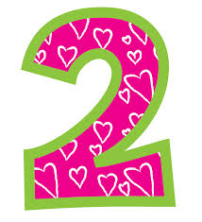
Use now and next boards to transition between activities, the child must understand that both activities are to be led by THE ADULT.
Use language that is short and simple, but that includes key information.
For eg. For ‘Colourful Foam’ – you may say:
- Open it, Spray it, blue/red etc, push it down…….
See below for a list of example activities:

Activity | Equipment
Flour Shaking | Sieve, black paper, flour
Flour castles | Flour, paper cones, small cups, ice cube trays
Tapioca pouring | Tapioca, black tray, clear plastic tube, funnel, xylophone, cake tins
Fish in the Sea | Shower curtain, 2x watering cans, food colouring (blue/yellow) tissue paper fish, 2x plastic bottles
Tube of Colour | Lay flat poly tubing, bucket of water, food colouring x 2 (red, yellow), glitter
Swirly Painting | Lazy susan, paint
Shooting stars | Shower curtain, watering can, black food colouring, foil stars, glitter
Bath bombs | Water tray (clear) bath bomb
Squirty colour | Plastic syringe, water, food colouring, shower curtain
Colourful tracks | Plastic drain (halved), toy cars dipped in paint, white paper

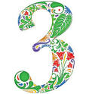
Use your imagination to pick activities that you know the children will enjoy, fits into the curriculum (science etc) or that follows seasonal diaries.
Move onto stage 3 using the same criteria as for stage one.
Stage three

Stage three contains the bucket and then a turn taking activity.
Aim: The child learns how to shift their attention to their own individual participation and then back to the group
Use now and next boards to transition between activities, the child must understand that both activities are to be led by THE ADULT, but that in the second activity they are invited to take a role.
Use language that is short and simple, but that includes key information.

How?

Other points to remember:
- Avoid predictable patterns of turn taking
- Practice not getting a turn – remember life isn’t fair
- Let anxious children watch several turns

Activity | Equipment
Raining on you | See through umbrella, Shower curtain, Tapioca (hail) or watering can + glitter (rain), Stool.  How: Fill the watering can with ‘water’ from a bottle. Offer a child to have a turn. Child sits on the stool and holds the umbrella. Pour the water over the umbrella.  Oh look it’s raining on you, raining on you, raining on you….’
Roll the sausage | Blanket.  How: offer the child a turn to lie on the blanket. Roll them up ‘Roll, roll, roll the sausage…’
Standing on the stool | Stool.  How: Stand on the stool and then jump. Offer the child a go.  I am standing on the stool, on the stool, on the stool. I am standing on the stool, watch me as I jump. Ready, steady, go.’
Tickle sticks | 2x feather dusters. Stool.  How: Children are invited to sit on the stool and be tickled by the tickle sticks.  X is sitting on the stool, sitting on the stool. And on this stool she gets a tickle, yes she gets a tickle. (to old MacDonald). Tickle, tickle, tickle.

Remember:
- Always bring your whiteboard!
- Make tidying up part of the activity.
- If a child does not want a turn (stage 3), this is ok – move onto the next child.

HAVE FUN!!

