Matching and Sorting

Why are matching and sorting activities so important?
Matching and sorting activities help children to develop a range of thinking skills and build the foundations for later concepts. The visual memory and discrimination involved and the identification of patterns and relationships and similarity and difference, help children to learn about early representation and problem solving. Matching and sorting activities can also be good for developing fine motor skills and can help support early numeracy skills.
There are lots of commercially available resources to support matching and sorting: picture lotto, pairs card games, inset puzzles, shape sorters etc. Children with special educational needs may also benefit from more personalised resources:
- A matching game with pictures that are meaningful to the child can be created using photos or picture cards that can be velcro’d on to a base board. These can be matched with a duplicate set of cards or with real life objects.

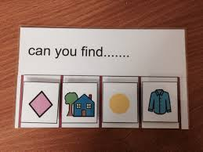

- Colour matching: Set out plain coloured base boards in as many colours as appropriate to the child and ask the child to find familiar objects in the environment that match the base colours. This can be extended when appropriate to incorporate colours and shape

