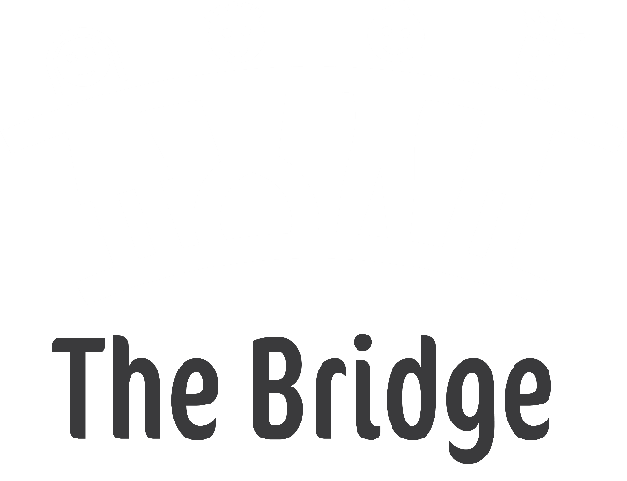
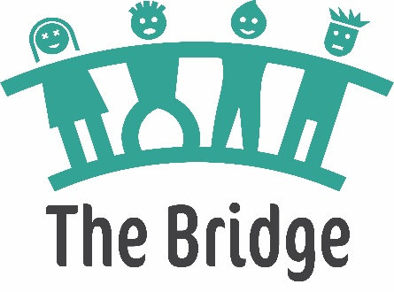

The Bridge
Service Level Agreement
This agreement sets out the provision of alternative education for primary school children in the Royal Borough of Kingston and London Borough of Richmond.

Parties
This Agreement is between Achieving for Children (AfC) of Guildhall 2, High Street, Kingston upon Thames, KT1 1EU and Primary School named (at bottom of document). Achieving for Children enters into this agreement in its capacity as the local education authority for Kingston and Richmond boroughs which are responsible for ensuring that all children have a school place.

Background
This agreement relates to the provision of alternative education provision based at New Malden Children’s Centre for primary aged children in Kingston and Richmond who are finding their mainstream difficult to access, or at risk of permanent exclusion, with the aim of supporting these children so that they can be re-integrated back into their school within a specified period of time.
Places for primary alternative education in Kingston and Richmond boroughs will be provided at The Bridge for which Achieving for Children is the admissions authority. The Bridge has a management committee who is a party to this agreement.

Purpose of the agreement
Achieving for Children and The Bridge have key roles and responsibilities in the provision of alternative education for primary aged children in the Kingston and Richmond boroughs. The purpose of this agreement is to outline the roles and responsibilities of Achieving for Children and The Bridge in relation to the current arrangements in the Kingston and Richmond Boroughs for primary alternative education.

Aims of the agreement
- To provide timely short term intervention for pupils with behavioural difficulties who are finding it difficult to access mainstream education provision
- To work in partnership with the child’s current school to sustain the child in their mainstream provision
- To provide opportunities for primary aged pupils to make behavioural, social, emotional and academic progress within an appropriate environment in preparation for reintegration to mainstream school
- To provide opportunities for primary pupils to develop skills, strategies and resilience which will support capacity to thrive in a mainstream classroom
- To support schools to manage the needs of pupils as part of their transition back into their own school
- To reduce the number of fixed period and permanently excluded children of primary school age

Service levels

AfC will:
- pay place funding of £50 per pupil, per day to The Bridge for 12 alternative education places at The Bridge or for such other number of places as agreed annually by the parties
- adhere to requirements as defined in the document “Alternative Provision – Statutory Guidance for Local Authorities January 2013”
- develop an agreed protocol for entry into The Bridge and integration back to school, to include defining, prior to entry, three clear targets and success criteria for each pupil accessing the provision.
- arrange a panel consisting of representatives from The Bridge and the local authority to discuss entry requests from initial referrals. Provide a route for schools to appeal a decision whereby a pupil has been deemed not to meet the threshold for securing a place (via the Assistant Director for Pupil Support)
- provide support with travel (within the local authority guidelines and only where necessary) for pupils to be able to access The Bridge (at Day 6 for PEx) through the agreed process. It is expected that where parents are able to transport their child to The Bridge they will
- monitor the progress of pupils whilst at The Bridge and after returning to school; termly for the first two terms, and then annually for two years
- support reintegration of dual placement pupils back into the child’s current schools
- support integration of permanently excluded pupils into new schools
- implement a protocol to ensure that schools who dual roll children at The Bridge understand and support their role and are clear of protocol and expectations

The Bridge will:
- provide appropriate levels of staffing for The Bridge including a teacher in-charge
- work in close collaboration with the assigned staff member from school for each pupil, ensure they are invited to any meetings to discuss a pupil’s progress, including the induction meeting at the start of the placement
- assess pupils’ social and emotional needs within three weeks of entry and assess at least half termly for evidence of impact of interventions
- ensure a Boxall profile has been completed for each
- develop a thematic curriculum based on the National Curriculum, with a focus on both social and emotional development (using the six Nurture principles) and academic achievement; differentiated to meet the individual needs of each pupil
- provide a formal report, incorporating the views of the pupil, their family and other professionals involved, for the pupil’s mainstream school and parents or carer after week six of the placement and at the end of the placement
- prepare pupils for timely return to mainstream school, or an alternative placement; having a clear exit plan on entry to The Bridge and ensuring that assessment evidence positively supports transfer to the next setting
- provide AfC with termly information on reading, writing and mathematics progress of each pupil and the social and emotional development of each pupil
- proactively provide opportunities for parents and carers to work in partnership with The Bridge, so that they are involved and engaged in their children’s development of social and emotional skills and core curriculum learning
- work with the main school to support submission of requests for education, health and care needs assessments where it is agreed by all professionals involved that this is in the best interests of the pupil. This should not directly influence the length of stay within The Bridge and submit additional information where requested by a school to support a request for an education, health and care needs assessment
- participate in project development and networking across schools and local authority services; working in collaboration with other agencies, where appropriate, to ensure the best outcomes for the pupil

Primary school will:
- pay place funding of £50 per pupil, per day to The Bridge for up to three days a week.
In exceptional circumstances should a pupil need to attend for more than three days,
this will be charged at £100 per day per pupil
- attend all meetings that form part of the process (initial and final review)
- work closely with parents and associated professionals throughout the pupil’s placement at The Bridge and also during the reintegration back into full time attendance at the mainstream school
- provide relevant impact data to The Bridge during the dual placement period and following full time reintegration into the mainstream setting
- provide The Bridge with regular updates on pupil performance and wellbeing whilst dual registered and following full time reintegration into the mainstream setting
- embed the agreed strategies into teaching and intervention given to the pupil during their dual registration and following full time reintegration into the mainstream setting

Terms and review of agreement
This agreement will remain valid until superseded by a revised agreement entered into by the parties or their successors or until determined by the parties. The parties will review the Agreement annually or at such other frequency as agreed by the parties.

Signed on behalf of The Bridge (Achieving for Children)
Authorised signature:
Name:
Position:
Date:

Signed on behalf of the school
School name:
Headteacher’s name
Authorised signature:
Name:
Position:
Date:

