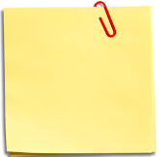
Week 7:
Learning from failure and mistakes

In the PowerPoint you learned about the value of receiving feedback. Feedback from others helps us to know how to improve.

Have a think about what you would like some feedback on and make a note in these thought bubbles:

Learning from mistakes

Making mistakes is part of our journey to learning. Mistakes and experiences of failure happen, they are nothing to be ashamed of, and they help us to better understand what we need to work on to keep improving our skills. This worksheet helps us to practice turning a mistake into a learning experience
Rather than feeling down about it - Consider what you have learned

 | Describe the mistake or failure: | What is one thing you learned from this experience?
1
2
3
4

