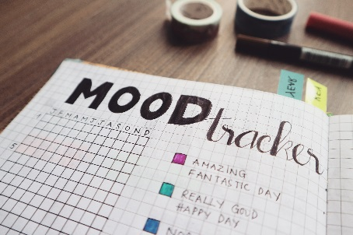
Thoughts & Feeling’s Journal

Day | Morning, Afternoon or Evening? | Situation | What were you thinking? | What were you feeling? | What were you doing? | Anger/Anxiety/Upset Rating  (out of 10)

