Children and Young People with Autism
Change, Transition and Going Back to School

The Complex Communication and Autism Team’s
3 Pillars Transition and Change Resource
is available to support your planning and preparation. It brings together:
Planning Issues
All About Me
Transition Books

- Planning, key issues to consider and
prepare for, and why they are important
- Key information about a child or young
person and how to support them effectively
brought together in an All About Me
document
- Transition Books and Social Stories
for the child or young person to help them
get ready

We have many changes to deal with in our daily lives as well as transitions between places and activities where we meet different people.

Some of our children and young people with autism find change and transition difficult.
Change and transition includes:
- Changes between places such as from primary to secondary school
- Changes within places such as changing class at the end of each year
- Daily routine changes and transitions such as moving from one activity to another, working with a different adult, going on a trip These within and between activity transitions may not always be acknowledged as a major difficulty by other people, but the way such changes and transitions are managed can make a big difference to well-being, ability to learn skills, make progress and build relationships.

Coping with change depends on understanding why something is happening and being aware of the social rules and expectations, as well as managing feelings of anxiety when things change unexpectedly or are not as expected. Communication skills and social understanding are also important for understanding and managing change. Some children and young people with autism may experience stress and anxiety when even
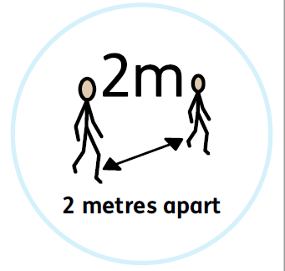
minor changes in routine occur and may display rigid thinking and behaviour in order to regain control of the situation and
create some predictability.

This is particularly relevant now; everyone has had to cope with
sudden and significant changes to the usual routines and
pattern of daily life.

As children and young people begin to return to school, the environment, people and routines are different. Others are preparing to change schools without the usual transition visits which pepper the Summer Term.

For children and young people with autism, prepreparation and planning are vital for successful transitions and managing change.
Key principles for this planning are:
- Understanding how autism affects each child and young person individually
- Planning for and providing predictability and consistency
- Using language that is clear and concise, in small steps as an action sequence
- Help the child or young person understand and manage their anxiety
- Be aware of sensory issues
- Plan for a well-structured day with clear physical boundaries for activities and visual supports

Our 3 Pillars Transition and Change Resource Pack supports planning and preparation. The resource includes:

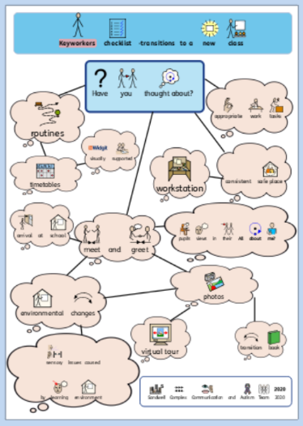

Have You Thought About?
A checklist planning map with key questions and issues to consider.
As well as the checklist, more detailed advice
about why each of the issues is important is
available in a ‘bite- sized’ format.

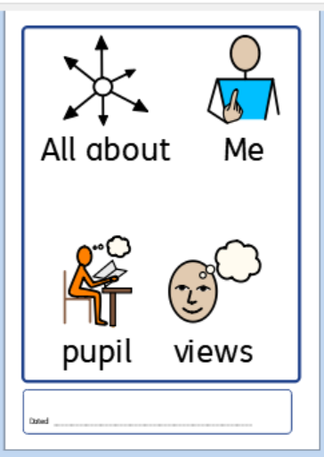

‘All About Me’
A revised ‘All About Me Pupil Views’ document which is important for communicating about how an individual child or young person’s autism affects them, their likes and dislikes and how to support them effectively.

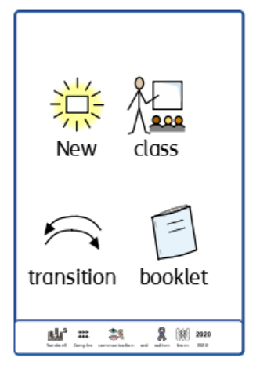
Transition Books- Social Stories
A range of transition books which can be personalised. They are available to support young people who are going to a new school or changing class. These can be used together with Social Stories about the current situation, including ‘Social Distancing’ and ‘Washing Your Hands’.

For further information, support with personalisation or copies of any of the resources, please contact any member of the Complex Communication and Autism Team:

jane_campbell@sandwell.gov.uk, emma_cox@sandwell.gov.uk, donna_oakshott@sandwell.gov.uk, louise_pearce@sandwell.gov.uk, miriam_nash@sandwell.gov.uk pip_hodgetts@sandwell.gov.uk, ruth_tipping@sandwell.gov.uk, katrina_morgan@sandwell.gov.uk

