Stages of Behaviour

The Traffic Light System

The traffic lights system is a format that has been found to be particularly useful in helping practitioners and parents/carers to understand the different stages of behaviour.

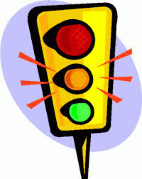
Green = calm and relaxed

Amber = anxious, aroused or distressed

Red = incident!

Blue = calming down – but still need to be careful!

Colour coding a behaviour support plan using this format can be a very useful way of clarifying the different stages of the behaviour. Using the traffic light system analogy, an individual’s behaviour moves from ‘typical behaviour’ (green), to a level that indicates that problems are about to occur (amber) prior to the occurrence of the behaviour itself (red).
After the behaviour (blue) care must be taken to ensure that the person returns to the green phase. This format enables practitioners and parent/carers to more easily identify when they could intervene to prevent behaviour escalating into an episode of challenging behaviour.

