My Difficult Situation
Behaviour Plan (example)

Child’s Name: Joe Bloggs Date: 16/4/2018
Version: 1
My difficult situation  Car journeys, especially when:  - We have to stop at a red light  - We get stuck in traffic  - We take an unfamiliar route  - I misunderstand where we are going  - I don’t know where we’re going  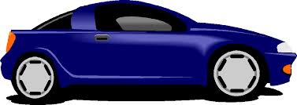 | Behaviours I might display  Early warning signs:  - Tense mouth  - Face looks tense  - I will ignore you if you try to talk to me.  - I will start to rock backwards and forwards.  If early warning signs are not noticed I may:  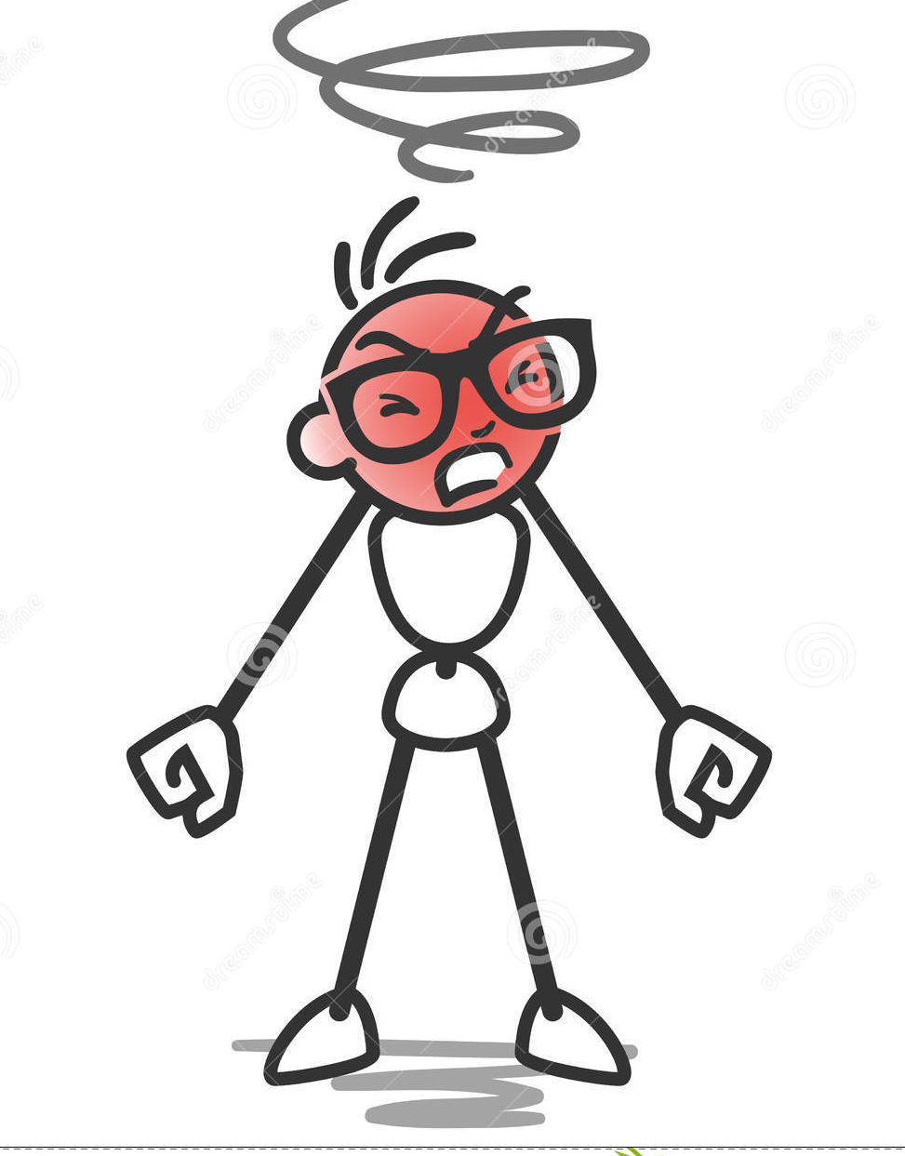  - Rock back and forward violently  - Try to get out of my seat  - Bang my head against the windows  - Try to pull the drivers hair, pull at their clothes or anything else I can reach.  - Try to kick the driver.  - Scream and shout at the top of my voice  - Throw anything that is within reach in the car
What you can do to avoid this difficult situation  - Make sure I know exactly where we are going and remind me throughout the journey.  - Give me a picture/symbol card of where we are going to so I can hold it to remind myself of where we are going throughout the journey.  - Slowly talk me through what will happen on the route. “first we will go past the cinema…”  - Take familiar routes wherever possible  - If we have to go on an unfamiliar road warn me beforehand  - Provide a running commentary of the journey e.g if we are coming up to a red light say ‘we’re going to stop behind this car’  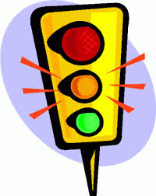  - If something happens to alter the route talk me through this too  - Play my favourite music to distract me. | What you can do if I display challenging behaviour  When I am showing early earning signs:  - Remind me where we are going  - Make sure I have hold of my picture card play my favourite music to try to distract me  - Tell me about the fun things we are going to do when we get to our destination.  If the situation has escalated:  - Talk in a calm voice  - Don’t use too many words  - If you can work out where I think we are going (that is distressing me), tell me where we are really going  - If I am trying to pull your hair/pull your clothes, say ‘sit on your hands’  - If I am banging my head on the window or getting very distressed, find a safe place to stop, help me out of the car  - Do not continue in the journey until I can sit calmly  Afterwards:  - Continue the journey, calmly talking me through what is happening.

