

My Plan at SEN Support

A Step by Step Guide for Early Years settings.

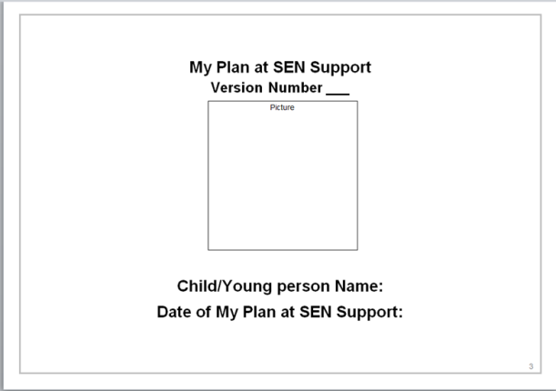

Created by

Bath and North East Somerset Council

Area Senco Team

October 2018

**Front cover:**

**Complete version number and add date.**

***Don’t forget:***  *change the version number where necessary and add a lovely picture of the child ☺*

C:\Users\rogersb\AppData\Local\Microsoft\Windows\Temporary Internet Files\Content.IE5\NVL6SZY2\qPzBM[1].pngThe whole **My Plan at SEN Support** should be reviewed every 12 weeks!

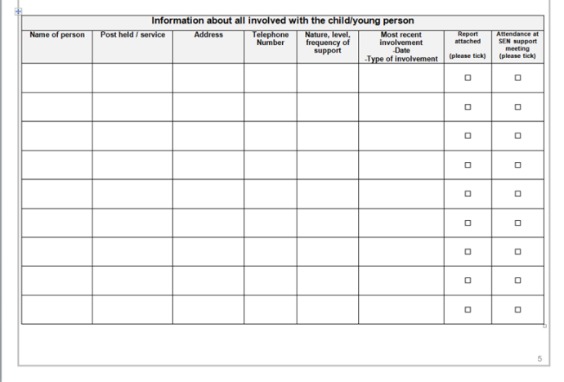

**Professionals involved**

C:\Users\rogersb\AppData\Local\Microsoft\Windows\Temporary Internet Files\Content.IE5\NVL6SZY2\bulb_on[1].pngList all people involved with the child, including the SENCo and keyperson. If you have any recent reports tick the box. It will help you keep track of the reports you have and may need to include for any future SENDIP request.

*A good time to do this would be at a Team Around the Child* C:\Users\rogersb\AppData\Local\Microsoft\Windows\Temporary Internet Files\Content.IE5\NVL6SZY2\bulb_on[1].png *(TAC) or SEN support meeting*

**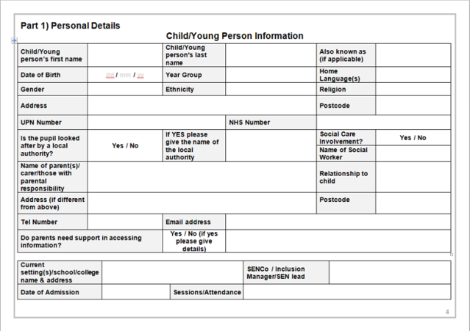Part 1: Personal Details**

Complete fully, not forgetting to include date of admission and attendance.

*As the child is not yet in school he/she will not yet have a UPN number so this box can be left blank*

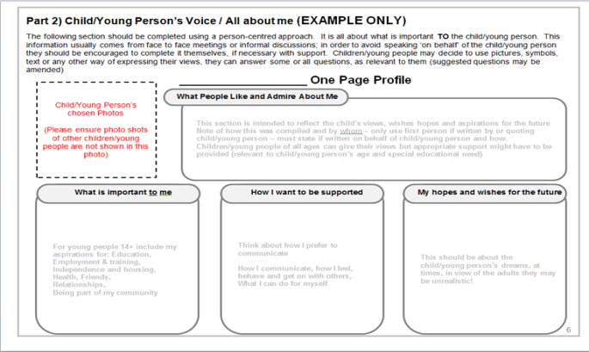**Part 2: One Page Profile**

Use the template included as a guide to how to complete the One Page Profile. This should be your starting point for support and be created with the child’s parent/carers.

*You do not need to use this particular style and there are lots of templates that can also be used to suit a child’s interests. For some ideas go to:* [*www.sheffkids.co.uk*](http://www.sheffkids.co.uk) *or* [*www.helensandersonassociates.co.uk*](http://www.helensandersonassociates.co.uk)

**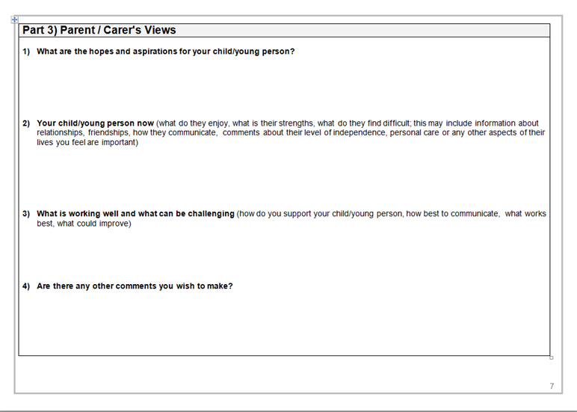Part 3: Parent/Carer views**

It is **very** important that the parents are fully involved with putting together the My Plan at SEN Support. This section is where they can have their voice.

**Some parents may need support to complete this fully and it is the SENCo/keypersons role to enable this.

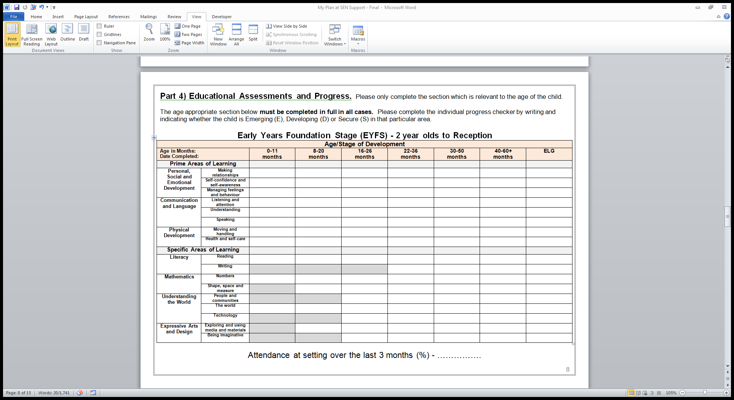**Part 4: Educational Assessments and Progress (SEND Progress tracker)**

Complete fully using the guidance information included in your pack. Ensure you are highlighting the level of support given.

*Please ensure that you are including the date completed, age in months and attendance over the last 3 months. If you can’t record this as a percentage just put how many sessions out of the total allocated they have attended.*

**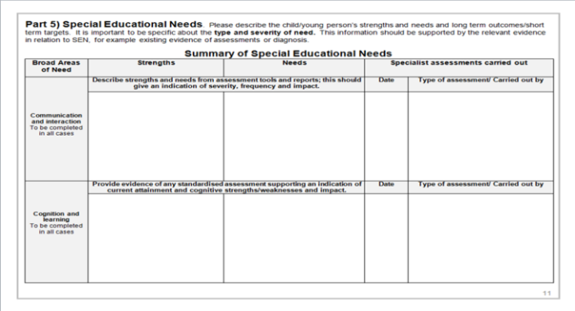**

**Part 5: Summary of Special Educational Need**

*C:\Users\rogersb\AppData\Local\Microsoft\Windows\Temporary Internet Files\Content.IE5\NVL6SZY2\bulb_on[1].png*Fill in each of the **4 Broad Areas of Need** as fully as possible, acknowledging strengths and also areas that need support.

*Use the example included in your pack to help you!*

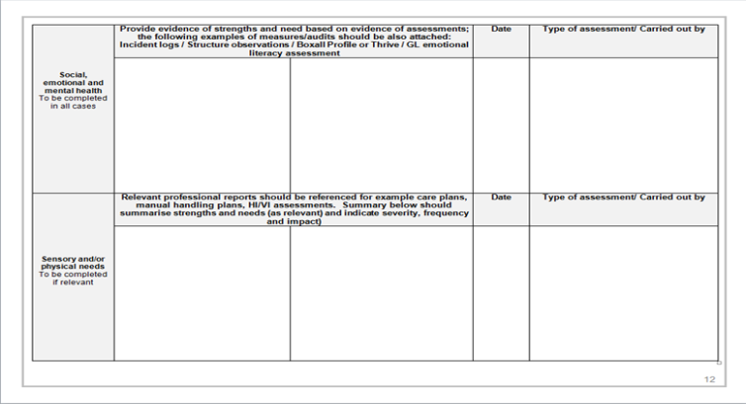It is important to highlight the **type** and **level of support** that is needed and to use any evidence, from professionals involved and/ or from setting observations and assessments, to give a clear picture of the child’s ongoing needs.

*C:\Users\rogersb\AppData\Local\Microsoft\Windows\Temporary Internet Files\Content.IE5\NVL6SZY2\bulb_on[1].pngUse the Nasen leaflet in your pack to help you understand more clearly the 4 Broad Areas of need or visit their website:* [*www.nasen.org.uk*](http://www.nasen.org.uk)

**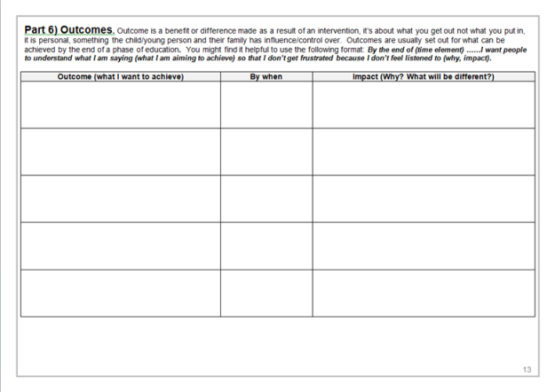Part 6: Outcomes**

Use this page to agree the long term Outcomes for the child that you are supporting.

The instructions on the top of this page make it clear what this should look like.

*Remember: Outcomes are what is hoped will happen in the future as a result of the interventions and strategies that have been put into place. They are not short term targets.*

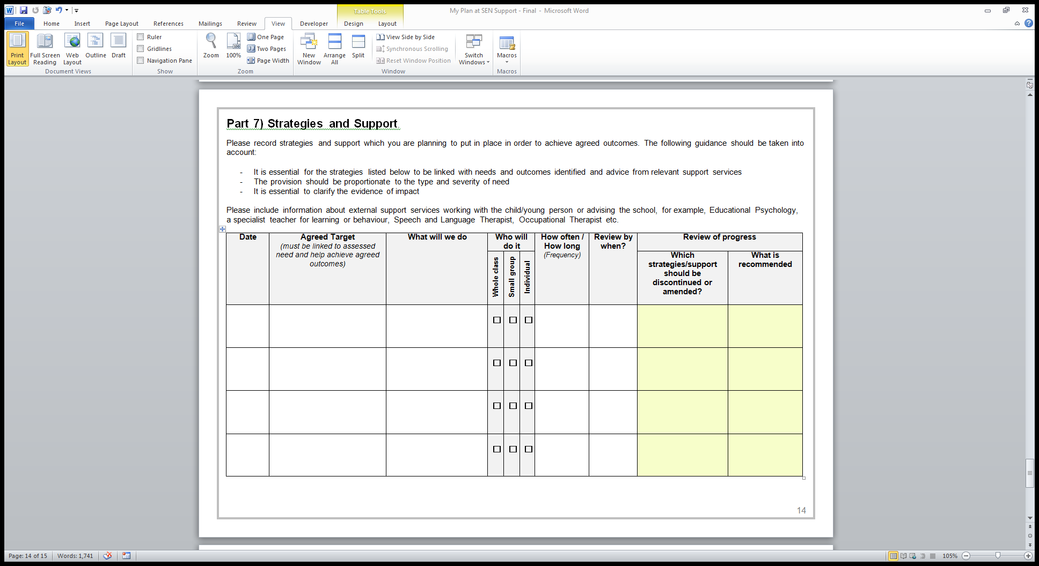**Part 7: Strategies and Support**

These are your short term targets and should be reviewed *every 6 weeks*.

Ensure that they are SMART (Specific, Measurable, Achievable, Realistic/Relevant, Timely) and that they reflect any professional advice/targets given.

*C:\Users\rogersb\AppData\Local\Microsoft\Windows\Temporary Internet Files\Content.IE5\NVL6SZY2\bulb_on[1].pngYou could use a monitoring sheet alongside this document to evidence progress made when you review.*

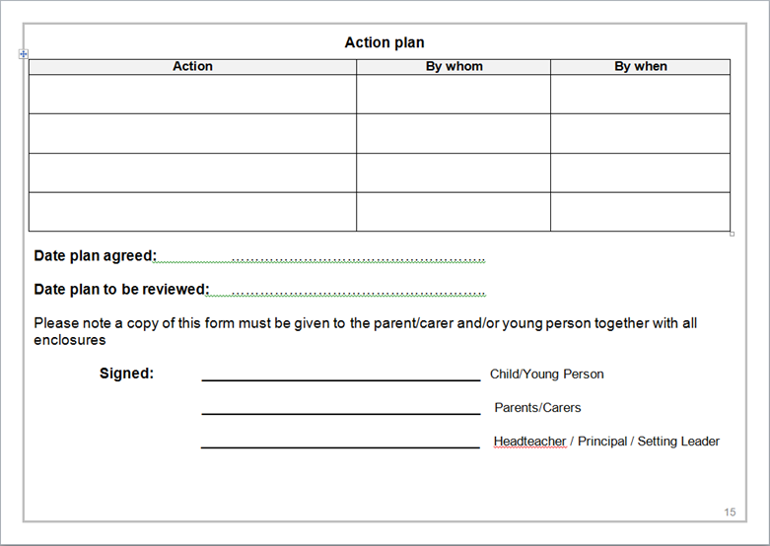

**Action Plan:**

This is where you will record any actions discussed at the My Plan review and set next steps. It needs to be signed by the parent and setting leader.

*C:\Users\rogersb\AppData\Local\Microsoft\Windows\Temporary Internet Files\Content.IE5\NVL6SZY2\bulb_on[1].pngA good time to do this would be at the Team Around the Child (TAC) or SEN Support meeting.*