The Five Stages of Pretend Play

Why is Pretend Play important?

Pretend play or symbolic play is important for several reasons:
- Developing understanding of what objects are used for.
- Developing the concept that a word can represent/symbolise an object just like a toy can be used to represent a real object.
- Developing flexible thinking and imagination.
- Learning about real-life situations and acting them out.
- Language often develops alongside pretend play.
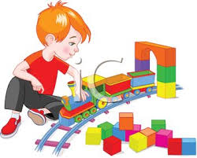

First Stage – pretend play with real objects.
This shows that a child understands what objects are and what we do with them.

- Before drink time get out the child’s empty cup and pretend to drink
from it and encourage the child to do the same, and then go ahead
with drink time.

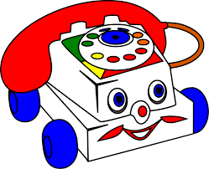
- Collect several everyday items in a box for example, a hat, hairbrush, toothbrush, key, cup, toy phone, and blanket. Produce them one at a time, pretend to use them and encourage/help the child to do the same, for example, putting the phone to their ear, pretending to sleep with the blanket. Make appropriate symbolic noises such as a phone ringing sound or “shhh” with the blanket.

- Once the child has learned how to use the objects themselves, encourage them to relate them to other people, for example, help the child to brush your hair.

Second Stage – Playing with teddies and dolls.
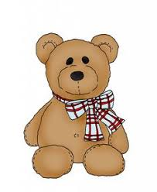
- Pretend to use the familiar objects on a large doll /teddy or toy character such as Peppa Pig. Help the child to do the same, you could feed teddy, brush doll’s hair, put teddy to bed, wash baby or make a teddy’s tea party. Use appropriate sounds and words such mmm, snoring noises

Third Stage – sequences of pretend play

- Encourage the child to copy everyday activities at home such as sweeping, washing cups, cooking, washing clothes.

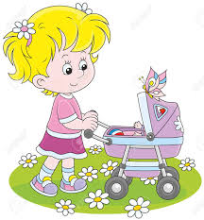
- Model and encourage pretend play with everyday objects: teddy, dolly,
bed, table, food, and blanket. Extend the play into short sequences of play, for example, brush doll’s hair then wash doll’s face or give teddy a cup of tea then make him go for a walk.

Continue to extend these sequences as the child becomes more confident.

Fourth Stage – small world play

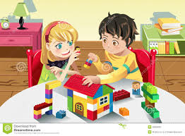
- Make the transition to small world toys such as dolls’ houses, garages or farms so that play becomes more imaginative and less dependent on the real objects

- Encourage the child to make small world figures or dolls interact with each other, for example, making a figure kick a football to another.

- At first you may need to lead the play and encourage the child to join in and copy. Later, the child might start the play; if so, respond by following
his lead.
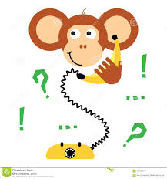

- Around this time, you can help the child start to use objects symbolically, pretending something is something else, for example pretending a banana is a phone.

Fifth Stage – encouraging complex symbolic play and role play.

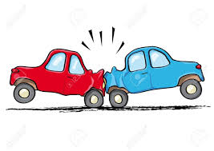
- Matchbox cars, play people, farm and zoo animals, soldiers etc – so that real life situations can be acted out and stories can be made up.

- Extend the child’s storylines by introducing new ideas, for example, your car crashes into his car, so you get an ambulance and give him the breakdown lorry.

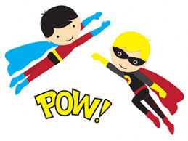
- Increase the amount of spoken interaction alongside the physical interaction between the toys, for example, the police car arrives and you act out the policeman asking him, the driver, why the crash happened.
- Increase the imaginative element, so that there is a shift away from the real to the make believe for example, dressing up games and role play such as police officer, turning empty boxes into boats, cars, houses.

- Create opportunities for children to act out feelings and emotions, describe situations, ask questions, give instructions, and act out the real world.

And most importantly of all…
