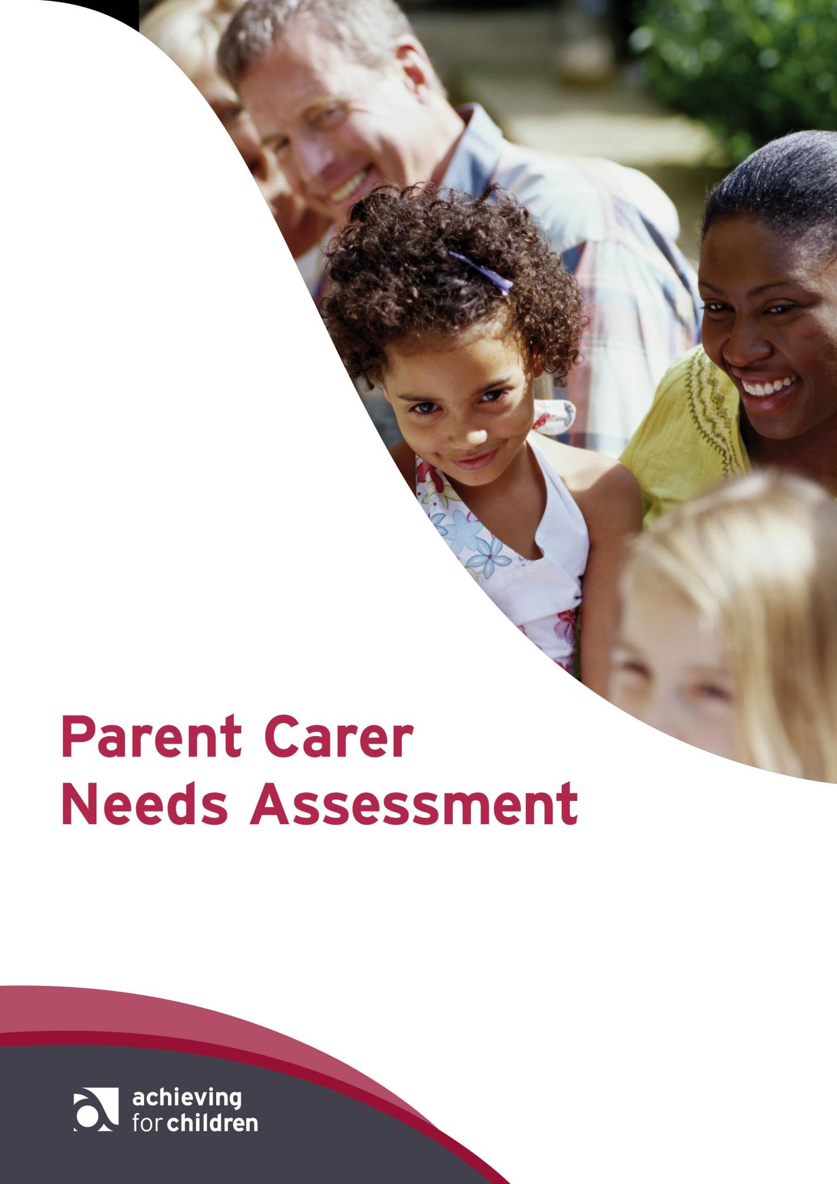

Contents | Page
Section 1: Family composition and details | 3
Section 2: Assessment information – information about the child | 4
Section 3: Assessment information – information about the parent/carer | 4
Section 4: Future Plans | 7
Section 5: Parent/Carer Support Plan | 7
Section 6: Form completed by  Section 7: Information sharing and consent | 8  8

Date of assessment:
Name of professional carrying out the assessment:
Job title of professional carrying out the assessment:

Section 1: Family composition and details
Include all those living in the family home
Name of child/ren with disabilities: | DOB: | Gender: | Ethnic origin:
Siblings’ names: | DOB: | Gender: | Ethnic origin:
Parents’/Carers’ names: | Relationship to child: | Parental responsibility? | Ethnic origin:
Family address
(including postcode):
Phone number(s):
Email address:

Details of any significant others not living in family home:
Name: | Relationship: | Address:

Further information about the family:
Information about the child’s disability:

If relevant, do any of the siblings have a caring responsibility?
Is there anything else about the family composition that is relevant for this assessment? E.g. single parent family

Details of Family Group Meeting
Date meeting took place: | Attendees: | Family plan outcome:
Please note; if a Family Group meeting has NOT taken place, this must happen PRIOR to submitting PCNA to ensure all support options have been considered. You can ask your Allocated worker to arrange this with you.

Section 2: Assessment information – information about the child
Role / team /agency | Worker name | Supporting who?
GP:

School/Nursery: (indicate not of school age or NEET where relevant)

Role/Team/Agency: | Worker name: | Supporting who?
Does the child/ren take part in any activities? If yes, what is the activity? When does it take place? | Where is it based? | Name and contact details of provider?

Section 3: Assessment information – information about the parent/carer

Work/Training

Does the primary carer work? | Yes / No | Full Time  Part Time
If not, would they like to? | Yes / No | Full Time  Part Time
Does the primary carer need support in finding work? | Yes / No
Can you give details on what would assist in this process:
Is the primary carer studying/training? | Yes / No | Full Time  Part Time
If the primary carer is not studying/training, would they like to? | Yes / No
Does the primary carer need support in seeking appropriate training? | Yes / No
Can you give details on what would assist in this process:

Health

Does the primary carer have any significant health issues? | Yes / No | Please give further details:
Does the primary carer feel that their caring role is impacting on their physical health? | Yes / No | Please give further details:
Does the primary carer feel that their caring role is impacting on their emotional wellbeing? | Yes / No | Please give further details:
Does the primary carer feel that their caring role impacts on their ability to access appropriate health services? | Yes / No | Please give further details:
Is there a support network currently in place? (nb. This includes any short breaks, respite, clubs etc) | Yes / No | Please give further details:

Which of the following educational resources would benefit the carer in their caring role?

Resources / Training Sessions / Information / Signposting | Please tick all that apply:
Makaton/British Sign Language
Sexual Health and Relationship Awareness for parents/carers
Sexual Health and Relationships for children/young people
Internet Safety for parents/carers
Internet Safety for children/young people
Resource Making (Social Stories, Reward Charts, etc.)
Communication Aids
Behavioural strategies
Incontinence issues
Eating difficulties
Sleeping concerns
Short breaks for children/young people
Parent/carer support groups
Other:

How would you like to receive information?

Tick
Telephone
Email
Look at the AfC local offer website
Parent Group
Other

What is working well? What strategies do you already use in your caring role?

Is there anything else you would like to tell us about?
Section 4: Future Plans
Would you consider the above Family plan inclusive of an emergency plan? This is a plan to ensure the person you look after would still receive the support they require if you were unexpectedly unable to do so.
Yes / No
If yes, please describe your emergency plan:

If no, would you like help to develop an emergency plan? Yes /No

Section 5: Parent/Carer Support Plan

What does the parent/carer and professional feel needs to happen? | Action/s: | Who will do this? | By when?
Example:  John to attend after school club every Wednesday. | Aiming High Application to be completed. | Mrs Smith | March 2018

Please note: if one of the actions is for the child/ren to attend short breaks, the assessor must ensure they consult with the child to ascertain what kind of activities they enjoy.

Section 6: Form completed by:

Worker Name:  Worker Email:  Worker tel: | Date completed:
Signed:

Section 7: Information sharing and consent

I understand that information that is relevant to this assessment including my child’s/my needs will be recorded and securely stored as a paper or electronic file.

I agree that this assessment can be shared with relevant agencies in order to help provide and co-ordinate support to my family.

Parent/carer name: | Date signed (by Parent/carer):
Signed:

If there is evidence or reasonable cause to believe a child/young person is suffering, or at risk of suffering significant harm, practitioners have a legal responsibility to inform Children’s Social Care. In most cases, they will discuss this with you first.

