Culture 4 Keeps: At Home
Would you like to do an art activity supported by Culture 4 Keeps? Artist and C4K Coordinator Gwen Ramsay has fun and easy art activities to do at home. You can be posted some simple materials, use bits from home or be sent links to options to purchase the items. The activity this week is a step-by-step letter stamp. Next week is a fun Easter postcard activity with a step by step. Examples of activities are below. Choose each week which activity to do.
The activities will be sent to you by email and specify if you want materials by post. Follow up support can be provided by email. If your child would like to do a virtual session please say when you reply.
To sign up or for any questions please contact Gwen at Gwen.ramsay@achievingforchildren.org.uk

Learn how to draw a pet.
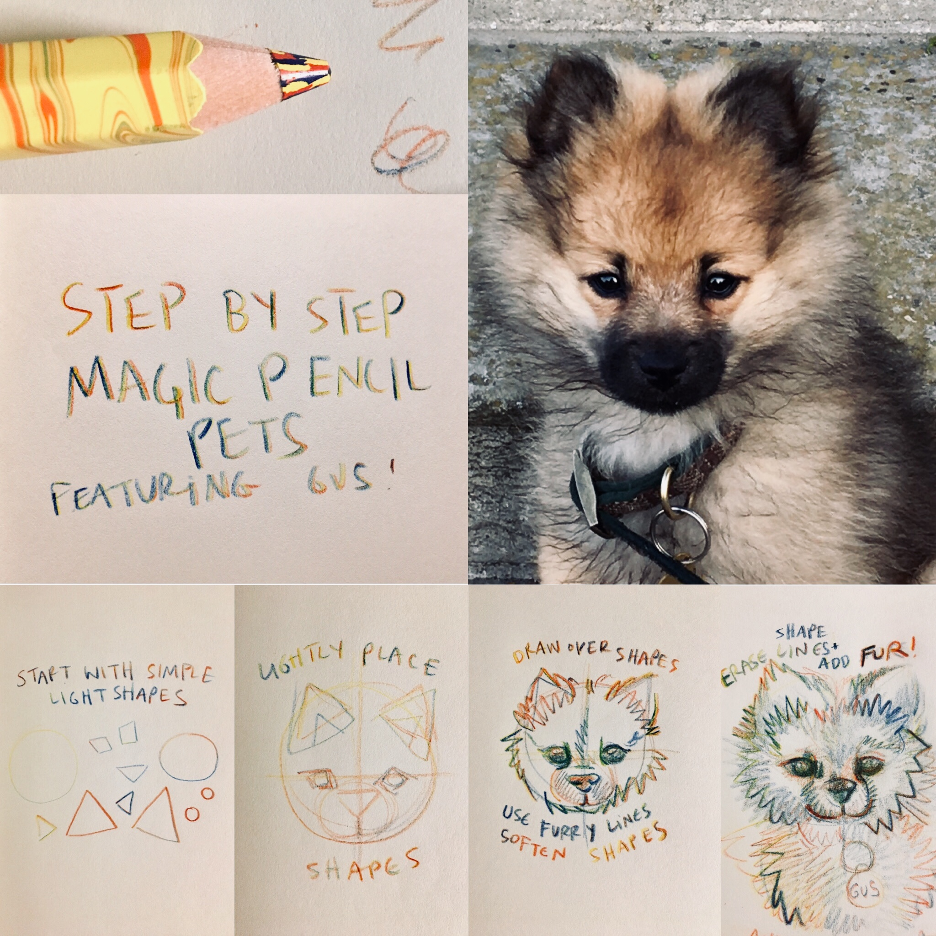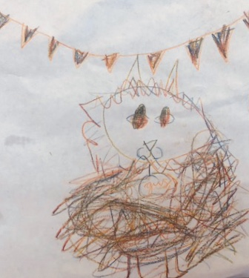

Make a rubber stamp. Make a monochrome postcard to send to a friend.
