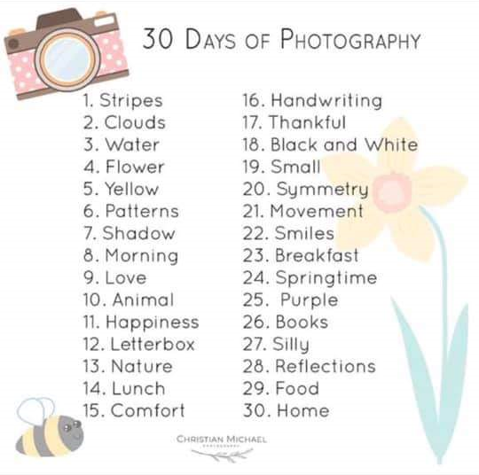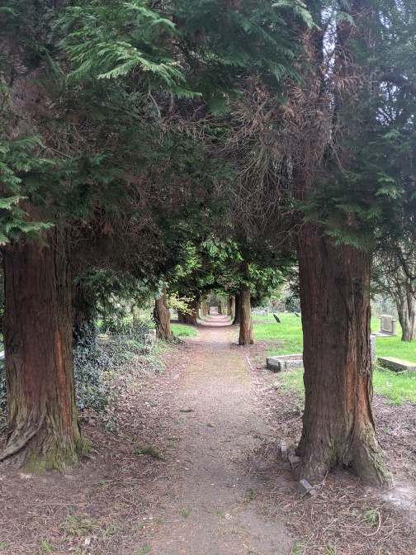

On the 2nd April, the National Theatre started to stream free full-length plays! They are releasing a play each Thursday, which will be available to watch on YouTube for 7 days.

Their first play is an online premiere of One Man Two Guvnors, staring James Corden.

New plays every Thursday at 7pm, on YouTube.

Why not try taking a   
picture of something   
new each day?

Here are some ideas  
to get you started…

Have fun!

Week two is complete! As we go into our third week of isolation, remember everyone is in the same boat here. No one expects you to have it all together, to be able to work in the same way you usually do, or to provide your child with the perfect school timetable. Don’t put pressure on yourselves to replicate the working day or a school day.

As we said last week, make time for yourself. Speak to people outside your house maybe a colleague or family member, get some fresh air and have regular breaks.

Seen on Social Media

Keep in contact with your child’s school if you need advice on any of the work they have set. They understand that these are challenging times and are there to help you!

Top Tip for Parents

YOUR

**NICE**-OLATION

NEWS

A WEEKLY NEWSLETTER PROVIDED BY THE SANDWELL EDUCATION AL PSYCHOLOGY TEAM

Free to Access

A man in a car saw a Golden Door, Silver Door and a Bronze Door. What door did he open first?

Last week’s answer: Fire

This week the Educational Psychology team have been working hard to coordinate their response to COVID-19. This will be a tough time for so many of us. The team has been collating and creating resources to support school staff, parents, children and young people. A **resource booklet**has been sent out to Head Teachers, full of useful links and services that can be contacted to access support in times of need.

Make a mood board to help plan a future event or decorate a room.

Bright Ideas

Team Update

Staph making the most of her one trip out of the house to exercise!

Easy Recipe

Brain Teaser

Picture of the Week

Thought for the Week

A Consultant Clinical Psychologist has produced advice for getting through lockdown together with teenagers. She acknowledges that it can be hard to ‘get it right’ where teenagers are concerned; and their first response to an idea is often to reject it.

She suggests using the acronym O.A.K:

O – offer opportunities often

A – anticipate rejection

K – keep the door open

Read the full article:

<https://weneedtotalkaboutchildrensmentalhealth.wordpress.com/2020/03/29/2and-getting-through-lockdown-together-with-teenagers/>

Make your own: Flapjacks

Ingredients:

* Porridge Oats
* Butter
* Brown Sugar
* Golden Syrup

<https://www.bbcgoodfood.com/recipes/yummy-golden-syrup-flapjacks>

“Easy to make and ready in half an hour!”

Perfect for those with a sweet tooth!