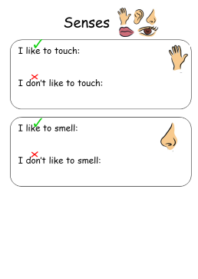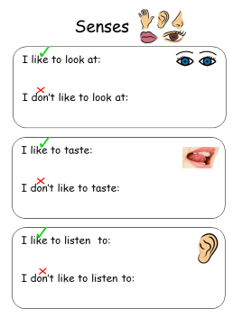This belongs to: _______________________________________________

This belongs to: _______________________________________________

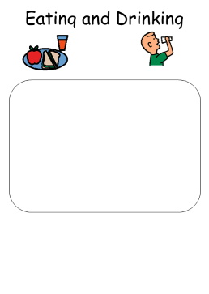I Like:



I don’t like: