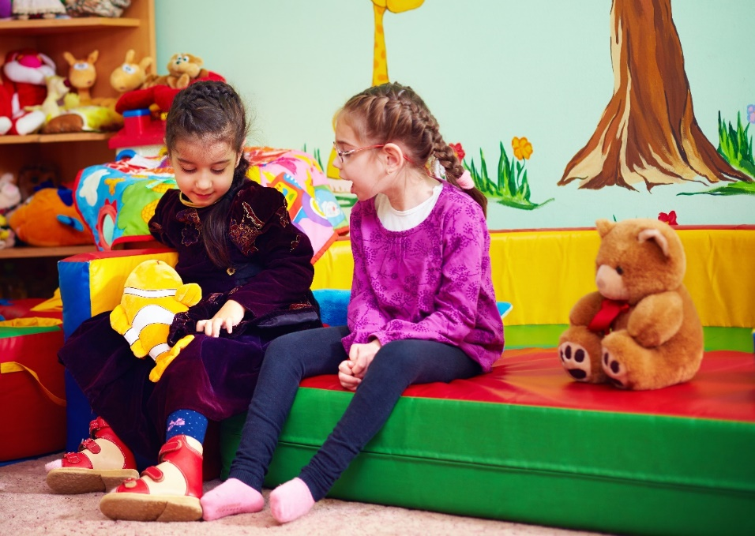

Richmond SEND Futures Plan

Consultation
2019-22

Easy Read
‘SEND Futures’ is our plan for improving services for children and young people with SEND in Richmond. We would like to know what you think. Please share your views about the Plan, by filling in this survey.

The consultation closes at midnight on 14 July 2019.

If you would like some help completing it, please contact julia.hunt@achievingforchildren.org.uk

There will be drop-in events where you can speak to people from the Council, Achieving for Children or the Clinical Commissioning Group about the Plan:
- 1 July, 10am to 11am
Castelnau Community Centre
7 Stillingfleet Road
Barnes, SW13 9AQ
- 3 July, 7pm to 8.30pm
Ham Youth Centre
Ham Close (off Ashburnham Road)
Ham, TW10 7PL
- 4 July, 1:30pm to 3pm
Twickenham Training Centre
53 Grimwood Road
TW1 1BY
If you would like to attend one of these events, please register here.

We will also use the SEND Futures Conference on 27 June to speak to attendees about the Plan.

Here is some information which you may find useful:

- There are around 4,500 children and young people with special educational needs and disabilities who live in or are educated in Richmond.

- 1,408 of these children and young people (34%) have Education, Health and Care Plans (EHCPs), which set out the support that they need.

- On average, children and young people with EHCPs in Richmond achieve better school results than their peers at a national level, and have higher attendance rates.

- Across the country, the number of children and young people needing an EHCP has been rising for several years. In Richmond, the number of EHCPs has risen by 20% since 2016.

- The money we receive from the Government isn’t enough to provide the support that children and young people with SEND need. The difference between the money we spend on SEND and the money we get from Government over recent years has reached £15million.

- 10% of children and young people with an EHCP go to independent schools. They are often outside the borough. Independent school placements use 28% of money spent on SEND. Children often have to travel a long way to get to these placements. This adds more cost.

- All Councils which are spending a lot more money on SEND support than they receive from Government have to write a ‘Deficit Recovery Plan’. You can read Richmond’s Deficit Recovery Plan here.

If you would like more information about the SEND Futures Plan, click on these links:

- An easy read version of the SEND Futures Plan.
This can be found here. The easy read plan contains a glossary of useful words or phrases.

- The full version of the SEND Futures Plan.
This can be found here.

Information about you:
- We won’t ask for your name or any other information which might identify you.
- Your answers will be collected and stored securely, in line with data protection law.
- We hold this information for the specific purpose of this consultation.
- We will not share it with other agencies or organisations without seeking your explicit consent.
For more detail, please read our full privacy policy here: www.achievingforchildren.org.uk/privacy-notice/

WORKSTREAM 1:
CO-PRODUCTION, ENGAGEMENT AND PARTICIPATION (with parents, carers, children and young people)

Activities
  - Support the new local Parent Carer Forum, once it has been set up.
  - Work with children and young people to find out how they want to be involved in decision-making about their own support.
  - Work with families to find out how well participation is working.
  - Promote co-production and ensure people know what it means.
  - Promote the Local Offer website (www.afcinfo.org.uk) to families and professionals.
Do you think these activities will help with co-production, engagement and participation?

☐Yes
☐Not sure
☐No

Do you have any comments about these activities?

WORKSTREAM 2: JOINT COMMISSIONING (working together to purchase services from other providers)

Activities
  - Understand and include the needs of children and young people in all of our plans.
  - Work with children, young people and families to find out about the quality of services.
  - Review how much we spend on support for children with complex needs, and out-of-area placements.
  - Develop ways to commission services in partnership.
  - Review our contracts with independent schools, to reduce costs.

Do you think these activities will help commissioners to work together to buy good services that children and young people need?

☐Yes
☐Not sure
☐No

Do you have any comments about these activities?

WORKSTREAM 3:
LOCAL PROVISION (improving the choice and quality of local schools and colleges)

Activities
  - Work with local people to find how inclusive our community is.
  - Support the voluntary sector, so that it can provide more opportunities for children and young people with SEND.
  - Improve the support available for families after children have been diagnosed with SEND.
  - Write a 10-year plan for SEND places in specialist and mainstream schools. Over 250 new places have been set up already or are due to open soon, but we would like to create more places.
  - Develop education opportunities for young people aged 16-25.
  - Review alternative education and the cost of school exclusion.
  - Review SEND transport arrangements and funding.

Do you think these activities will help us to have good, local services?

☐Yes
☐Not sure
☐No

Do you have any comments about these activities?

WORKSTREAM 4:
EARLY INTERVENTION AND TRANSITION (providing timely support and advice, including the move from children’s to adult services)

Activities
- Support schools and teachers to learn from each other.
- Review needs of 0-5 year olds. Develop new services to help.
- Encourage schools to support pupils’ wellbeing, including through a digital youth project.
- Review the support that families need, so children can be at home rather than in residential school.
- Improve transition from children’s to adult’s services, through a new ‘Transitions Protocol’.
- Improve access to apprenticeships and training.

Do you think these activities will mean we help people sooner, and that transitions be more successful?

☐Yes
☐Not sure
☐No

Do you have any comments about these activities?

WORKSTREAM 5:
ASSESSMENT AND PLANNING (of the Educational, Health & Care Plan processes)

Activities
- Make sure that EHCPs are good quality
and on time.
- Deliver new training to social care, health and education staff about EHCPs.
- Support organisations to take part in annual EHCP reviews.
- Make sure Annual Reviews are of good quality.
- Improve the SEND case management system.

Do you think that these activities will help with assessment and planning?
☐Yes
☐Not sure
☐No

Do you have any comments about these activities?

Do you have any final comments about the Plan?

ABOUT YOU

Do you live in the borough of Richmond or have a child who attends school, college or other educational settings in Richmond?

☐Yes
☐No

Are you completing the consultation as a:
(Click as many as apply)
☐Parent/carer of a child or young person with SEND
☐Parent/carer of a child or young person without SEND
☐Young person with SEND
☐Young person without SEND
☐Representative of a voluntary and community organisation
☐Representative of a school
☐Other (please specify):

If you are a parent carer of a child or young person with SEND, what is the age of your child or children with SEND?
☐0-4
☐5-10
☐11-16
☐17-25

Thank you!

Thank you for filling in our survey.

Please return the completed survey to Julia Hunt at Achieving for Children. You can either do this by email (to Julia.hunt@achievingforchildren.org.uk) or by post to:

Julia Hunt
Achieving for Children
King Charles Centre
Hollyfield Road
Surbiton
KT5 9AL

The results will help Richmond councillors to agree the final version of the Richmond SEND Futures Plan at their Education & Children’s Services meeting on 25 July.

Design by Clare Tarling
Easy Read Design and Training
www.claretarling.co.uk

