Application for Aiming High Commissioned Swimming Lessons

Achieving for Children (AFC) is excited to offer some new block swimming lessons opportunities. These block lessons are available during October half term for 5 days from Monday 22nd October to Friday 26th October. Each session will last for 30 minutes and be on Monday to Friday every day at the same time. There is no cost to attend these sessions.

To be eligible to access these groups the child/young person has to:
- Be aged 0-17
- Live within The Royal Borough of Kingston upon Thames or The London Borough of Richmond upon Thames
- Has a diagnosed disability and/or have an Education Health Care Plan (EHCP) or Statement of Educational Need

Applications received will be reviewed holistically and take into account support you are currently receiving.

In instances where demand outstrips supply, preference will be given to children/young people who are eligible for Free School Meals.

To apply for the swimming lessons please complete the application form and email back to:
David Arrow – david.arrow@achievingforchildren.org.uk

The deadline for all applications is Friday 5th October. Please ensure we receive your application before this date. We will be reviewing all applications on Monday 8th October and let all parents/carers know the outcome of panel by Friday 12th October.

Child/ Young person’s Information
Child’s Name: | Date of Birth:
Gender: | Parent/Carer Name:
Address: | Parent/Carer Email Address:  Tel Number:
Emergency telephone number:  Name & relationship to child: | Additional telephone number:  Name & relationship to child:
Disability:
Do you have an Educational Health Care Plan (EHCP) or Statement Education of Need? Please Highlight | Yes | No

Swimming ability and venue
Which venue would you prefer to attend? Please circle | Pools on the Park, Richmond | Teddington Pool and Fitness Centre
What are your preferred times? Please list 1 to 4. 1 being the most and 4 the least | 10.30 to 11.00am  11.00 to 11.30am  11.30 to 12.00pm  12.30 to 1.00pm | 1.00 to 1.30pm  1.30 to 2.00pm  2.00 to 2.30pm  2.30 to 3.00pm
Has your child had swimming lessons before? | Yes | No
Is your child happy to go under the water? | Yes | No
Can your child swim without buoyancy aids? | Yes | No
Is your child confident in deep water? | Yes | No
Would your child require any special assistance? Eg hoist

Would your child prefer a group session (2-1) or 1-1? Please circle | 2-1 | 1-1
Does your child currently receive swimming lessons paid for by Achieving for Children? Please circle | Yes | No

Child and family information sharing consent
This is for parents or carers to give their consent to share information relevant to organising the appropriate care and support of their child during short breaks activities in 2018/2019. This is in compliance with the EU General Data Protection Regulation (GDPR)
By signing this form, you confirm that you are happy for Achieving for Children to share relevant information with your short break provider. We will only share confidential information with other professionals with your consent unless there is a safeguarding concern that requires us to share information according to the child’s best interest. We value the welfare of children and young people as paramount.
I give consent to information provided about my child being shared between Achieving for Children and my short break provider, in order to organise the appropriate short break support required for my child.
I give consent for my email address and name to go onto a mailing list to receive information about short breaks available in the local area. (Please tick)

Signed |  | Date
Print name
Relationship to child
The support I need…..

My Name is…
I like to be called…
Emergency contact number:

Insert Photo
- To be completed by the child or young person with adult support if necessary

My 1-page profile

Dislikes….
Likes….

Things that might upset or scare me....

How to know if im upset….
What you can do to help me….

Allergies:
My health needs:

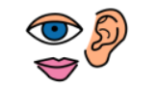
My communication profile
Communication
How I communicate to you

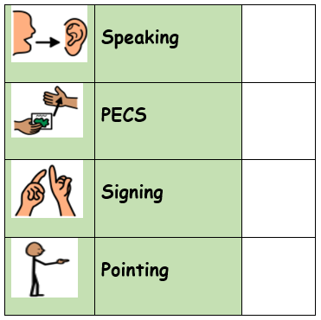
How to communicate with me

Signature …………………………………………………… Date……………………………………

