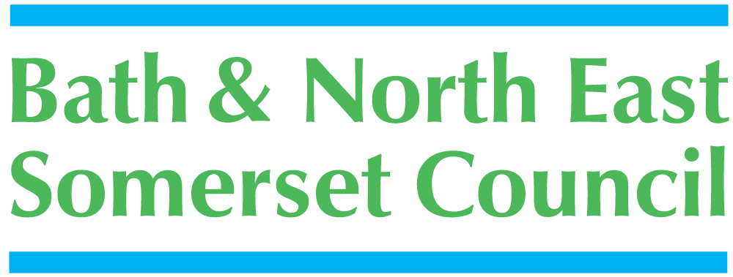



Guidance Information

Rainbow Resource Scheme

For Children and Young People 0-25 years old with Special Educational Needs and Disabilities (SEND) or an Additional Need

What is the Rainbow Resource Scheme?

The Rainbow Resource is a useful source of information for children and young people aged between 0-25 years who have a special educational need or disability or any additional need and who are resident in Bath and North East Somerset. The Rainbow Resource Scheme is held by Bath and North East Somerset Council on a database which can be accessed only by authorised staff and will comply with data protection. Inclusion on the list is voluntary.
All information about an individual will be treated as confidential and such details
will not be given to any person without agreement from the disabled young person or their parent or carer.

On submission of this form you will receive a card which may entitle you to reduced or free admission to some leisure venues and attractions.

What will the Rainbow Resource be used for?

The main purposes of the Rainbow Resource Scheme are:

- to liaise with disabled young people and their parents and carers about the services and activities they receive
- to identify gaps in services and to shape any future provision

Bath and North East Somerset –
the place to live, work and visit
Will the information be kept up to date?

Once each year the information held about you or your child will be checked on our database. If at any other time you need to change the information please tell us and it will be amended.

How do I register or de-register my child?

If you or your child is aged 0 - 25 has a SEN or is disabled and would like to be included in The Rainbow Resource Scheme, please fill in the form attached and return it to:

The Rainbow Resource Scheme
People & Communities Communications Team
Bath and North East Somerset Council,
Lewis House,
Manvers Street,
BATH BA1 1JG

Or the form can be scanned and sent by email to p_c_comms@bathnes.gov.uk

What happens if I do not want to register?

Nothing at all. This is entirely voluntary and your rights are not affected in any way. If you register and then change your mind you can ask for your details to be removed at any time.

How can I obtain more information?

Email: p_c_comms@bathnes.gov.uk

This information can be made available in a range of languages, large print, Braille, on tape, electronic and accessible formats.
Contact P & C Communications Team by email p_c_comms@bathnes.gov.uk
If you need translation or interpretation, or someone to sign in BSL for you this can also be arranged.

Updated: May 2018

Rainbow Resource Scheme

Registration Form

Your Health Visitor, Social Worker or supporting professional will be happy to help you fill in this form.

This form can be completed by a parent/carer, young person/child.
- Name of Child/Young Person (One child/young person per application form)

- Home address
Postcode:

Email address:

- Name of parent or carer

Updated May 2018

Bath and North East Somerset –
the place to live, work and visit
- Child’s Date of Birth
Day | Month | Year

- Child's Gender:

- Your child's/young person’s needs. Please use the box below to describe briefly your child’s/young person’s needs: (e.g. communication, mobility, continence, epilepsy, etc. please note that a food allergy is not classed as a SEND)

- If a professional has given you a diagnosis of your child's condition, please state the condition and the name, address and status (e.g. Paediatrician, GP) of the professional

Diagnosed condition :

Date of diagnosis :

Name of professional :

Address :

Postcode : Tel No :

- Does your child/young person have an Education and Health Care Plan (EHCP)?
YES NO

- How did you hear about The Rainbow Resource Scheme?

- We are always looking to expand the scheme, and are open to your suggestions for new places and attractions where your Rainbow Resource Card can be used.
Let us have your ideas:

Please read and complete the declaration below

I give my consent for:

- The details that I have given on this form to be entered on to the Bath and North East Somerset Rainbow Resource database.
- This information will be shared anonymously for monitoring purposes and will not be shared with any other parties.

I understand that:

- This information will be treated as confidential If my child’s/young person’s circumstances change I am required to inform you accordingly

Please sign below to indicate that you consent to the above declaration.
*You don't need to provide a signature if completing online form.

Signature : | Date :
Please print your name :
Relationship to child :
Signature : | Date :
Please print your name :
Relationship to child :
Young person’s signature :
(if appropriate)
Please print name : | Date :

Please return to:

The Rainbow Resource Scheme
P & C Communications Team
Bath and North East Somerset Council,
Lewis House,
Manvers Street,
BATH BA1 1JG

Or you can scan and email to p_c_comms@bathnes.gov.uk
This information can be made available in a range of languages, large print, Braille, on tape, electronic and accessible formats.
Email p_c_comms@bathnes.gov.uk
If you need translation or interpretation, or someone to sign in BSL for you this can also be arranged.

