SOCIAL SKILLS REFERRAL FORM
CHILD’S NAME:

D.O.B:

DIAGNOSIS:

ADDRESS:

PARENT/CARERS NAME:

CONTACT TELEPHONE NUMBERS:

EMAIL:

SCHOOL:

There is currently a waiting list for places. It is best to add your child’s details to the list as soon as possible , even if they are not yet eight.
Please send to Tracey Barnes, Social Skills Group, The Moor Lane Centre, Chessington, Surrey, KT9 2AA or email to tracey.barnes@achievingforchildren.org.uk

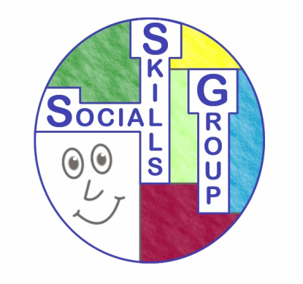 The Social Skills Group is a club for children with Autistic Spectrum Disorder and/or social and communication difficulties attending mainstream school. The children are all aged between 8 and 12.

