**KINGSTON WELCARE  
FAMILIES APART: PRISONER FAMILIES SERVICE**

*SUPPORTING KINGSTON CHILDREN, YOUNG PEOPLE AND PARENTS/CARERS WITH A PARENT OR CLOSE RELATIVE IN PRISON*

**E-bulletin December 2017**

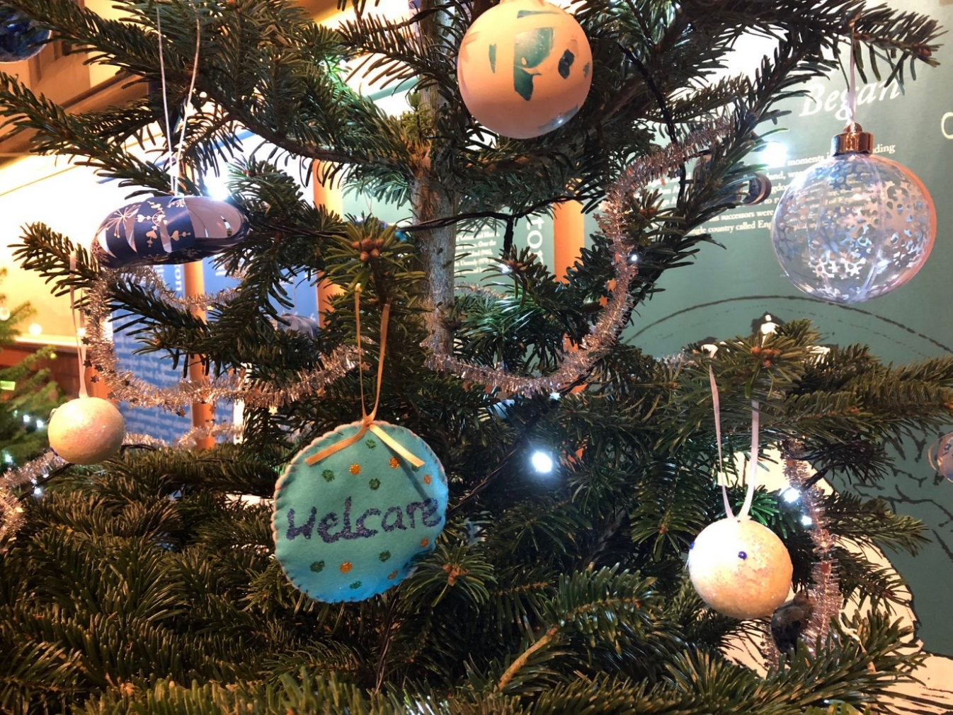

*Hello and welcome to the December e-bulletin of Kingston WelCare’s very own prisoner families project ‘Familes Apart’. We would like to wish you all a very Happy Christmas and many thanks to our funders ‘Achieving for Children’ for another great year in which we have supported and guided parents and professionals to manage the impact of parental/significant relative imprisonment on the lives of children and young people in our community.*

*Please note that our service closes on Thursday 21st December and re-opens Monday 8th January*

**TRAINING:**

**IN NEED OF A NEW YEARS RESOLOUTION?**



*‘Walking in Their Shoes’ prison visiting experience at HMP Bronzefield November 2017*

**Hidden Sentence Training**:

Make your first professional development New Year’s resolution to raise your awareness of the needs of children and young people with a parent, grandparent or sibling in prison by booking a place on our upcoming training **Wednesday 7th March 10-12pm at The King Charles Centre, Surbiton.**

**Walking in Their Shoes: Prison Visiting Experience**

Walk in the shoes of a prison visiting child at **HMP Wandsworth prison**. Meet staff and **prisoner fathers** to discuss the impact on children. Please note: Places are only offered to those who have attended our Hidden Sentence Training**. (Only 4 places left)**

Places are open to book: please email familiesapart@welcarekingston.org.uk

**RESOURCES:**

**HOW DADS IN PRISON ARE ABLE TO READ THEIR CHILDREN A BEDTIME STORY THIS CHRISTMAS**



Children whose dads are in prison will still be able to hear them read a bedtime story on Christmas Eve, thanks to a charity initiative. [Storybook Dads](https://prisonersfamilies.us2.list-manage.com/track/click?u=5f6cc73bb000c10d9430a7929&id=24719a1527&e=23c04f3821) records prisoners reading bedtime stories onto CDs and DVDs so children in 5,000 families across the UK can share a festive moment with their dad and cherish the keepsake forever. The charity runs the scheme all year round, but Christmas is by far the busiest time of year for them.

[Visit Storybook Dads to find out more.](https://prisonersfamilies.us2.list-manage.com/track/click?u=5f6cc73bb000c10d9430a7929&id=1f27f7779d&e=23c04f3821)

**VISITING DAD IN PRISON AT CHRISTMAS:**

*“We try to make the day as happy as possible, but it’s not easy.”*

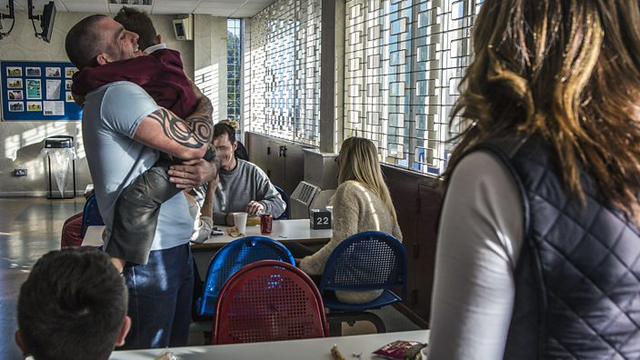

By Vikki Horn, Prison Warden at a male prison in Glasgow

We don’t allow visitors on Christmas day because we don’t have enough staff that day. I think that can actually take a bit of pressure off partners who then don’t have to fit in a prison visit on top of coping with Christmas on their own. They don’t have to worry about transport, or the kids getting tired or upset because they’re seeing their dad in prison on Christmas day. But that means Boxing Day can be really full on. It’s absolutely buzzing. Boxing Day is normally a fun day as the prisoners are excited to see family and friends. Plus we play bingo and have pool competitions and play games such as guess how many sweets are in the jar.

The families are really loud and the kids are hyper at seeing their dads and telling them about their Christmas Day. The dads are allowed to give their children presents which their partner or family have supplied, up to the value of £20. We do a wrapping service for them, which is facilitated by the family contact officer.

We try to make the day as happy as possible, but it’s not easy. Often, when the children are young, the parents won’t tell them that dad’s in prison- they’ll say he’s working there, so we try to distract the children while we’re searching mum.

It’s an emotional time so it’s not unusual to have feelings running very high, and not just with tired out toddlers having tantrums. It’s hard for people coping alone while their partners are in prison so there can be tension on both sides.

**USEFUL LINKS**

To find out more about Families Apart check out the Kingston Welcare website [www.welcarekingston.org.uk](http://www.welcarekingston.org.uk) and look out for our tweets @welcarekingston: Please note that our service closes on Thursday 21st December and re-opens Monday 8th January.

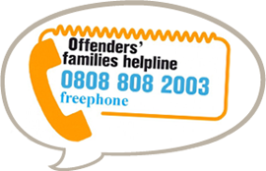

**Offenders Families Helpline-** A national helpline offering information and support to anyone with a relative or a friend in prison. Telephone 0808 808 2003 (free phone) or visit their website [www.offendersfamilieshelpline.org.uk](http://www.offendersfamilieshelpline.org.uk/) If you are a family member, and living outside the borough of Kingston contact Offender Families Helpline for information in your area.

*If you have any queries or would like to refer a family who may require support please contact Families Apart on 020 8546 3258 or email us at* [*familiesapart@welcarekingston.org.uk*](mailto:familiesapart@welcarekingston.org.uk)



Families Apart

Funded for Kingston Families by

