Education, Health and Care Plan

Your name:

Your photo

Plan number  (change the number each time your plan is updated) | Date completed
No.1 – your first plan

Date of your first SEN statement
Date your education, health and care plan was agreed
Date your education, health and care plan review is due

‘All About Me’ (Section A)

This section of the plan is all about you!

It is about your views, your ideas your hopes and wishes and the support you want and need. Your education, health and care plan cannot be written without this section.

You can fill in this form to give your views. You can write, draw or stick in photos. If you don’t want to use this form, you could make a video, write your own report or give your views in any other way you like! You do not have to fill in every box, just the ones you feel are important.

You can ask someone to help you give your views. This person should also make sure that you are involved in decisions about the rest of your plan and in your reviews:

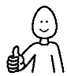 | The person I would like to support me with my plan and reviews is:

It is important to know how best to communicate with you, so that you can be fully involved. Please tell us about how you communicate here:

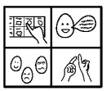 | How I communicate and express my views
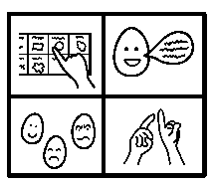 | How you should communicate with me

My likes and dislikes
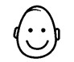  Things I like | 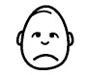  Things I dislike

Things I do well and things I like about myself

What other people like and admire about me

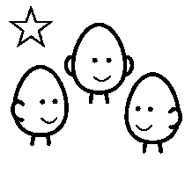
Important people in my life

Important information about me
My story so far
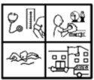
My health, education and activities
Other information people should know about me

My life at the moment
Things that are going well | 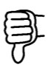  Things not going well

Supporting me
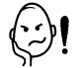  Things I find difficult | 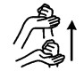  How to support me

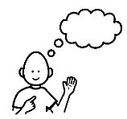
Things I want to do and learn, my hopes and dreams

Views of your parents or carers
If your parents or carers would like to add some information about you, your history, their hopes and dreams for you, their experiences or preferences, they can add them here.
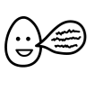
Parents’ or carers’ views

It is really important that your views are represented in your
‘All About Me’. Please tick one of these boxes to tell us how it was completed.

I completed ‘All about me’ independently

I completed ‘All About Me’ with help from

‘All About Me’ was completed for me, by

If other people have added their views too, please show this by using different colours for different people on the form or using initials.

If someone helped with you with this form, please tell us how:

Names, roles and signatures of people who have completed or contributed to this form
Name | Role | Signature

