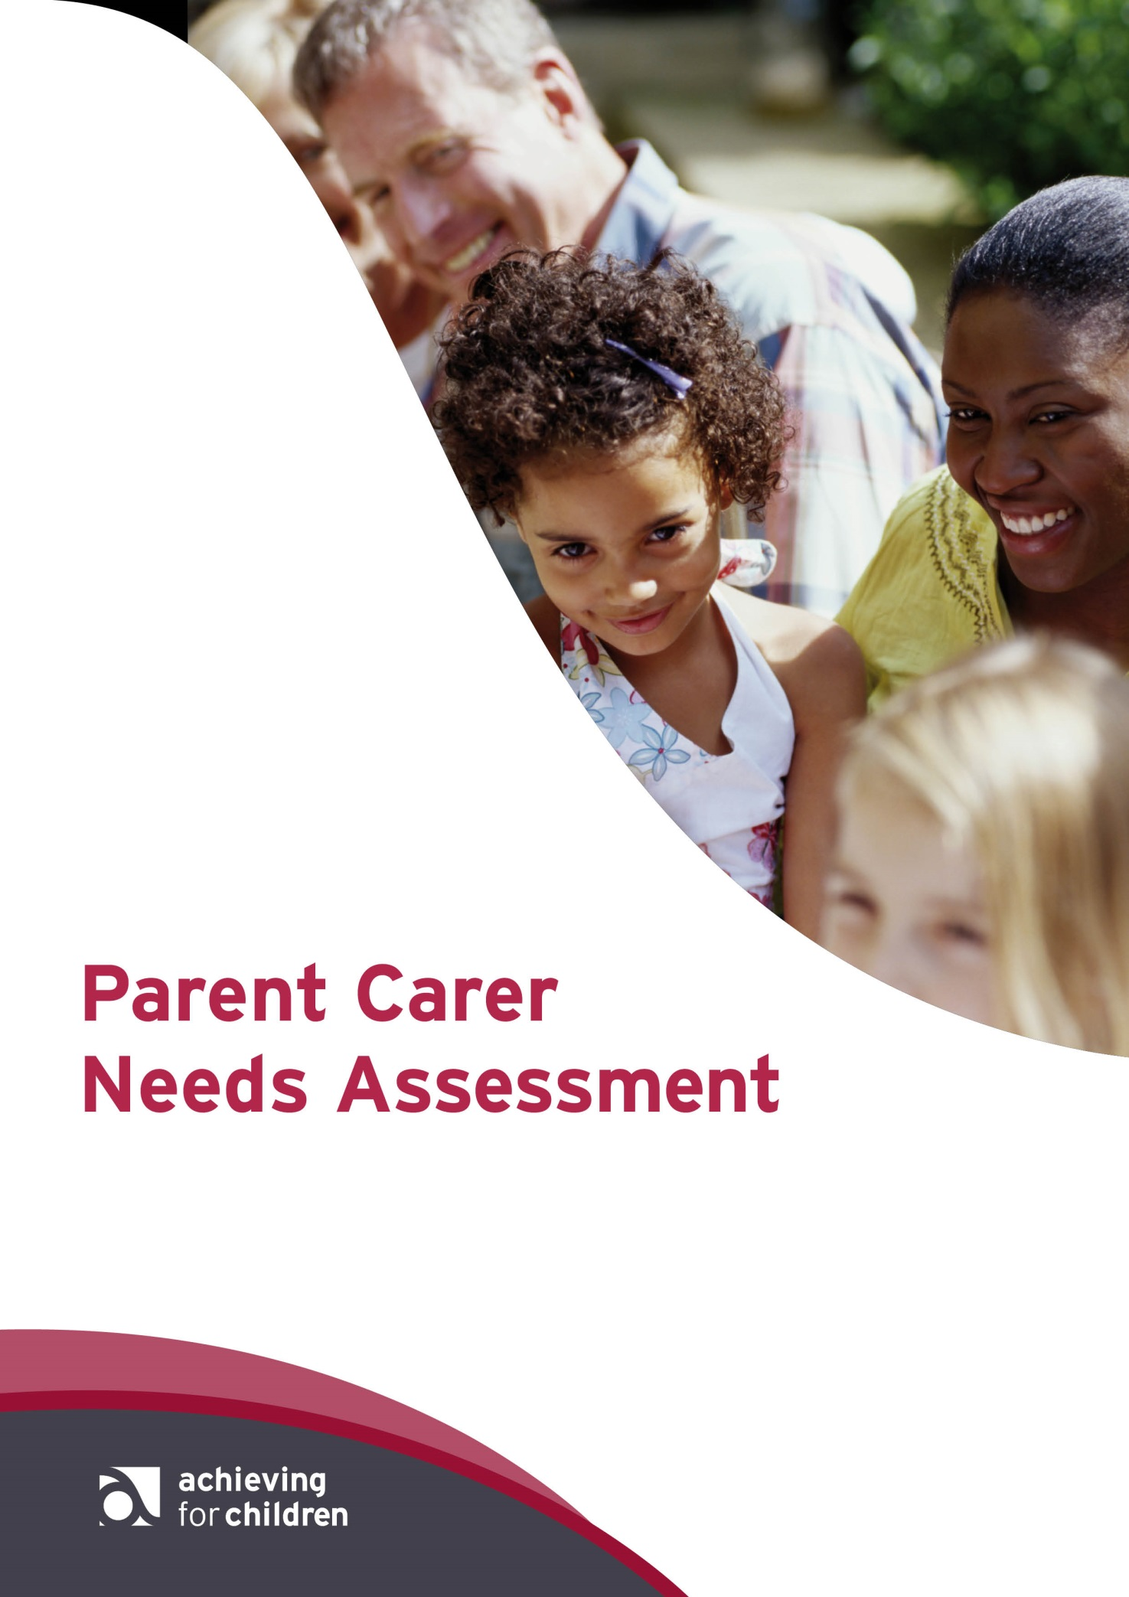

Developed by Achieving for Children in partnership with SEND Family Voices
Kingston Carers Network
Richmond Carers Centre

Please return your completed form to:

Single Point of Access
Achieving for Children
First Floor
Guildhall 2
High Street
Kingston
KT1 1EU

Tel: 020 8547 5008
Email: spa@rbk.kingston.gov.uk

www.afcinfo.org.uk

Content

What is a Parent Carer Needs Assessment (PCNA)? 1
Should I complete this assessment? 1
About this assessment 2
Section 1: Your details 3
Section 2: About the children and/or young people you look after 4
Section 3: Caring responsibilities 5
Section 4: How caring affects you 10
What can I expect as a result of this assessment? 14
What can I do if I need help to complete this assessment? 14
What happens next? 14
Protecting your personal information 15
Your feedback on this form 16
Achieving for Children’s Family Support Team 17
Achieving for Children’s Integrated Service for Children with Disabilities 17
Achieving for Children’s Local Offer 17
Parent Carer Needs Assessment – Personal Support Plan 19

What is a Parent Carer Needs Assessment (PCNA)?
Parents carers of children under 18 years have a standalone right to assessments and services under the Children’s and Families Act 2014 which amends the Children Act 1989 to require local
authorities to assess parent carers on the appearance of need or where an assessment is
requested by the parent carer. This is called a Parent Carer Needs Assessment (PCNA).

Very simply, a PCNA looks at what parent carers need to enable them to carry on caring.

It is your chance to consider your role as a carer and what help you may need to support you to maintain your own health, as well as balancing your caring role with other aspects of your life, such as work and family. Your PCNA will help clarify your needs and identify sources of support that could help you.

The law recognises that the needs of parent carers are just as important as those of a child or young person. If a parent carers needs are not met, how can they continue to care for their child or young person? Your PCNA will support Achieving for Children (AfC) to work with local partners and ensure sufficient local services available through the Local Offer reflect this.

And this is what a PCNA is all about.

Achieving for Children has the responsibility for doing the assessment. It then provides a personal support plan which describes the current support available. This will make your journey in getting support easier. The primary AfC services that will help you are:

- Family Support
- The Local Offer
- Integrated Services for Children with Disabilities
These are all described in more detail on pages 17 and 18.

Should I complete this assessment?
You should complete this assessment, if you are:
- aged 18 or over; AND
- you provide unpaid care and support to a child or young person who is ill, frail, has a physical disability, has a learning disability, has sight or hearing loss, has mental health difficulties, has other additional needs OR, you are the parent or guardian of a disabled child ( the definition of disability is set out in section 17(11) Children Act 1989); AND
- the person you care for lives within the boroughs of Kingston or Richmond (pays Council Tax to Kingston or Richmond Council). If the person lives in a different local authority area, please contact that local authority to request your Parent Carer Needs Assessment (PCNA). All parents and carers are entitled to an assessment of their own needs.

Please note:
- support is not linked to your income or savings
- you don’t have to provide care for a minimum number of days or hours
- you don’t have to live with the person you care for
- you may have other responsibilities like a job or looking after your family.

If you need some support urgently contact the Single Point of Access (SPA) straight away on:
Phone: 020 8547 5008 from 8am to 6pm, Monday to Friday

Young carers are likely to face some issues which are different from adult carers - we have a separate process for assessing young carers’ needs.

If you are a young carer (under 19 years of age) or are supporting a young carer, you can request a Common Assessment Framework (CAF) or young carer’s assessment by contacting the single Point of Access or making an online referral via Kingston’s or Richmond’s websites.

This information can be made available in alternative formats (such as Braille, audiotape or large print), or in other languages, on request. Please contact the Single Point of Access as above.

About this assessment
This assessment will help Achieving for Children (AfC) to help you, as well as help AfC to plan new services to meet parent’s or carer’s needs. You can complete this assessment if you:
- have had no previous contact with social care or
- your situation has changed and you would like us to review how we can support you

If you are in any doubt at all, please call us on the SPA numbers above.

Section 1: Your details
Title
First name
Last name
Gender
Telephone no
Email
Permanent address

What is your preferred language?
What is your religion?

What is your ethnicity?

White | British  Eastern European  Irish  Other White background | Mixed | White and Black  Caribbean  White and Asian  White and Black African  Other mixed background
Asian or Asian British | Indian British  Afghan Bangladeshi  Pakistani Tamil  Other Asian Background | Black or  Black  British | Caribbean  African  British  Other Black background
Other Ethnic Background | Chinese Korean  Middle Eastern  Gypsy, Traveller, Romany  Vietnamese | Prefer  not to say | (Unknown or not  specified)

Section 2: About the children and/or young people you look after
Title
First name
Last name
Gender
Permanent address

Title
First name
Last name
Gender
Permanent address

Title
First name
Last name
Gender
Permanent address

Title
First name
Last name
Gender
Permanent address

Are you supported by any other services? | Yes No
Is there anything else you would like us to know about the people you care for?

Section 3: Caring responsibilities
You should only consider the difference between the help and support your child needs over the support a similarly aged child without disabilities would be expected to need.

Personal hygiene
This includes any help you provide to your child or young person to maintain their personal hygiene and includes things like washing, bathing, grooming, tooth care, make-up, managing pressure sores, skin conditions, nail care, etc.
Do you support, or can you continue to support the child or young person you care for with their personal hygiene?
They do not need help with this
I can continue to provide the support they need on my own
I can continue to provide support, but need help to meet all their needs
I cannot continue to provide this support without help
I cannot continue to provide this support
I do not provide this support

If you provide this support how often do you currently provide it?
Constantly
Daily
Twice a day or more
Once a day
Once a week
Less often

Being appropriately clothed
This includes any help you provide to help your child or young person be appropriately dressed, including help with choosing suitable clothing for the weather, getting dressed, putting glasses on, putting in hearing aids, etc.

Do you support, or can you continue to support the child or young person you care for with dressing?
They do not need help with this
I can continue to provide the support they need on my own
I can continue to provide support, but need help to meet all their needs
I cannot continue to provide this support without help
I cannot continue to provide this support
I do not provide this support

If you provide this support how often do you currently provide it?
Constantly
Daily
Twice a day or more
Once a day
Once a week
Less often

Toilet needs
This includes any help you provide to support the child or young person to get to the bathroom or toilet, get on and off the toilet or using incontinence aids.
Do you support, or can you continue to support the child or young person you care for with their toilet need?
They do not need help with this
I can continue to provide the support they need on my own
I can continue to provide support, but need help to meet all their needs
I cannot continue to provide this support without help
I cannot continue to provide this support
I do not provide this support
If you provide this support how often do you currently provide it?
Constantly
Daily
Twice a day or more
Once a day
Once a week
Less often

Managing and maintaining nutrition
This includes any help you provide to the child or young person to manage their nutritional needs such as help with preparing meals, hot drinks and snacks, making healthy food choices, help with eating (cutting up food, feeding, encouraging or prompting to eat or PEG gastro feeding) and help to manage any special dietary needs and preferences (allergies, diabetes, food allergies, cultural, religious needs and other preferences).
Do you support, or can you continue to support the child or young person you care for with their nutrition?
They do not need help with this
I can continue to provide the support they need on my own
I can continue to provide support, but need help to meet all their needs
I cannot continue to provide this support without help
I cannot continue to provide this support
I do not provide this support
If you provide this support how often do you currently provide it?
Constantly
Daily
Twice a day or more
Once a day
Once a week
Less often

Living in and using the home safely
This includes any help you provide to support the child or young person to live in and use the home safely - such as help with moving between rooms and floors, lifting in and out of a chair or bed, help with using stairs, accessing the garden, getting out of the house, help with taking medication, locking doors and windows, and managing risks from drugs, alcohol or smoking.
Do you support, or can you continue to support the child or young person you care for to live in and use their home safely?
They do not need help with this
I can continue to provide the support they need on my own
I can continue to provide support, but need help to meet all their needs
I cannot continue to provide this support without help
I cannot continue to provide this support
I do not provide this support
If you provide this support how often do you currently provide it?
Constantly
Daily
Twice a day or more
Once a day
Once a week
Less often

Developing and maintaining relationships
This includes any help you provide to support the child or young person to develop and maintain personal relationships - such as help to see or stay in touch with family and friends, going out or to social groups, lunch clubs, etc. Do you support them to make decisions and choices about their day to day life?

Parents and carers of children and young people with disabilities should only consider the difference between help or support your child needs over the support a similarly aged child or young person without disabilities would be expected to need.

Do you support, or can you continue to support the child or young person you care for to develop and maintain their personal relationships?
They do not need help with this
I can continue to provide the support they need on my own
I can continue to provide support, but need help to meet all their needs
I cannot continue to provide this support without help
I cannot continue to provide this support
I do not provide this support
If you provide this support how often do you currently provide it?
Constantly
Daily
Twice a day or more
Once a day
Once a week
Less often

Making use of community facilities, transport and services
This includes any help you provide the person you look after to get around (providing transport, help with public transport or taxis) and/or supporting them to use community services, leisure facilities and social and extra-curricular activities.

They do not need help with this
I can continue to provide the support they need on my own
I can continue to provide support, but need help to meet all their needs
I cannot continue to provide this support without help
I cannot continue to provide this support
I do not provide this support
If you provide this support how often do you currently provide it?
Constantly
Daily
Twice a day or more
Once a day
Once a week
Less often

Accessing work, training, education or volunteering
They do not need help with this
I can continue to provide the support they need on my own
I can continue to provide support, but need help to meet all their needs
I cannot continue to provide this support without help
I cannot continue to provide this support
I do not provide this support
If you provide this support how often do you currently provide it?
Constantly
Daily
Twice a day or more
Once a day
Once a week
Less often
Is there anything else you would like to tell us about?
Do you have a back-up plan for emergencies? This is a plan to ensure the person you look after would still get help they depend on if you were suddenly not able to provide support.
Yes No
If yes, please describe your plan:
Would you like help to make or review a back-up plan? Yes No

Section 4: How caring affects you
Do you feel caring has had an effect on your physical or mental health? (This can include feeling tired, low mood or stressed)? Yes No
If yes, please give details:

Does caring prevent you from achieving everything you want to?
Although caring can be very rewarding, it can limit your ability to do other things. Please tell us if:
- caring means you are unable to manage any of the following without help
- caring means you can only achieve these things with some pain, distress or anxiety
- you can manage, but only at the cost of putting someone's health or safety at risk
(yours, the child or young person you care for, other people you look after).

Caring limits my ability to care for children who are dependent on me
This doesn’t apply to me
I can manage without help
I need some support with this because of my caring role

Caring limits my ability to care for other adults who are dependent on me
This doesn’t apply to me
I can manage without help
I need some support with this because of my caring role

Caring limits my ability to keep my own home clean and comfortable
This doesn’t apply to me
I can manage without help
I need some support with this because of my caring role

Caring limits my ability to eat healthily to stay well
This doesn’t apply to me
I can manage without help
I need some support with this because of my caring role

Caring limits my ability to stay in touch with family and friends
This doesn’t apply to me
I can manage without help
I need some support with this because of my caring role

Caring limits my ability to take part in work, training, education or volunteering
This doesn’t apply to me
I can manage without help
I need some support with this because of my caring role

Caring limits my ability to use community facilities services what are these?
This doesn’t apply to me
I can manage without help
I need some support with this because of my caring role

Caring limits my ability to take part in leisure activities
This doesn’t apply to me
I can manage without help
I need some support with this because of my caring role

If you indicated you are unable to achieve at least one of these things without assistance,
what would change that?

Impact on your wellbeing
To assess the impact your caring role has on your wellbeing, please say how often you feel the following statements are true for you.
Caring means I don’t get enough time to myself
All of the time
Most of the time
Some of the time
Never

Caring makes me very tired
All of the time
Most of the time
Some of the time
Never

Caring means I don’t always feel able to take care of myself properly
All of the time
Most of the time
Some of the time
Never

Caring means I don’t get as much sleep as I need.
All of the time
Most of the time
Some of the time
Never

Caring leaves me isolated
All of the time
Most of the time
Some of the time
Never

Caring makes me feel stressed
All of the time
Most of the time
Some of the time
Never

Caring has put me under financial strain
All of the time
Most of the time
Some of the time
Never

I worry about being able to cope with my caring responsibilities
All of the time
Most of the time
Some of the time
Never

Caring has put my relationship with my children/young person under strain
All of the time
Most of the time
Some of the time
Never

Caring has put my relationship with my partner under strain
All of the time
Most of the time
Some of the time
Never

Caring means I don’t have time for any personal relationships
All of the time
Most of the time
Some of the time
Never

I feel unsafe in my caring role
All of the time
Most of the time
Some of the time
Never
Please describe any other ways you feel caring has impacted on your wellbeing.

Do you have concerns about the long term future? If so, what would you like to plan for?

What can I expect as a result of this assessment?
This assessment is a tool by which your needs are understood and described and as result determines which needs could be met by Achieving for Children. These may include:
- advice and signposting to services within the Local Offer
- spot purchase of support services (including counselling)
- family support services from the Children’s Disabled Team (CDT)
- family assessment via the Common Assessment Framework (CAF)
- assessment or reassessment by DCT for child
- support via Family Coach Service
- parenting programmes
- children centres
- Support and co-ordination
- a one off payment to meet a specific need
- short breaks and respite care
- a one off payment to meet a specific need
- activities for parents
- care planning and future planning
- support with education, health and care plans (EHCPs)
- other commissioned services.

What can I do if I need help to complete this assessment?
If you would like help completing the PCNA, please contact us the Single Point of Access. We can then arrange to help you complete this assessment. Or, you can ask one of these organisations to help you:

Kingston Carers Network 020 3031 2757
Richmond Carers Centre 020 8867 2380

What happens next?
Once you have completed the PCNA, the entire process will take no more than 20 working days and the result is a personal support plan.
- When you return your form, we will contact you within three working days to say that we have received it.
- One of our support workers will compile a personal support plan and contact you to arrange a meeting (or telephone call) to discuss this with you. This meeting can take place anywhere that suits you.
- At the meeting, you can ask questions about any aspect of the personal support plan agree any further actions or queries that need an answer.
- The personal support plan is only complete when both you and Achieving for Children sign and date the plan. This will be done within three working days of the meeting, and any further queries will be completed within 10 working days (which includes the first three working days).

Protecting your personal information
We will treat your information as confidential and will not share it with any other organisation unless we are required by law to share it, or unless you or any other person will come to harm if we do not share it. We will only ever share the minimum information we need to share.

I understand the information that is recorded on this form and that it will be stored and used for the purpose of providing services. Please tick one of the following:

Please tick one of the following:
I agree to my information being used as in ‘Your Information’ above.
I agree to my information being used as in ‘Your Information’ above,
except for:

Please say what information you do not want shared, and/or the people or agencies you do not want it to be shared with below

Signed

Dated

Your feedback on this form
We are interested to find out about your experience of completing this form and any comments and/or suggestions you have that could help us improve the assessment process.

How easy did you find this form to complete?
It was very clear and easy to complete
It was very clear and easy to complete
It was mostly unclear and difficult to complete
It was all very difficult to complete

Please give details of any specific difficulties

Do you have any suggestions to help us improve this form?
Please deliver or post your completed form to:
Single Point of Access
Achieving for Children
First Floor
Guildhall 2
High Street
Kingston
KT1 1EU
Tel: 020 8547 5008
Email: spa@rbk.kingston.gov.uk
www.afcinfo.org.uk

Achieving for Children’s Family Support Team
The family support workers (FSWs) coordinate support for the family through the Common Assessment Framework (CAF) process and hold regular Team Around the Child or Team Around the Family (TAC/TAF) meetings every six to eight weeks.

The team works with a child and family-centred approach to empower children and their parents to make positive changes by:
- working in partnership with the family and other agencies such as schools, health, and children’s centres
- offering one-to-one parenting support and group parenting courses to tackle emotional and behavioural issues
- offering advice on raising children’s confidence and self esteem
- providing housing, benefits, and financial advice and signposting to services
- supporting around additional needs such as ADHD and autism
- supporting transitions to nursery, primary school and secondary school
- signposting to services and activities for children, young people and families.

Achieving for Children’s Integrated Service for Children with Disabilities
The Integrated Service for Children with Disabilities (ISCD) is a multi-disciplinary service, made up of teams from health and social care that supports children and young people from birth to 18 years of age within the local community. Children and young people are assessed as to their eligibility for access to the services.

The ISCD provides community paediatrics, community nursing and therapies in Kingston and social care, short breaks - both domiciliary and in the community, transition to adulthood and specialist family support across Kingston and Richmond.

Local Offer for Kingston and Richmond
The Local Offer is all the services and support available for families including children and young people aged 0 to 25 years with SEN or a disability, in your local area. The offer of support for parents and carers contained within the offer includes the following:
- short breaks and respite care
- local and national support organisations and parents groups
- details of social activities offering support and friendship to parents and carers
- relaxation and therapeutic activities aimed at parents and carers
- organisations that offer counselling
- parenting courses and other training and learning opportunities
- information about financial and practical help available
- support for siblings
Some of these services may be free of charge and open to anyone to access, others may have eligibility criteria and have a cost.
The Local Offer for Kingston and Richmond can be viewed at www.afcinfo.org.uk
Email: sendlocaloffer@achievingforchildren.org.uk
Phone: 020 8547 4722

Parent Carer Needs Assessment – Personal Support Plan
(To be completed after the assessment)
Due date | Details of support and/or advice | Who is going to do this?
24 Mar | EXAMPLE - Direct payments to contribute to a specialist swimming lessons | Family Support Worker – J Smith

Agreed by:

Worker
Name
Signature
Date

Parent or carer
Name
Signature
Date

