Glue Ear
Glue ear is one of the most common childhood conditions. It is usually linked with colds and ear infections and is mostly temporary, but long-term glue ear can affect children's hearing, speech development, behaviours and self confidence and cause them to fall behind at school. Glue ear can be triggered by allergies and passive smoking, it is also associated with conditions such as cleft palate and Downs syndrome.
Glue ear can affect as many as 1 in 4 children and occurs from early childhood, with most cases between 20 months and 6 years of age. Most children will have outgrown their glue ear by the time they are 12
How ears work
For ears to work properly the middle ear needs to be kept full of air. The air travels through the Eustachian tube which runs from the middle ear to the back of the throat. In children this tube is not as vertical and wide as it will be when they get older and as a result doesn’t work as well. If the Eustachian tube becomes blocked, air cannot enter the middle ear. When this happens, the cells lining the middle ear begin to produce fluid. This is a runny liquid which can get thicker as it fills the middle ear.
With fluid blocking the middle ear, it becomes harder for sound to pass through to the inner ear, making quieter sounds difficult to hear.

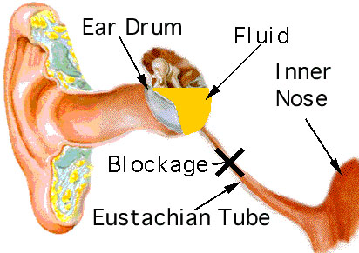

Children are much more prone to glue ear than adults because their Eustachian tubes are more horizontal and of course, smaller so they’re easily blocked.

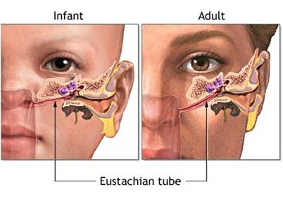

Glue ear is a conductive hearing problem. This means that it is caused by an obstruction in the ear which affects the way that sound is carried through the ear rather than a problem with the hearing nerve and the perception of sound

What to look for?

Every child is different, but if a child’s behaviour changes and several of these factors are observed hey may well have a problem hearing;

- May appear tired or fatigue very quickly
- May become frustrated quickly, cross or upset
- May show poor attention and concentration
- May become more withdrawn, play alone or at boundaries of groups
- May become more noisy and boisterous
- May have inconsistent responses when called by name
- May be reluctant to join in noisy or large group activities
- May find excuses to be out of the group e.g. frequent toilet/handwashing breaks
- May pull at ear/s or rub them
- May appear congested, full of cold, breathe through mouth, runny nose
- Speech clarity and social interaction/confidence may be affected
- May appear to have ‘selective hearing’ or to have stopped following instructions
- May need volume turned up on t.v, music etc. or move to be very close to sound source
- May become over sensitive to certain sounds and cover ears

What’s the treatment?

If you suspect that a child has a hearing loss –

Inform the parents that a GP referral will need to be made to have a hearing test usually in a community clinic.

If a conductive loss is diagnosed, depending on the degree of loss this will either be monitored at the local clinic or the pupil will be referred to the local hospital – audiology / ENT department for hearing aids / grommet insertion

Glue ear is very treatable. Mild glue will go away by itself, but if a child is having lots of episodes of glue ear their doctor might refer them to an Ear Nose and Throat specialist and they might have a grommet inserted.

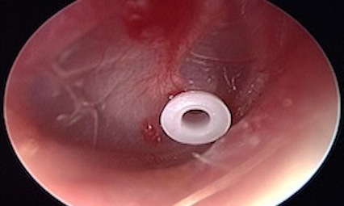

A grommet is a tiny tube which is placed in the eardrum to allow air into the middle ear

How about at school or nursery?

Glue ear can be unpredictable and hearing levels can fluctuate. But the good news is that we can control listening environments, which can help a lot.

There are 3 things which affect how clear the sounds we hear are;

- Distance
- Noise
- Reverberation (echo)

If we can take steps to cut down on these we can make listening much easier for everyone.

Distance

- The best listening distance is within 2 metres. Try to keep all instructions and interactions inside this ‘listening bubble’
- Make sure you have eye contact before speaking, use the child’s name to cue them into listening
- Allow extra time to process information...listening with reduced hearing is a bit like doing a jigsaw puzzle, a bit of time is needed to fill in the gaps
- Use visual cues, clues and prompts as much as possible
- Chunk information and instructions...be prepared to repeat or rephrase and check for understanding
- Buddy a weaker listener up with a peer for some activities

Noise
- Be aware that background noise can be very distracting and can cut out a lot of useful information
- Try to keep noise levels low
- If it is noisy close down the distance between you and the listener and make sure they have good eye contact before speaking
- Give weaker listeners as much 1:1 and small group listening experiences as possible

Reverberation
- High ceilings, hard surfaces and hard floors mean that sound will bounce around and make listening difficult.
- Controlling overall noise levels will help
- Having quiet areas and breakaway spaces
- Pin boards and display boards will absorb sound
- Curtains and fabric also absorb sound

Curriculum

Phonics can cause particular concern when sounds are similar, such as f/v, t/d, p/b and c/g – use visual cues such as jolly phonics actions. Word endings can be harder to hear because they’re unstressed and high-pitched sounds such as /s/ /th/ /t/ /sh/ can be hard to hear especially if there is a lot of background noise.

Vocabulary - use known vocabulary to explain new vocabulary and use visual clues and real objects as much as possible

Useful website www.ndcs.org.uk

For more information please contact:
Helen Joseph
Education Service for Sensory Impairments (ESSI)
helen.joseph@achievingforchildren.org.uk

