All About Me and Who is Looking After Me

Child’s name: Ryan Soliman
DOB: 02/04/2014
Footprints of my day |  | Monday |  |  |  | Tuesday |  |  |  | Wednesday |  |  |  | Thursday |  |  |  | Friday
Who is looking after me | Contact | Before 9am | AM | PM | After  3pm | Before 9am | AM | PM | After  3pm | Before 9am | AM | PM | After  3pm | Before 9am | AM | PM | After  3pm | Before 9am | AM | PM | After  3pm
Sunny Preschool | 020 8775 7777 |  | √ |  |  |  | √ |  |  |  |  | √
Sue Spark (childminder) | 0778 888 8888 | √ |  | √ | √ | √ |  | √ | √ | √ | √ |  | √ | √ | √ | √ | √
Things I like  Trains  Animals  Sand  Messy play | Things I do not like  Lunch  Water  Loud noises | When I am happy I  Play with my friends  Cuddle my teacher  Sing
When I am sad I  Like to sit alone  Cry  Want my mummy/teddy | Things that help me when I am distressed  My teddy  Photos of my family  Stories  Humming | Things that make me feel safe  The teachers  Mummy  My blanket
I am good at  Singing  Playing with my friends  Jumping | I need help with  Putting my shoes on  Asking for a drink | Other languages that I speak/or hear at home are:
Medicine I take regularly: | My special needs/unique needs: | My cultural and religious events:
Siblings:  Big brother Bobby at Latchmere School (Year 1) | Allergies: | Other:

Provider 1
Name: Sunny Preschool
Type of Provider: Preschool Specialism: Montessori
Hours the child attends:  Monday: 9-12  Tuesday: 9-12  Wednesday 1-4 | Key person info:  Name: Sandra Callum | How/when will outdoor provision be accessed?  No outdoor area, occasional trips to the local area to support learning and development
Method and system of observation and assessment:  Moving On  When/how often are assessments carried out?  Termly assessments carried out at every half term | Meals/snacks  Morning snack  Afternoon snack | Other:

Provider 2
Name: Sue Spark
Type of Provider: Childminder Specialism: N/A
Hours the child attends:  Monday: 7.30-9am and 12-6pm  Tuesday: 7.30-9am and 12-6pm  Wednesday: 7.30am-1pm and 4-6pm  Thursday: 7.30am-6pm | Key person details:  Name: Sue Spark  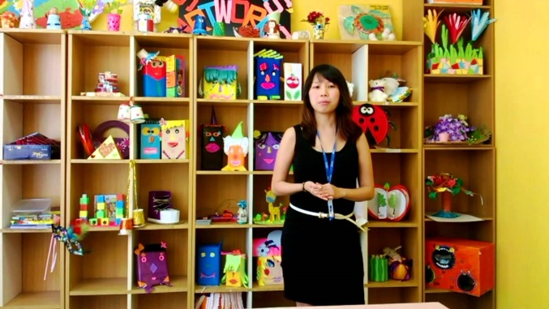 | How/when will outdoor provision be accessed?  I have a garden and we go on daily trips to the local park/shops/community
Method and system of observation and assessment:  Small Steps  When/how often are assessments carried out?  Termly assessments carried out at every half term | Meals/snacks  Breakfast (7.30-9am)  Morning snack  Lunch (12.30-1pm)  Afternoon snack  Evening tea/dinner | Other:

