Insert picture here
Education, Health and Care Plan for
<Known as> <Surname>

Address
Contact phone number
Date of birth
Country of birth
Educational setting

Gender |  | Ethnicity
Religion |  | Language

Is this child or young person
looked after?
Full Care Order, Interim Care Order
or Section 20
Does this child or young person
have a child protection plan?
Name of social worker
Social worker contact details
Lead Professional

Name of parents or carers
Parental responsibility?
Addresses
Preferred contact
Other contact details

Document reference | Date

The EHCP Golden Thread

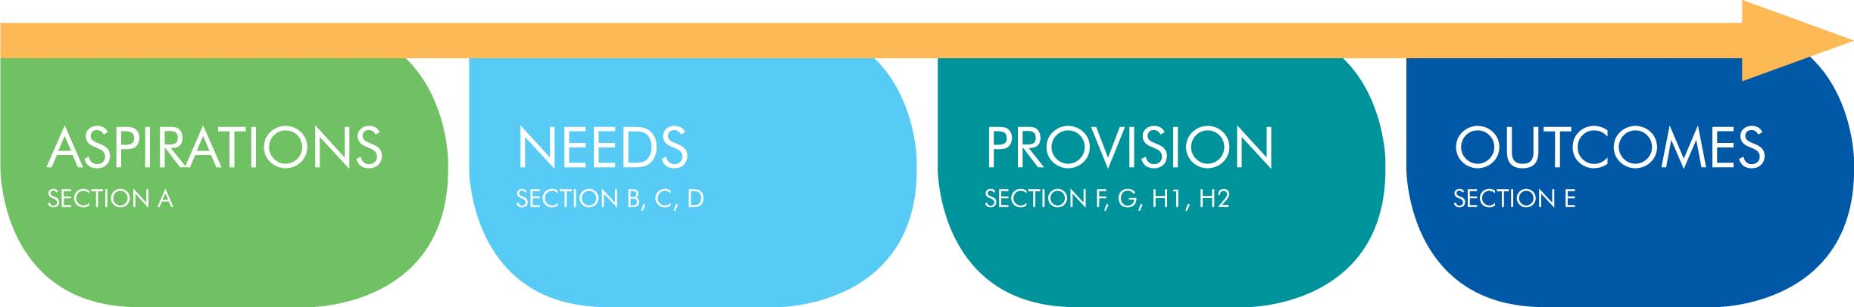

For detailed information on how to complete this form please refer to the Golden Binder on the Local Offer https://www.afclocaloffer.org.uk/uploads/afclocaloffer/document/file/383/05_GOLDEN_BINDER_Detailed_EHCP_Form_Guide_v2_311016.pdf

Section A:

The views, interests and aspirations of the child and their parents, or of the young person

For ease of use Section A is available as a separate form, which can be given to the parent or young person at the beginning of the process (there are 2 versions of the form – either may be used).
The two versions of the section A template can be downloaded from the Local Offer or using this link:
Standard version: https://www.afclocaloffer.org.uk/uploads/afclocaloffer/document/file/176/EHC-A1_EHCP_Template_Section_A_-_v2_311016.docx
Accessible version for children and young people: https://www.afclocaloffer.org.uk/uploads/afclocaloffer/document/file/178/EHC-A2_EHCP_Template_Section_A_-_YP_s_version_V2_311016.docx
Once it has been completed by the child, young person or family Section A must be copied and pasted into this document (either as a word document or a scan of a handwritten section A). If a wiki is used rather than a form the wiki should be referenced here.
Section A must be included within an EHCP. Section A describes the aspirations, which are the start of the “golden thread” that should run through the plan and underpin the remaining sections B-K.
Insert Section A – ‘My views, interests and aspirations’ here

Section B: Summary of <Known as>’s strengths and special educational needs (SEN):

Overview

Cognition and learning
Strengths:

Special educational needs:

Communication and interaction
Strengths:

Special educational needs:

Social, emotional and mental health
Strengths:

Special educational needs:

Sensory and physical
Strengths:

Special educational needs:

For children / young people in year 9 append the Preparing for Adulthood categories to this document (Form EHC-PFA). From Year 10 upwards for new EHCPs – the Preparing for Adulthood Version of the Form should be used (EHC-2). For existing EHCPs rather than updating the whole form the relevant sections can be copied into the existing EHCP from the form EHC-PFA.

Sections C – I: <Known as>’s Support Plan
Each identified special educational need in Section B requires a provision necessary to achieve the outcome.
Briefly describe how the Outcomes documented in this section link to the Aspirations described in Section A

Section E. Outcomes (by the end of Key Stage, or other to specify) | Section F. SEN provision | By whom
Cognition and learning

Communication and interaction

Social, emotional and mental health

Sensory and physical

For children / young people in year 9 append the Preparing for Adulthood categories to this document (Form EHC-PFA). From Year 10 upwards for new EHCPs – the Preparing for Adulthood Version of the Form should be used (EHC-2). For existing EHCPs ather than updating the whole form the relevant sections can be copied into the existing EHCP from the form EHC-PFA.

Note: Needs defined in Section B to Provision defined here (section F) should be linked by using reference numbers. For more detailed information refer to the guidance in the Golden Binder

Section C. Health needs | Section G. Health provision | By whom

Section D. Care needs | Section H1. Care provision relating to CSDPA (under 18s only) | By whom
 | Section H2. Other Social Care provision | By whom
 | Information for the family on support for <Known as>’s social needs can be found at: https://www.afclocaloffer.org.uk/

Level of funding to meet needs identified in plan (complete either early years or mainstream)
(not relevant for special schools or specialist provision such as a unit)
For a mainstream setting | Delegated funding (£)
 | Top up (£)
For an early years setting | Amount (£)

Section I. Placement and type of provision

Section J. Personal budget - including arrangements for direct payments

This section provides information on any personal budget that will be used to secure provision in the EHC Plan and to meet the outcomes detailed in the plan
Has the family made a request for a personal budget? | Yes : | No:

Provision and outcomes | Provider | Type | Annual amount

Total personal budget

The amount of personal budget to be taken as a direct payment
To be read alongside the Direct Payment Contract Agreement.

Section K. Appendices – advice and information gathered during the production of this plan
Source |  | Evidence

Arrangements for review

Next key transition points

Date of draft plan
Date of final plan
Final plan signed on behalf of AfC by

