


Connection
Coffee Mornings
for Parents and Carers who live in Havering
We are pleased to invite parents and carers of children and young people with Social Communication and Interaction differences to join us for a cup of tea or coffee, share ideas, strategies and interventions.
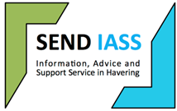
Havering SEND IASS provide a free, impartial and confidential information, advice and support service offering assistance to parents/carers of children with SEND aged 0-16 years and young people themselves 16-25 years.

We have the pleasure of representatives of SENDIASS attending our coffee event to share their information on the Services available to parents and families.
Tuesday 23rd June 2026
1pm – 2:30pm
Venue: Collier Row Children Centre, 28 Clockhouse Lane, Romford RM5 3QJ

Please just turn up to the session on the day. There is no need to book.

SEND Education Support Service
Email: SENDeducation@havering.gov.uk
Telephone: 01708 433936

