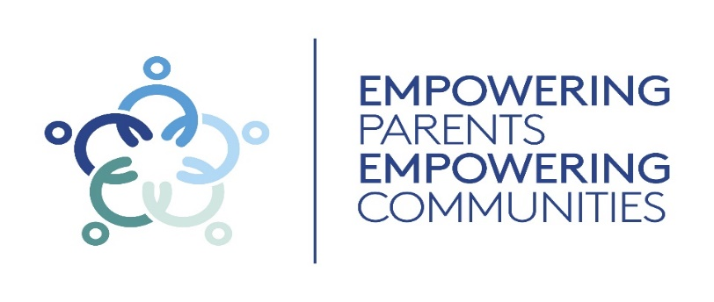
Upcoming course information

Venue: TBC

Date
Time:

Venue: TBC

Date
Time: (No crèche will be provided)


If you are interested and wish to come along, please email:
EPEC@havering.gov.uk

BEING A PARENT AUTISM
All families are different, and all autistic children are different.


Our free course supports you and your autistic child.

What is the EPEC Being a Parent Autism Course?
The Empowering Parents Empowering Communities (EPEC) Being a Parent (BAP) Autism is a 10 week course offered to parents/careers of children with an Autism diagnoses or on the referral pathway.
The 10 week course will give you the opportunity to take a step back and understand how Autism affects your child.
The course will also give you a chance to
- Meet other parents
- Get practical support
- Take time out for yourself
You will receive a variety of ideas to help you support your child, including
- The effects of Autism
- Parenting and family life
- Communicating with your child
- Encouraging flexibility
- Social skills and communication
- Positive parenting, managing behaviour and coping with meltdowns

Why is it different?
The Being a Parent Course is facilitated by accredited members who have completed the EPEC Parent Group Leader (PGL) training. Their experiences, backgrounds, skills and qualities make each session inviting and engaging.

Who is the course for?
The group aims to support children and families to get the best start in life by supporting you to manage your and your child’s feelings, communicate and interact positively with your child, using positive behaviour management strategies and manage parental stress.
Pre-schools, nurseries, early year’s settings, children’s centres and schools in the London Borough of Havering recognise the course content.

“I have all the tools I need to get me through the challenging times with my children”

