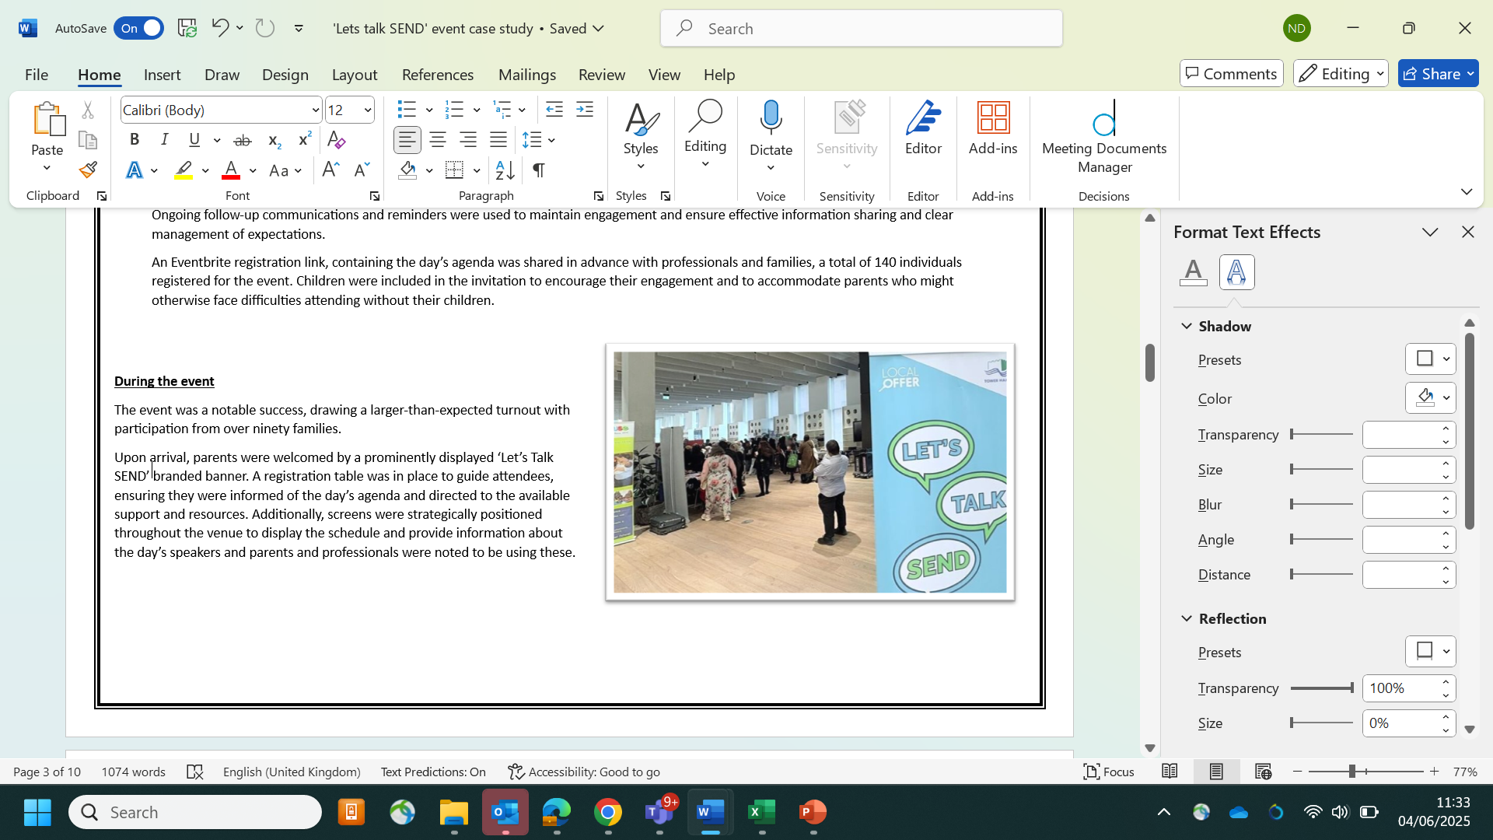
Let’s talk SEND event – Social communication difference and Autism
Context:
In Tower Hamlets, the number of children and young people with additional needs is above the national average, with a growing number of families seeking support. The majority of children with Special Educational Needs (SEN) require assistance with speech, language, communication, and emotional development. Among those with Education, Health and Care (EHC) Plans, the most commonly identified needs are Autism Spectrum Disorder (ASD) and speech and language difficulties. Notably, the prevalence of autism in Tower Hamlets exceeds the national average (Children and Young People with SEND in Tower Hamlets: An Overview).
The Tower Hamlets SEND Strategy (2024–2029) underscores the importance of improving the early identification of additional needs in children under the age of five. Furthermore, the Tower Hamlets SEND Improvement Board has recognised the need for enhanced support for families awaiting a diagnosis.
In response to these priorities, a Special Educational Needs and Disabilities (SEND) Information and Support Event was held on Thursday, 22 May 2025, at Tower Hamlets Town Hall. The event focused on supporting families of children aged 0–7 with social communication differences, both before and after diagnosis.
Aims and Objectives:
The event was organised with three primary aims in mind:
a. To create a welcoming space for parents and carers of children aged 0–7, both pre- and post-diagnosis, offering the opportunity to learn about local services, access valuable resources, and build supportive community connections.
b. To gather meaningful insights from parents' experiences and provide a chance to learn, with the goal of identifying areas for improvement and informing service development.
c. Promoting service integration by offering an opportunity for services to learn about one another, fostering collaboration and better coordinated support for families.
These aims aligned with key priorities outlined in the Tower Hamlets SEND and Inclusion strategy (2024-2029) relating to timely and coordinated support, user-friendly services, early identification for under-fives, and promoting inclusion and celebration of children with SEND and neurodiversity.
The process:
To ensure the success of the event, comprehensive planning and coordination were essential. This involved collaborative meetings with key stakeholders, as well as presentations to wider services to gather input and clearly communicate the event’s objectives, structure, and agenda.
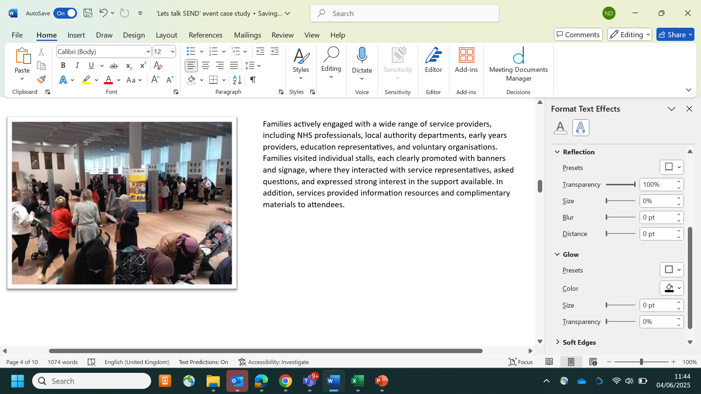
An Eventbrite registration link, which included the full agenda for the day, was shared in advance with professionals and families. Invitations were specifically extended to families on the autism waiting list to ensure they were included. A total of 140 individuals registered to attend. Families were encouraged to bring their children to promote their engagement and to support parents who might otherwise have been unable to attend without childcare.
Promotional materials were disseminated widely through official communication channels, with partners encouraged to share them further with service users and relevant networks. Ongoing follow-up communications and timely reminders helped maintain engagement, ensure effective information sharing, and manage expectations clearly in the lead-up to the event.
During the event
The event was a significant success, with 140 individuals registering via the Eventbrite platform and attendance exceeding expectations, with over ninety families participating. It brought together 23 stakeholders from diverse sectors, including health and education professionals, local authority staff, and members of the voluntary and community sector.
Key attendees included staff from the Health Visiting Service, specifically Specialist Community Public Health Nurses, who support children from birth to five years old and play a vital role in identifying early developmental needs.
Representatives from the Autism Spectrum Disorder Assessment Service (ASDAS) also participated. ASDAS is instrumental in assessing and diagnosing autism in children and provides support to families after diagnosis.
The Healthy Dialogues team was present as well. They specialise in public health engagement, helping organisations understand community needs, gather feedback, and enhance services for families and children.
Housing representatives attended to highlight the critical impact of safe and healthy housing on children’s wellbeing. Issues such as overcrowding, dampness, and mould can adversely affect a child’s health, learning, and development.
This diverse participation reflected the strength and breadth of the evolving Local Offer. The event provided a valuable platform to share current information, offer practical support to families, and enhance collaboration among services delivering SEND support in Tower Hamlets.
Upon arrival, parents were welcomed by a prominently displayed ‘Let’s Talk SEND’ banner and a registration table. Screens throughout the venue displayed the day’s schedule and information about the speakers.
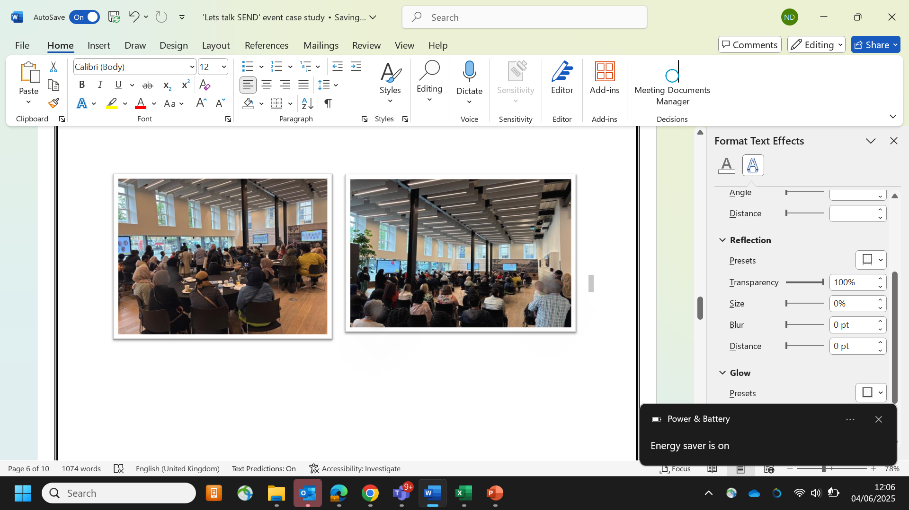
Families actively engaged with a wide range of service providers at clearly marked stalls, where they spoke with representatives, asked questions, and received information and complimentary materials.
A dedicated area of the hall was set aside as a calm, interactive play space, facilitated by the Family Hubs team. This area featured sensory activities such as sand play, bubble play, and rattle-making, designed to help children relax and engage. It served as a focused representation of the Family Hubs’ broader service offerings. Parents were provided with mini windmills, bubbles, and handmade rattles to take home, serving as meaningful reminders of the support available through Family Hubs.
Attendees also listened to brief presentations from key service representatives, including the Local Authority SEN team, Social Connect Pathway leads, ASDAS, the Phoenix Outreach Service, and SENDIASS. These sessions provided updates on diagnosis pathways, available support services, and opportunities for collaboration to improve outcomes for families and children with SEND.
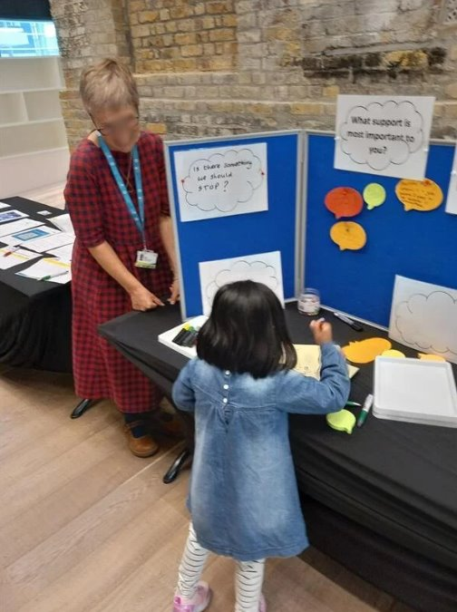
Feeback and suggestions
The venue was vibrant with active participation, as both parents and professionals engaged in meaningful and constructive dialogue. Throughout the event, professionals encouraged children and parents to share their feedback, offering multiple opportunities for both verbal and written contributions.
Several parents personally approached the organisers to express their appreciation for the initiative, noting that it provided a valuable platform to connect with others facing similar experiences. They also highlighted that the event helped raise awareness of available services about which they had not previously known.
Written feedback reflected similar views, with a strong consensus among parents highlighting several key needs.
These include:
- More opportunities for peer-to-peer networking with other parents.
- Access to multidisciplinary support before a formal diagnosis is made.
- Immediate guidance following a new diagnosis.
- Greater help in managing behavioural challenges and the demands of daily life.
In addition, parents emphasised the need for increased school funding to better support children with Special Educational Needs and Disabilities (SEND). Priorities identified included:
- Tailored support for non-English-speaking families, and
- More inclusive practices to ensure SEND children are better integrated into mainstream education.
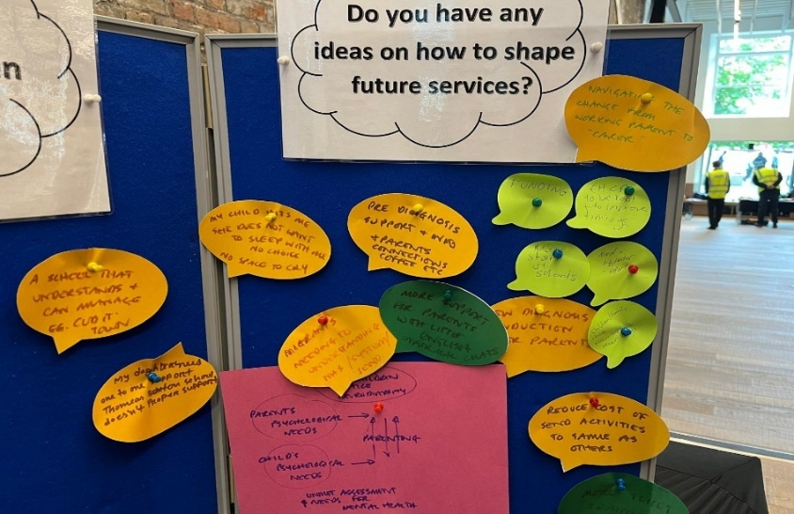
Next steps:
Moving forward, a regular Multi-Disciplinary Team (MDT) meeting will be established to support ongoing collaboration between key stakeholders, meetings will focus on:
- Addressing suggestions and feedback from parents and professionals and guiding service improvements.
- Strengthening and broadening pre-diagnosis support pathways to better equip parents in managing daily behaviours and meeting their child’s needs.
- Strengthening and broadening support services in the immediate post-diagnosis period.
- Enhancing parent engagement initiatives to facilitate peer learning, alleviate isolation, and build stronger community connections.
- Effectively promoting the available offer to ensure families are informed and able to access timely, coordinated assistance.
- Implementing more inclusive practices and providing tailored support that address individual needs, including language barriers and parental disabilities.
Compiled by: Naeema Patel (Specialist practitioner SEND – Health Visitor)
Ratified by: James Courtney (Senior Programme Manager- Children, Young People & Maternity Children’s Integrated Commissioning Team), Hamida Serdiwala-White (Head of service - health visiting), Suzy Liard (Children's Community Therapy Manager), Dr Julia Moody (Tower Hamlets GP, Clinical Lead for Babies, Children and Young People in TH, NEL ICB), Jenny Miller (Manager Family Information, Advice and Support Service, SENDIASS), Krupali Shah (Senior FIS and Local Offer Officer), Mark Penn (Participation and Co-production officer SENDIASS)

