SENSORS AND TRACKING DEVICES

You can keep your child safe in the home particularly if there is a risk that your child will leave your care due to reduced awareness of danger. The sensors and tracking devices can alert you that your child has entered or left an area unsupervised, allowing you to respond appropriately.

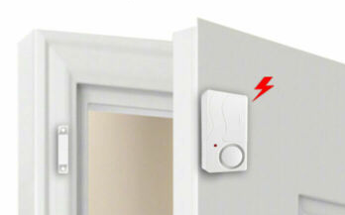
Possible Solutions:
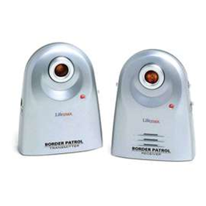
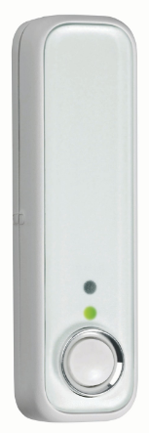
•Consider purchasing motion sensors in the form of door opening sensors, window opening sensors, pressure mats to monitor access to doors, and sensors along the tops of fences, gates or walls. The sensor sets off an alarm or alerts a pager system when triggered.

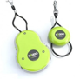
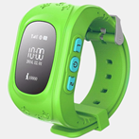
•Consider purchasing a tracking
device or personal locator as this
can be attached to your child. The pager alert remains with the parent or carer, who is alerted when your child has gone outside a set limit range.

•For older children, consider using mobile phone location apps.


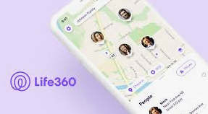
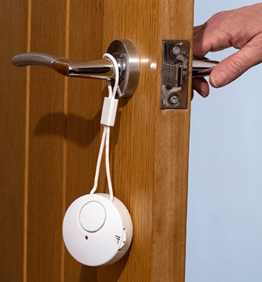

•Wireless door handle alarms can be purchased to alert parents when a door is opened.

General Considerations:
•Sensors and tracking devices do not replace the need for appropriate parental supervision.
•The alarm systems need to be checked regularly to ensure that they are operating effectively.
•Batteries need to be replaced on a regular basis.
•Ensure that the pagers & sensors are placed out of reach of your child.
•Contact the company and/or read manufacturers’ guidance to ensure products are suited to your child’s need.

