KITCHEN SAFETY

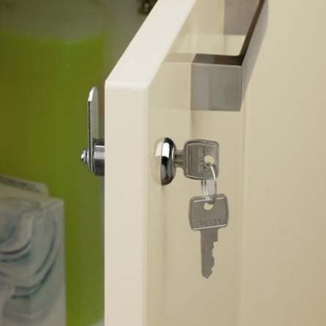
You can improve safety in the kitchen for your child. Children may need ongoing supervision and protection from harmful substances, hazardous items and appliances.

Possible Solutions:
•You may wish to alter the kitchen door and cupboard locks and handles to prevent unsupervised access.
•Lock away dangerous items in the kitchen, for example knives, medicines or dangerous liquids.
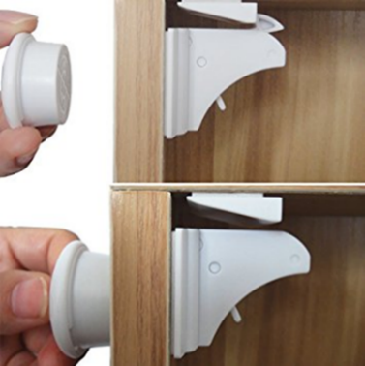
•Consider magnetic locks for cupboards and drawers. They are secure, concealed and almost impossible for the child to open without the magnetic key.
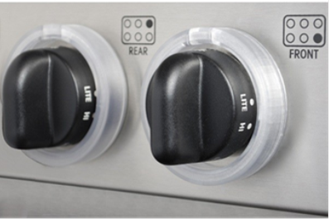
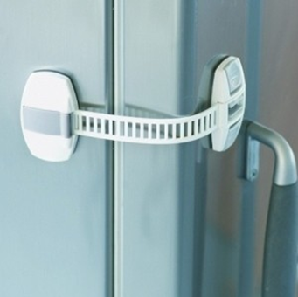

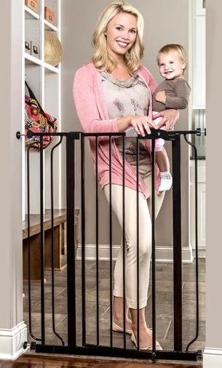
•Consider purchasing appliance locks to prevent children from opening appliances such as the fridge, microwave and oven.
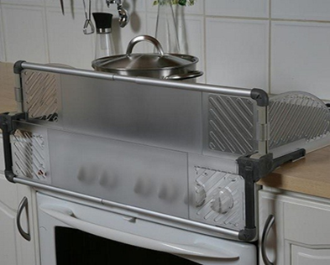
•Cooker top and oven guards prevent children from accessing the cooker hobs and hot oven doors. This will only work for smaller children.

•A stair gate at the kitchen door may be a good option to allow you to keep an eye on your child and keep them safe outside the kitchen.

General Considerations:

•Electric induction hobs are safer than gas cookers because they only heat up when there is a metal conducting pot touching.
•A lot of the equipment will only work with smaller children.
•Consider high handles so that your child cannot open the door independently or fit a loop and catch at the top of the cupboard door.
•A gas safety shut-off key can be used to cut off the gas supply when not in use. All gas related work should be undertaken by a Gas Safe registered engineer www.gassaferegister.co.uk
Before fixing any door locks, please contact your Local Fire Service for advice on 0800 028 4428 or www.london-fire.gov.uk
•Ensure that your child has access to drinking water throughout the day, for example in the form of bottled water.

