GARDEN SAFETY


You can keep your child safe in the yard or garden and reduce the risk of leaving the garden unsupervised or unaware. Playing outdoors can be a useful outlet for extra energy. Your child may need modifications such as additional or altered fencing and secure gates to enable them to play safely.

Possible Solutions:
•Consider having large plants along the fence to deter your child from climbing the fence.
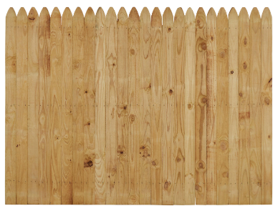

•Large wooden boards could be fixed to the inside of the fencing and gate to cover up horizontal wooden slats to reduce the risk of climbing.
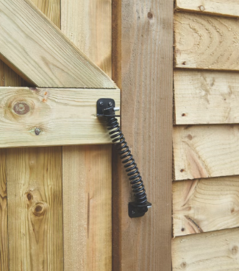


•Consider sensors/alarms with pager to alert you to your child attempting to climb over the fence or opening an external door.
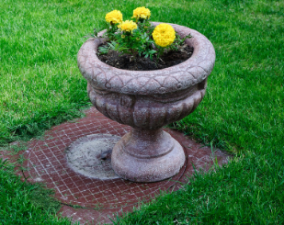

•Consider a spring-loaded gate to ensure it is not left open.

•Place a large pot plant on top of manholes to deter your child from lifting the manhole cover.
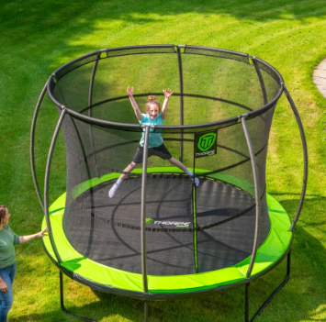
•Weighted and lockable manhole covers are commercially available from builders’ merchants.

•Trampolines (with netting) and punch bags can be a useful outlet for extra energy.

General Considerations:

•Your child may still require a high level of supervision in the garden despite suitable safety measures being in place.
•Please note that planning permission may be required for rear garden fencing higher than two meters (or six feet). Height limitations also exist on front garden fencing.
•General garden repair and maintenance is normally the responsibility of the occupants.

