**FURNITURE SAFETY**

Your child may climb on, throw and/or damage furniture, putting themselves and others at risk.

**Possible Solutions:**

•Magnetic curtain rails which can be pulled apart under pressure and can be easily re-attached may be an option to consider.

•Furniture e.g. wardrobes and drawers that are fixed to the wall or floor will be more secure.

•Durable, heavy tables and chairs, solid lockable cabinets with unbreakable front panels to hold your TV etc. can be purchased e.g. Tough Furniture.

•Sloping furniture helps to prevent climbing on the furniture.

•Lockable drawers can prevent your child from removing the drawers to use as a climbing frame or from damaging the contents.

•Consider washable paint instead of wallpaper as it is easier to clean.

•Polycarbonate/safety mirrors are safer for children who may break mirrors.

•Window safety film can reduce glare and the risk of being injured by broken glass.

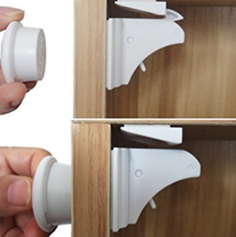

**General Considerations:**

•Consider minimal furniture in the child’s bedroom to reduce risk to your child.

•Use of corner protectors or rounded corner free furniture can reduce the risk of injury to your child on sharp corners/furniture.

•Magnetic cabinet locks are effective to prevent your child accessing cupboard contents.

•Consider the layout of the furniture to reduce your child’s access to high areas and windows.