ELECTRICAL SAFETY
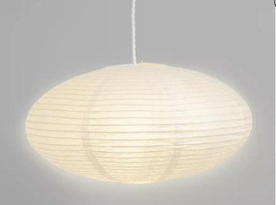
You can help keep your child safe from electrical components within the home. Electrical appliances and/or electrical sockets can be a risk to your child’s safety if these are tampered with.

Possible Solutions:
Lighting and sockets:

•Use non-breakable light shades to prevent impact on light bulbs such as fabric or paper light shades.

•Dome-type ceiling light covers instead of pendant lights may be safer.

•Light switches can be located outside the room.
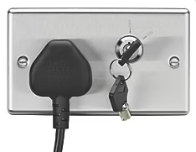
Stainless steel electrical sockets with lockable fronts are available for purchase.
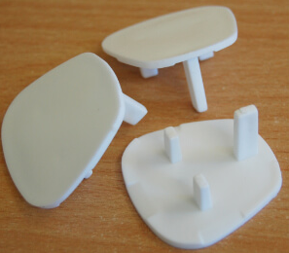
•Plastic covers that fit over the entire electrical fittings of a light switch or socket are readily available.
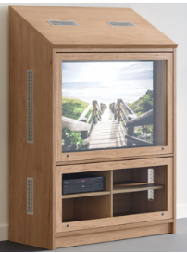
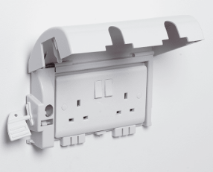

•Plug-in socket covers are readily available.

Electrical Products:
•DVD and Digibox protectors help prevent your child from touching the controls

•TV screen protectors can protect your TV from sticky fingers, crayons and damage.

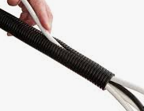
•Strong, lockable TV cabinets with unbreakable front panels can house your TV and DVD.

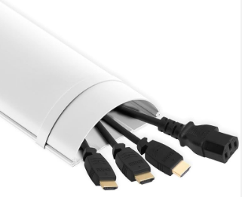
•A cable tidy is a protective sheath that is designed to encase wires and cables. This prevents children from being able to chew or pull-on wires.

•A cable bridge can be fixed to floors, walls or desks using screws or double-sided tape to hide cables.

General Considerations:
•When employing a tradesman for electrical works, it is advisable to employ a registered/certified provider. You may contact www.niceic.com or 0870 013 0382 to find a certified electrician.

