**DOOR SAFETY**

You can keep your child safe around doors whilst reducing the risk of them leaving the home uninformed and/or accessing rooms where there could be potential dangers, for example the kitchen and bathroom.

**Possible Solutions:**

•Install door opening restrictors.•Install a key safe or key cabinet near exit points to ensure that keys can be located quickly in the event of an emergency.

•Install keypad door locks. These ensure that only people with the security code can open the door and can prevent your child from entering a room when unsupervised.

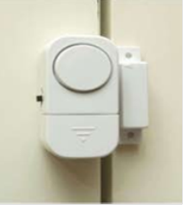•Sensors or alarms can be fitted to doors to alert you when your child has entered an area or opened a door.

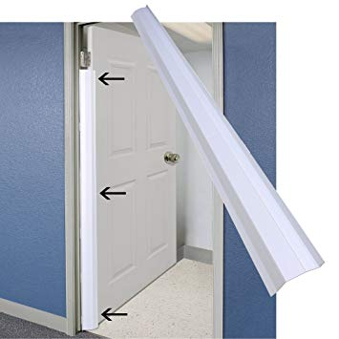

•Child safety door stops, finger guards and finger protection hinge guards are readily available to protect fingers.

•Perspex/polycarbonate smash-proof sheets that can come with screw fittings or adhesive backing can be easily fixed to doors/walls to prevent damage.

**General Considerations:**

•Before fitting any locks, please take advice from your Local Fire Service on 0800 028 4428 or [www.london-fire.gov.uk](http://www.london-fire.gov.uk)

•If doors are locked with keys, it is important that the keys can be found quickly in the event of an emergency.