COMMUNITY / OUTDOOR SAFETY

You can keep your child safe when out in the community. For example, children who have a reduced sense of danger may need a safety restraint to protect them when outdoors.

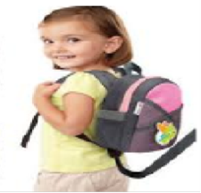
Possible Solutions:
•Consider purchasing walking reins or wrist strap.
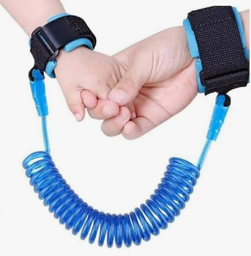
There are also rucksacks with reins if your child doesn’t tolerate reins or wrist straps.

•Reins may not be sufficient for some children who may be safer using a buggy or wheelchair.

•Buggies and wheelchairs can be fitted with 5-point harnesses and footrest straps to prevent the child from dragging their feet.
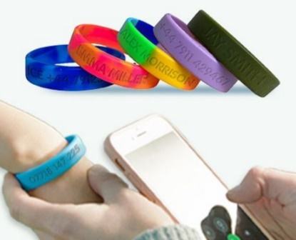
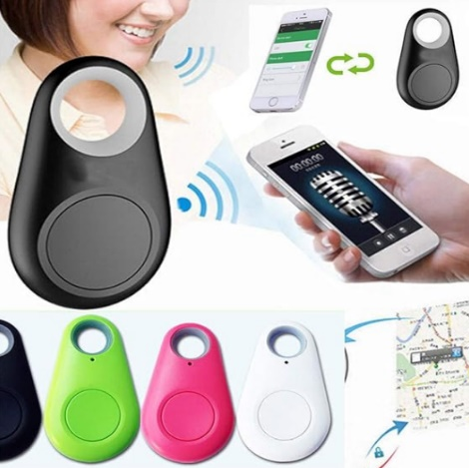
•Wrist bands with contact details can be useful for children should they get lost.

•Consider purchasing a tracking device or personal locator as this can be attached to your child’s clothing or accessories. The pager alert remains with the parent or carer who is alerted when your child has gone outside a set limit range.

•For older children, consider using mobile phone location apps.

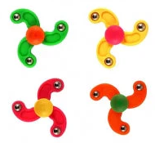
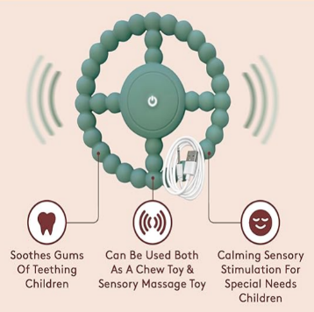


•You may wish to use a comfort object to provide reassurance and manage anxiety when you go out with your child such as a security blanket, or vibrating toy.

General Considerations:

•Children with challenging behaviour should always be closely supervised when outdoors.
•Contact your GP for a referral to the Wheelchair service who may be able to assist with a wheelchair.
•There are community services such as accessible swimming sessions, cinema screenings and trampoline park sessions which can be explored.

