**BEDROOM / LIVING ROOM SAFETY**

Some children may need twenty-four hour supervision, including when sleeping and playing. They may wander at night whilst parents are sleeping and place themselves at potential risk.

**Possible Solutions:**

•Heavy duty and reinforced TV cabinets and bed frames are available along with heavy duty, waterproof and highly durable mattresses.

•Foam/padded tiles can be attached/glued to walls/furniture to provide protection against a hard surface.

•Pop-up bed tents/indoor tents can encourage your child to sleep if they prefer smaller/confined spaces.

•Water resistant washable products to support children with continence issues, including duvets, pillows, mattress covers, sleeping bag liners, absorbent bed pads and breathable bedding protection can be purchased.

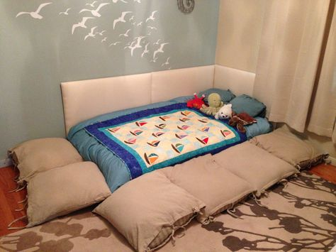

**General Considerations:**

•Where there are difficulties with your child jumping on the bed or being at risk of injuring themselves on furniture, try a mattress on the floor with limited furniture in the bedroom.

•Limit the sensory stimulation in the room so that your child is prompted to sleep at night time. For example, limit stimulating toys and wall coverings in the room and use black out blinds to reduce light disturbance.