BATHROOM / WATER SAFETY

Your child may enjoy water but may use water inappropriately causing flooding and damage to the home.
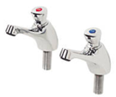
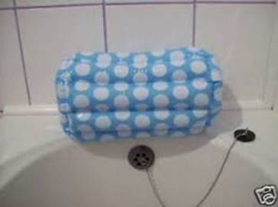
Possible Solutions:
•Install automatically operated/push taps, inflatable tap covers or anti-vandalism taps.
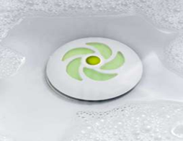

•Use Magiplug for sink or bath. This prevents flooding as the pressure of the water opens the plug when the sink or bath is full.
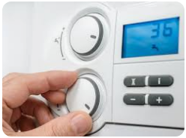
•Adjust the boiler water temperature to prevent water reaching scalding temperatures (maximum 43°C).
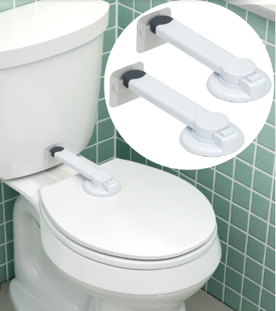

•Toilet cisterns can be boxed in/concealed behind a wall.

•Toilet safety locks for toilet seats can be purchased.

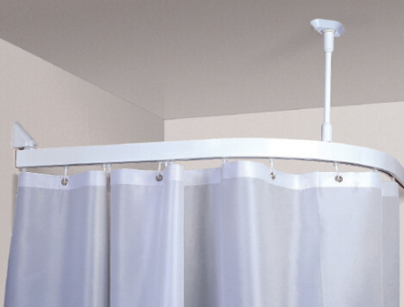

•Magnetic towel and shower curtain rails can be installed where the rail pulls apart from the brackets under pressure and can be easily reattached. These are also available for wardrobes and curtain rails.
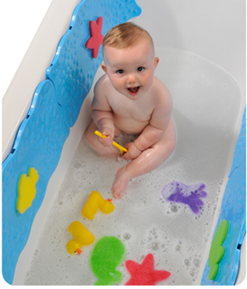

•Filling up the bath to a lower level will minimise the amount of water that is splashed.
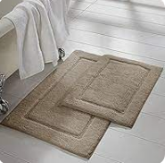

•Installing non-slip flooring and keeping extra bathmats/old towels on the floor will help to soak up water and reduce flooding/water damage.


•Polycarbonate/safety mirrors are available where there is a risk of your child breaking mirrors.

General Considerations:

•Ensure that your child has adequate access to drinking water throughout the day, for example in the form of bottled water.
•Make sure that you do not stop your child from getting to the toilet when necessary.

