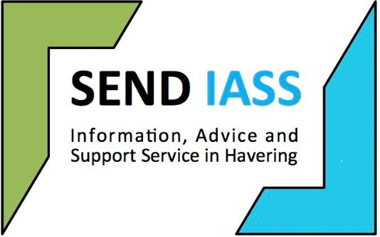

**Post 16 transition information sheet for young**

**people with an education, health and care plan**

**What is transition?**

During your last few years at school you should begin to think about your future and the decisions you may need to make as you move into adult life. This change is referred to as a transition.

**What does the law say?**

The law says that you must stay in education or training until you are 18years (Y13). This can be combined with up to **20hrs a week of paid or voluntary work.**

There are many options out there for you to consider and you are able to access free full time education until you are 19.

If you have an education, health and care plan (EHC plan) this can stay with you until you reach 25. However, this does depend on whether you stay in education and the what is agreed following discussions with your local authority case officer.

**What is a transition plan?**

A transition plan is when you and the adults supporting you can begin to make a plan to support you through your transition.

From year 9 onwards if you have an EHC plan you will be asked to attend a meeting which is part of a transition annual review. At this meeting you will discuss and confirm all the things that you need to support you as you move towards adult life. This is part of the “Preparing for Adulthood” process.

**Within this meeting you have a right to**

* Attend the transition meeting
* Be given support to help you make and communicate your choices
* State your preferences- your hopes, likes and dislikes and the educational facilities you need
* Have your educational needs identified
* Discuss other support you may qualify for such as transport and equipment

**What should I consider when preparing for the transition process and transition meetings?**

* Think about what you would like to do in the future
* Think about qualifications/skills needed for particular careers
* Look at college courses, work placements and supported internships and pre-supported internships that you may be of interest
* Think about the support you will need
* Continue to work hard

**Other important choices**

* Transport - getting around – How will you get there? How long will it take?
* The type of job you would like
* The money you will need
* Friends and relationships
* Health care
* Where you will live

**Who can support you with the transition process?**

* The special educational needs coordinator (SENCo) at school
* Prospects advisor
* Careers service
* Your parents/carers
* Social worker (if you have one)
* Local authority case officer

**Services and resources to help your transition**

**Havering Prospects**

**Tel**: 01708 746401

**Email:** [barbara.faulkner@prospects.co.uk](mailto:barbara.faulkner@prospects.co.uk)

**Website:** [Shaw Trust | Havering Directory](https://eur03.safelinks.protection.outlook.com/?url=https%3A%2F%2Ffamilyserviceshub.havering.gov.uk%2Fkb5%2Fhavering%2Fdirectory%2Fservice.page%3Fid%3DcaxyIcQ3U9Q&data=05%7C02%7CSENDIASS%40havering.gov.uk%7Cae24b7d9544645f20a6308dd13ba740b%7C353669e1971846f89bed95afc8776c8a%7C0%7C0%7C638688413719606063%7CUnknown%7CTWFpbGZsb3d8eyJFbXB0eU1hcGkiOnRydWUsIlYiOiIwLjAuMDAwMCIsIlAiOiJXaW4zMiIsIkFOIjoiTWFpbCIsIldUIjoyfQ%3D%3D%7C0%7C%7C%7C&sdata=Gm1RYGB2xnoY6EjXx431dflqFsx%2BcanSRnvzOxek9H4%3D&reserved=0)

**Havering Works**

**Tel:** 01708 434456.

**Email:** [havering.works@havering.gov.uk](mailto:havering.works@havering.gov.uk)

**Website:**  [Careers advice and employment | Havering Works: Employment and Skills advice | The London Borough Of Havering](https://eur03.safelinks.protection.outlook.com/?url=https%3A%2F%2Fwww.havering.gov.uk%2Fjobs-1%2Fhavering-works-employment-skills-advice&data=05%7C02%7CSENDIASS%40havering.gov.uk%7Cae24b7d9544645f20a6308dd13ba740b%7C353669e1971846f89bed95afc8776c8a%7C0%7C0%7C638688413719619577%7CUnknown%7CTWFpbGZsb3d8eyJFbXB0eU1hcGkiOnRydWUsIlYiOiIwLjAuMDAwMCIsIlAiOiJXaW4zMiIsIkFOIjoiTWFpbCIsIldUIjoyfQ%3D%3D%7C0%7C%7C%7C&sdata=7TysCxia6rTFL4LrGga2l4QOwD0Dh7amhp0lHyFOXpQ%3D&reserved=0)

**Havering SEN Service**

**Tel:** 01708 431 885

**Email:** [sen@havering.gov.uk](mailto:sen@havering.gov.uk)

**National Careers Advice**

**Tel:** 0800 100 900