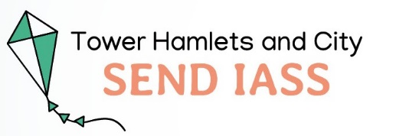

**What can I expect from Tower Hamlets & City Special Educational Needs Disability Information Advice and Support Service (SEND IASS)**

* A case worker will be in touch and they will provide you with their contact details – email, mobile and office number. This will happen within 10 working days of your case being allocated
* We may offer to meet with you - this could be “face to face” or virtually – or have contact with you over the telephone/ email.
* We will attend relevant meetings, with advance notice when we can
* If your case worker cannot keep an appointment, we will let you know.
* We will support you to complete forms such as Annual Review Forms, applications for schools and letters to relevant parties involved with Education Health and Care Plans (EHCP) and provide expert advice in relation to SEND law and practice
* We will give expert information, advice and support regarding appeals and tribunals and provide informal mediation where required and possible.



**What SENDIASS expects from you**

* When you call the office, please let us know if you already have an allocated caseworker. We will ensure they respond to your query
* Let us know if you cannot keep your appointment or you are going to be late for a meeting. This will enable us to offer support to more families
* Try to complete as much information on forms as you can before your appointment to help speed up the process and to make sure you get the most out of your appointment
* Let us know if school or other parties involved cancel meetings
* We are a small team and demand on our service is very high. Please bear this in mind
* **Areas we do not cover include** School complaints,

Housing, Welfare Rights and completion of Benefit Forms – if you require support with these please look on the Local Offer for details of Advice Servies that may be able to help in this area

For information about services in the Borough please look at Local Offer ([www.localoffertowerhamlets.co.uk](http://www.localoffertowerhamlets.co.uk)) or call 020 7364 6495

If you have any concerns, complaints - or compliments - about the service you receive from us please contact the Manager, Jenny Miller on 020 7364 7127 or email [jenny.miller@towerhamlets.gov.uk](mailto:jenny.miller@towerhamlets.gov.uk)

SEND Information, Advice and Support Service is an 'arm's length' Service from Tower Hamlets Local Authority and we give impartial and neutral advice. We support parents/carers of children with SEND, children and young people themselves and provide many services to facilitate this support.