

Short Breaks Self Referral for Disabled Children and Young People

Tower Hamlets Council working with partners, parents and voluntary sector organisations
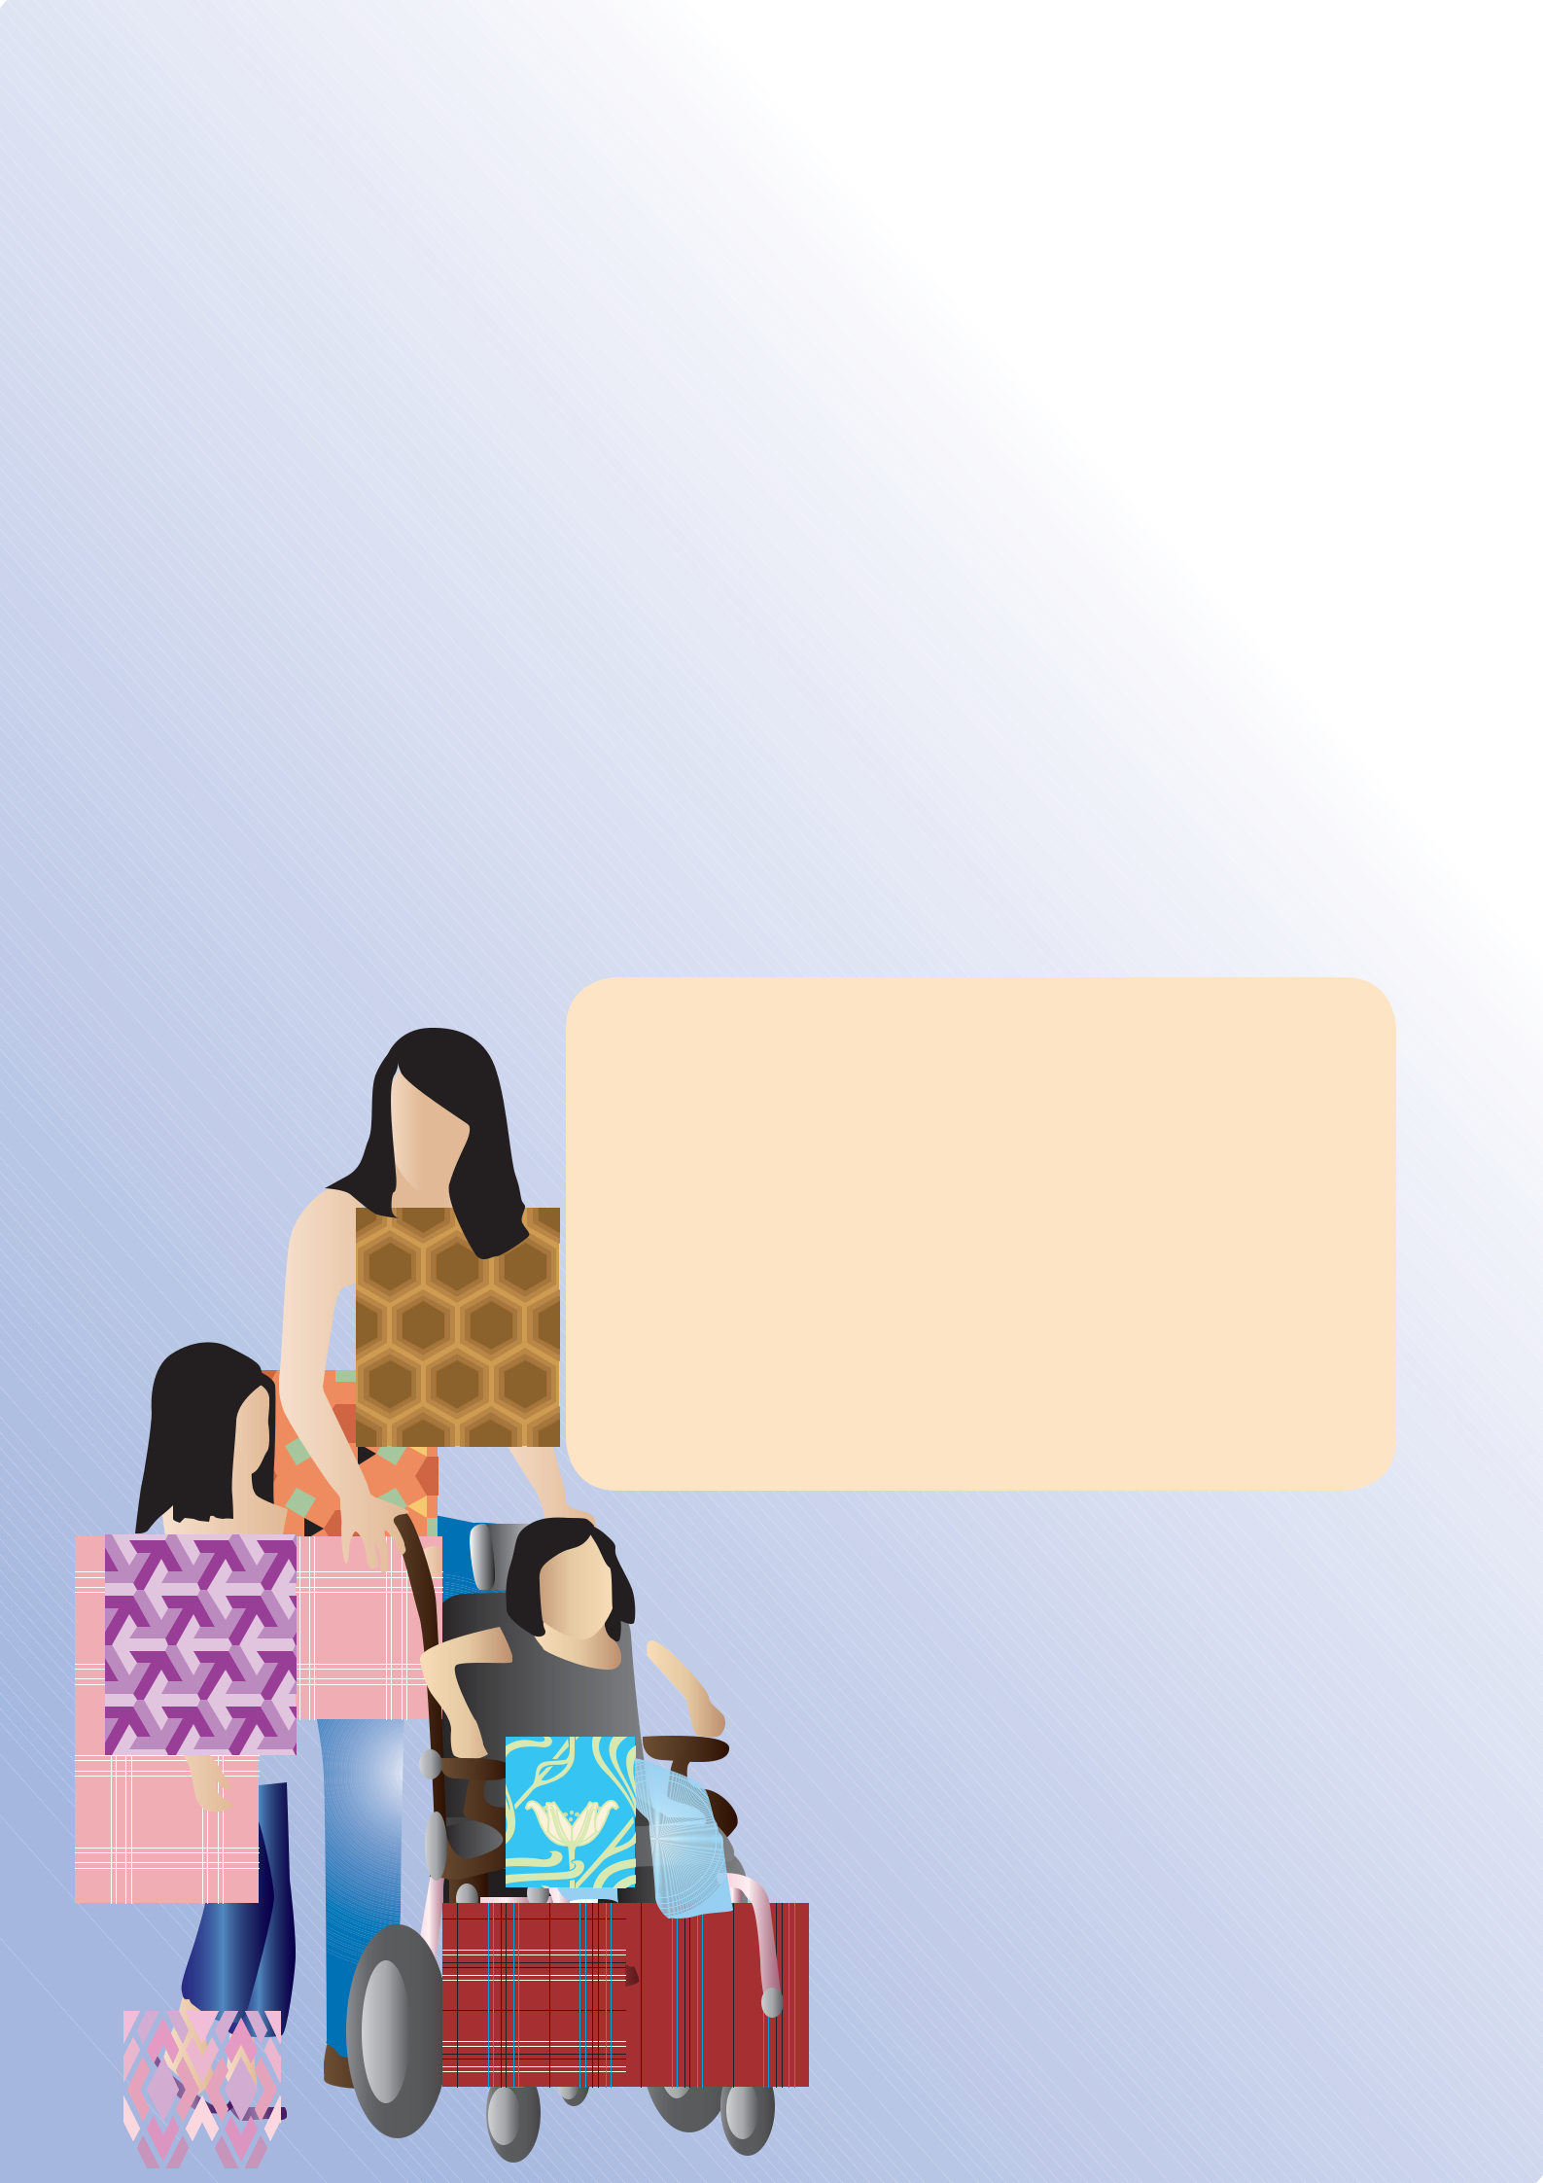
SHORT BREAKS SELF REFFRAL FORM

This form is designed to be completed by parents who would like their children to receive a short break service from those listed on page 5. The form can be used to request both specialist and universal services.

If you are currently receiving a short break service, there is no need to fill out this form unless you are requesting a change of short break service because, for example, your child’s needs have changed.

For a full outline of what each of these services provides and their target group, please see the Directory of Services and Short Breaks Statement for Disabled Children and Young People. If you do not have a copy of this, you can obtain one from the Family Information Service by calling 020 7364 6495.

If you wish to find out about the progress made in developing our short breaks provision as well as other general information on short breaks, please refer to the short breaks statement featuring in the Directory.

For help in completing the form, please contact the

Short Breaks Co-ordinator on:

Tel: 020 7364 1450

Email: short.breaks@towerhamlets.gov.uk

Website: www.towerhamlets.gov.uk/childrenwithdisabilities

Further copies of this form are available at:
www.towerhamlets.gov.uk/
childrenwithdisabilities

DEAR PARENTS/CARERS

Thank you for expressing an interest in applying for a short break service for your child. Please find attached the ‘Self Referral’ form which sets the eligibility on page 4 and is to be used as a guide to ensure that you are directed to the service you need. It is useful to bear in mind when making your choice that ‘specialist* services’ are allocated to disabled children and young people whose needs cannot be met by universal* services as they require a higher level of support. The needs of a majority of disabled children are met within universal services without the need for an assessment. Families can ask for an assessment if there is a change in circumstances or if more than one service is required. A short break can be accessed by one of the following:

- The Self Referral form

- Common Assessment Framework (CAF)

- A social care assessment

(which combines with a Carers Assessment)

An assessment is completed by a professional. It takes into account the child’s development, parent capacity and family and environmental factors, as families may have the same needs but manage differently. To request an assessment or access more than one specialist service, please contact the Children with Disabilities Team on 020 7364 2724.

We have tried to make the form as simple as possible. If you require any help or further explanation to complete this form, please don’t hesitate to call our Short Breaks Co-ordinator on 020 7364 1450. The co-ordinator is more than happy to talk you through it or support you in accessing the help you need to complete the form. Bi-lingual help is also available.

The Self Referral form does not have to be completed if your child already receives a specialist service. Once you have completed the Self Referral form, please send it back to:

Short Breaks Co-ordinator

Tower Hamlets Town Hall,

160 Whitechapel Road, London E11BJ

020 7364 1450

short.breaks@towerhamlets.gov.uk

We look forward to receiving your short breaks application shortly.

*The Authority aims to meet the needs of all children through the universally available, inclusive provision. However, the needs or disability may require targeted provision. The two categories are described below:

Universal services:
Universal services seek, in conjunction with parents and families, to meet all the needs of children and young people so that they are happy and healthy and able to learn and develop securely. Universal services are provided to all children and young people, including those with additional needs.

Examples of universal services are maternity services, health visiting, children’s centres, schools, extended schools services and youth services.

Targeted and specialist services: Services for children with additional needs that go beyond what is on offer in universal services are known as targeted or specialist services. Specialist short breaks are an example of a targeted service. Other examples include extra support during the early years such as the Portage team and additional help with learning in school. Statutory specialist services are where the needs of the child and their families mean that they need intensive statutory intervention to ensure their continued development. An example of this type of service is Children’s Social Care.


BASIC INFORMATION

Please complete in BLOCK LETTERS.

Child’s first name |  | Surname
Date of birth |  | Age
Ethnicity of child |  | Language(s) spoken
 |  | by family
Email
Disability
Please list the diagnosis/child’s disability in
this box. Choose from the disabilities listed in
categories A and B below (eligibility)
Group A:

Children and young people with Autistic Spectrum Disorder (who have severe learning disabilities or behaviour which is challenging) or those children and young people whose challenging behaviour is associated with other impairments such as severe learning disabilities.

Group B:
Children and young people with complex health needs including those with physical and/or learning disabilities, those who require palliative care (continuing care) and those with associated sensory impairments. Complex health needs includes children and young people with profound and multiple learning difficulties and complex and severe medical needs who may also have an additional physical and/or sensory impairment.
Form completed by

Relationship to child or young person

Address of child or young person

Postcode

Telephone |  | Mobile
Name of school or pre-school service
Please list any short break or other |  | 1.
services your child already receives |  | 2.
 |  | 3.
Are there any health support needs for
your child? If yes, give details (e.g. peg feeds,
naso-gastric, allergies, special diet, asthma,
skin conditions, diabetes, seizures)

Please tick all boxes that apply to your son/ daughter:

Is your son/daughter:

Verbal?

British Sign Language trained?

Using PECS/Makaton to communicate?

Hearing impaired?

Able to use the toilet independently?

In need of assistance when using the toilet?

 | Please let us know if we can contact you in the future regarding activities and services |  | Yes
 | that may be relevant to your child? Please tick the box as appropriate |  | No
 | Signed
 | Date

4


CHOOSE A SERVICE

Choose a service from the list of specialist and universal services

Look at the list of self referral services below (read more about each service in the Directory of Services and Short Break Statement for Disabled Children and Young People available from the Family Information Service) and then indicate what your first choice is by putting a ‘1’ in the white box next to that service. If you have a second choice then put a ‘2’ in the white box next to that service. Please limit your choices to a maximum of two. If there is a short break service you wish to apply for and is not listed below, please state the service as ‘other.’

Where more than one service is required to meet your child’s needs, which includes overnight short breaks and Continuing Care, please indicate below and contact the Children with Disabilities Team on 020 7364 2724 for an assessment.

Please tick one option from the following if you would like your child to be assessed.

I would like my child to be assessed for more than one provision

I would like my child to be assessed for an overnight provision

I would like to arrange my own short break through direct payments/Individual Budget

Self referral services: (the services listed are correct at time of publication)

Early years service or day care |  |  |  | Family Link
a. | Day Nursery |  |  | National Autistic Society- Befriending
b. | Child Minding |  |  | Service
c. | Children’s Centre |  |  | Scope Befriending Service
Tower Project Holiday Schemes |  |  |  | Tower Hamlets Inclusion Service
a. | Easter Scheme |  |  | Richard House Day Break
b. | Summer scheme |  |  | Play Factory- Holiday Childcare
 |  |  |  | Scheme
c. | February/ October half-term |  |  | Scheme
 | Scheme |  |  | Youth Services- Mayor’s Activities for
 |  |  |  | Young People e.g. Surjamuki Youth
Stephen Hawking School |  |  |  | Young People e.g. Surjamuki Youth
 |  |  |  | Project
a. | Easter Scheme (Whoosh) |  |  | Project
a. | Easter Scheme (Whoosh) |  |  | APASENTH- Youth Service
b. | Summer Scheme (Whoosh) |  |  | APASENTH- Youth Service
 |  |  |  | Leisure, sports and cultural activities
c. | Saturday Group with Siblings |  |  | Leisure, sports and cultural activities
c. | Saturday Group with Siblings |  |  | e.g. Mile End Leisure Centre
Discovery Home After School Club |  |  |  | e.g. Mile End Leisure Centre
 |  |  |  | Other- please state service below:
1 Discovery House After School Club |  |  |  | Other- please state service below:
Stay and Play delivered by the National
Autistic Society and Disabled Children
Outreach Service (DCOS)
How did you hear about short breaks?

5

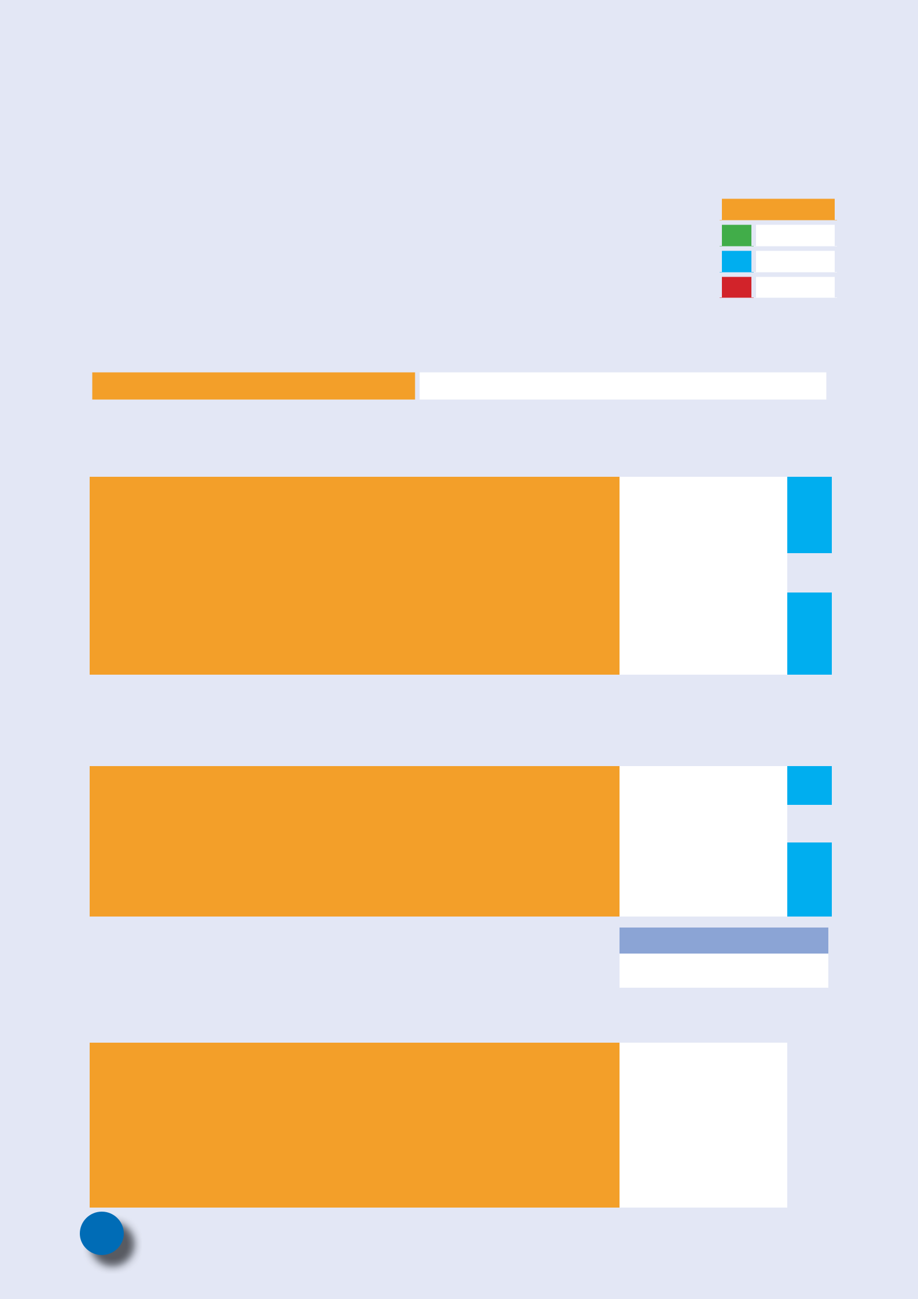
SELF SCORING BOXES

Detailed information using scoring

Now tell us about your child and family. In each of the sections below, put a tick in the box which most resembles your child’s situation. Please tick one box only from each section. Once you’ve completed ticking the relevant boxes, write the score for each section into the ‘Needs Score’ section and write the total score in the same section.

The first section is about the Care Component of the Disability Living Allowance (DLA) or Daily Living Component of the Personal Independence Payment (PIP) you receive for your child.

 | Key
1 | Low
2 | Medium
3 | High

Your DLA/PIP Reference Number is:

1. Disability Living Allowance – Care component |  | You receive
 |  | (tick one box only)
1. | You receive Low Level DLA |  |  |  | 2
2. | You receive Medium Level DLA |  |  |  | 2
3. | You receive High Level DLA |  |  |  | 3
4. | Do not claim DLA- but fall under either category A or |  |  |  | 2
 | category B (as stated on page 4) |  |  |  | 2
5. | Claim for DLA has been submitted |  |  |  | 2
OR
Personal Independence Payment |  | You receive
- The daily living component |  | (tick one box only)
1. | You receive the standard rate of PIP |  |  |  | 2
2. | You received the enhanced rate of PIP |  |  |  | 3
3. | Do not claim PIP but fall under the category A or B as stated |  |  |  | 2
 | on page 4 |  |  |  | 2
4. | Claim for PIP has been submitted |  |  |  | 2
Tick one box only |  | Yes |  | No
Do you receive Carers’ Allowance? |  |  |  | 2
2. Sleep |  | Tick one box only
1. | Your child sleeps well for their age. |  |  |  | 1
2. | There is some disturbance of your/ your partner’s sleep |  |  |  | 2
 | patterns due to the impact of your child’s disability. |  |  |  | 2
3. | You follow specialist advice or a sleep programme, but your/ |  |  |  | 3
 | your partner’s sleep is still disturbed 3-5 nights per week |  |  |  | 3
 | due to the impact of your child’s disability.

6

3. Child’s social education and leisure needs |  | Tick one box only
1. | Your child has a routine and participates in social activities
 | that are available within the local community with minor |  | 1
 | support.
2. | Your child would enjoy and benefit from participating in
 | social and leisure activities, however this is difficult as he |  | 2
 | she would need additional support such as a helper to |  | 2
 | access the service.
3. | Your child is socially isolated and does not attend any |  | 3
 | provision outside of school or health services. |  | 3
4. Effect on siblings under 18 years of age |  | Tick one box only
1. | Your disabled child has siblings or friends to play with. They |  | 1
 | have social relationships appropriate to their age. |  | 1
2. | Your disabled child has two or more siblings under school |  | 2
 | age. |  | 2
3. | Other children in your family have a significant caring role |  | 3
 | for their disabled brother or sister (known as a young carer). |  | 3

- If there is a young carer within the family, please provide their details so that we can provide you with information on services for young carers.

Name:

School:

Date of birth:

5. Family and social relationship |  | Tick one box only
1. | Your disabled child has a good relationship with all family |  | 1
 | members and they have age appropriate friendships. |  | 1
2. | You worry that your child may be excluded from some social
 | activities or does not have the opportunity to develop |  | 2
 | friendships out of school time.
3. | You feel that your child is isolated within the family |  | 3
 | environment for significant periods of time. |  | 3
6. Parental capacity |  | Tick one box only
1. | You are able to use support and help from family, |  | 1
 | community, universal and specialist services. |  | 1
2. | You need and use additional support in order to live an
 | ordinary life. You access support from professionals or your |  | 2
 | wider family on a regular basis.
3. | You have more than one disabled child or you are yourself |  | 3
 | disabled or have a diagnosed health need. |  | 3

7

7. Impact on family |  | Tick one box only
1. | You have supportive relationships within your family and |  | 1
 | community. |  | 1
2. | There are relationship difficulties within the family that
 | impact on your disabled child and not other children in your |  | 2
 | family. e.g. Family understanding and feelings about the |  | 2
 | child’s diagnosis.
3. | You are worried that there is a real risk of family breakdown. |  | 3
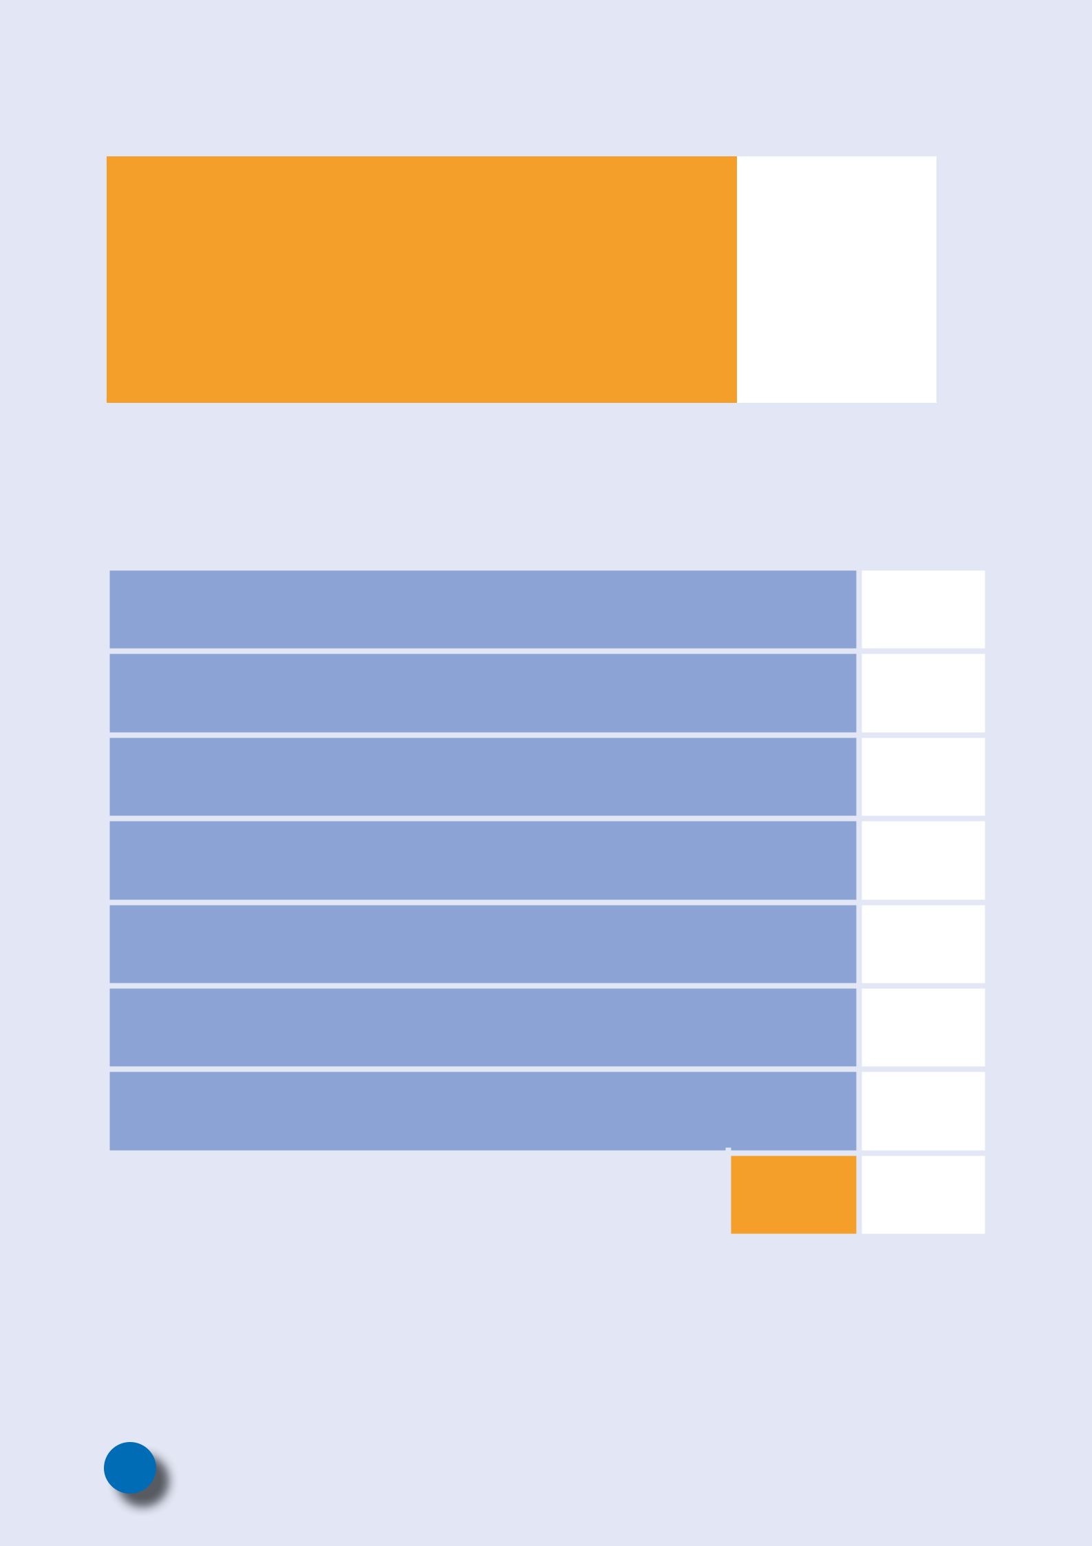

NEEDS SCORE

1. | Disability Living Allowance
2. | Sleep
3. | Child’s social education and leisure needs
4. | Effect on siblings under 18 years of age
5. | Family and social relationships
6. | Parental capacity
7. | Impact on family
 | Total

Please remember that this score is used as a guide only to
help us to understand the needs of your child and family.

8


WHAT HAPPENS NEXT

When completed, please return this form to:

Short Breaks Co-ordinator,

1st Floor, Tower Hamlets Town Hall, 160 Whitechapel Road, London, E1 1BJ Tel: 020 7364 1450

Email: short.breaks@towerhamlets.gov.uk

- When your application has been received, you will be contacted by the Short Breaks Co- ordinator to let you know that we have received your form.

- The information provided by you about your child and family will be reviewed by the Short Breaks Co-ordinator and then by the provider that you have requested a service from.

- We will use the information you have given as a guide to allocate the service of your fi rst choice or make suggestions about other services that may assist your child.
- Where we have a waiting list, we will let you know so you can tell us if you prefer to opt for your second choice. The Directory of Services and Short Breaks Statement for Disabled Children and Young People indicates how many places each provision has.

- Once a service is identified, the individual service provider will be in touch with you to tell you more about their services and complete a provision risk assessment with you. This shouldn’t take longer than 2 weeks, but if

there are complications, the provider will let you know the reason for the delay.
- When you have been allocated a service, the

provider will ask you to give feedback on your experience in order to help improve our

services to families in the .

• Please refer to the Short Break Referral

Pathway which appears on next page

setting out ways to access break

services.

9

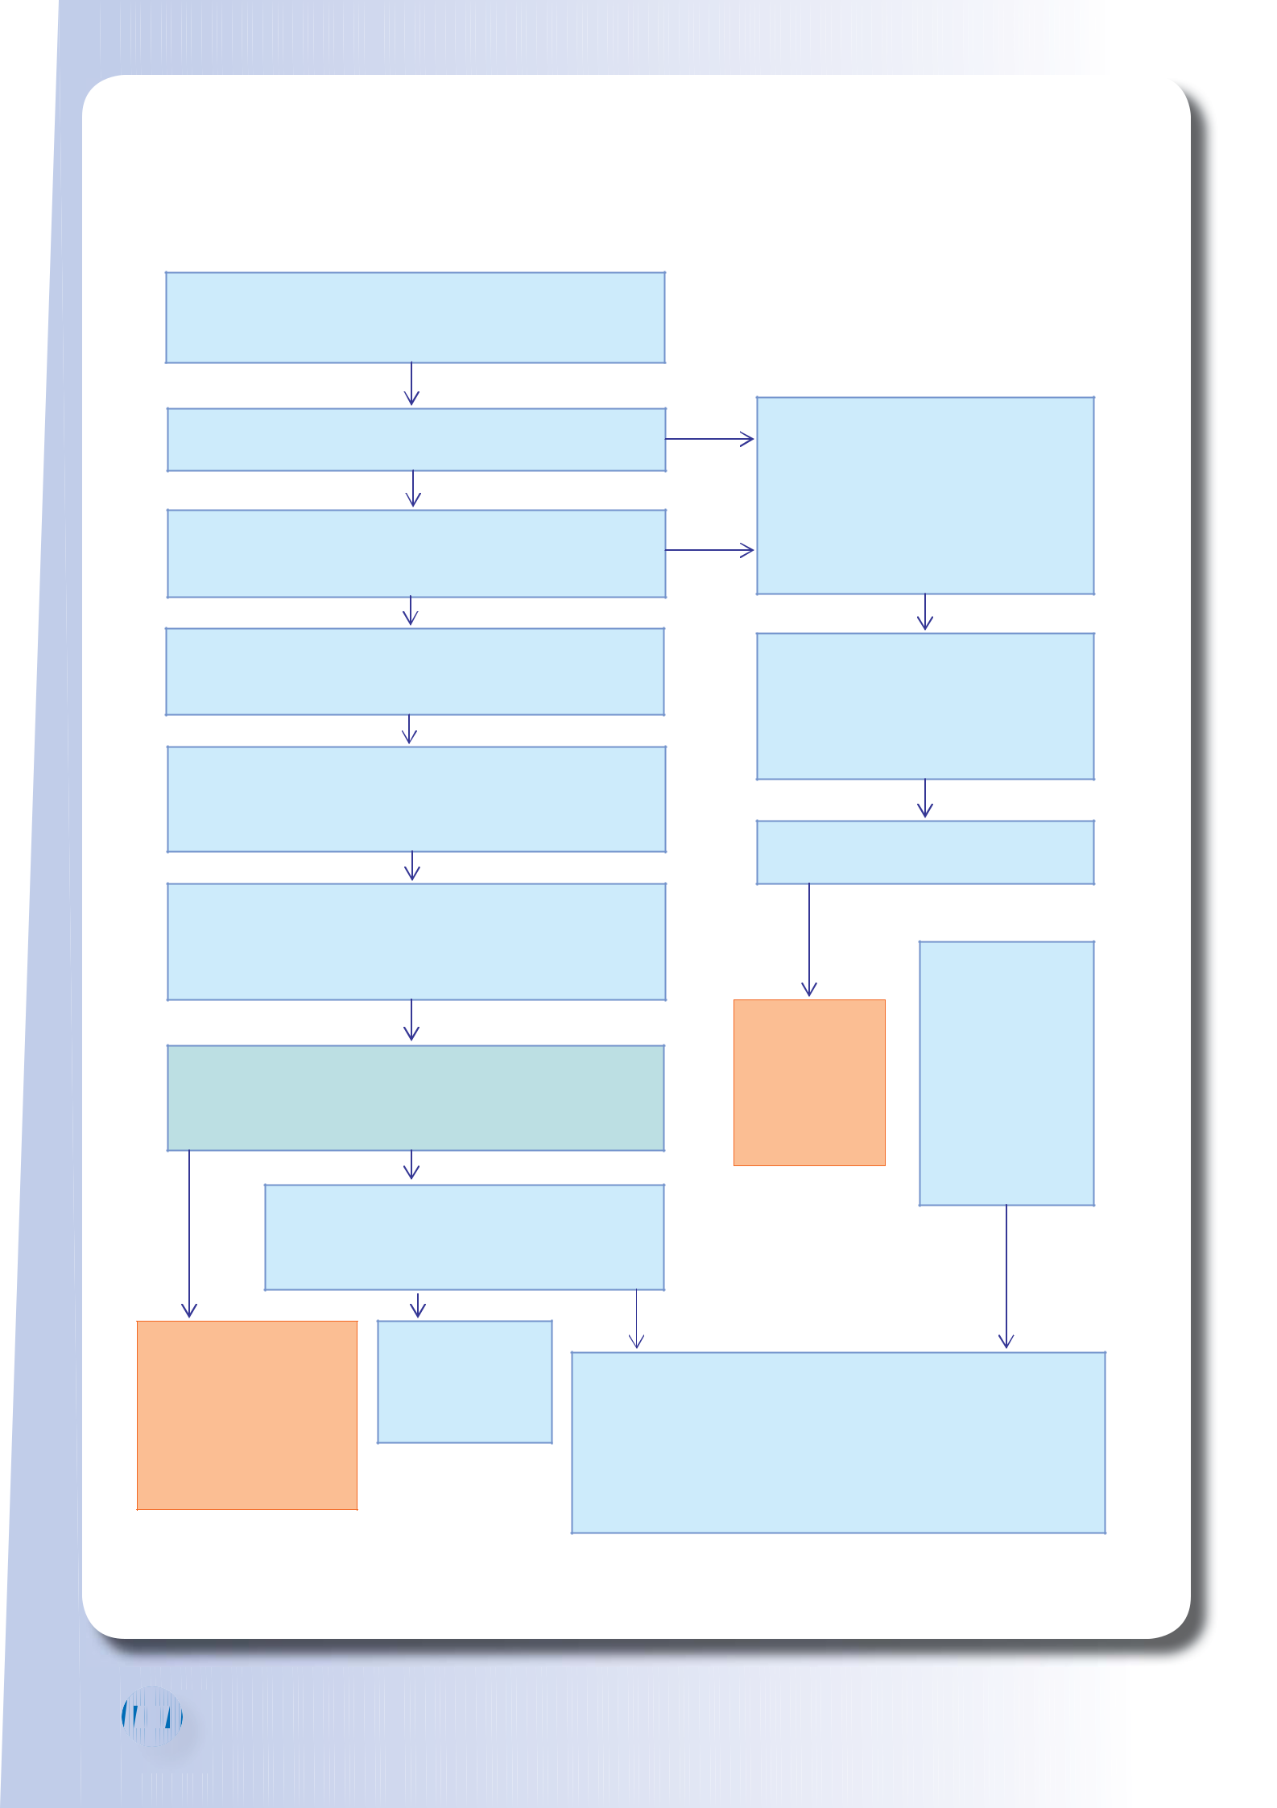
SHORT BREAK SELF REFERRAL PATHWAY

SELF REFERRAL AND PROFESSIONAL ASSESSMENT ROUTE

Child or young person is entitled to a short break, and the family or a professional want to arrange the short break of the family’s choice.

Is the preferred option an overnight short break?

No

Does the child or young person already access a specialist short break? This means a second or third specialist short break is being requested.

Yes

Yes

Professional Assessment Route The child or young person’s lead practitioner (often their social worker)

completes a Social Care Assessment or a Common Assessment Framework (CAF). The assessment will include

consideration of the child or young person’s continuing health care and personal care needs.

No

Parent or carer completes a self-referral form, available from the Short Breaks Co-ordinator, who can help the family complete the form if needed.

If the form is not returned within 2 weeks, the Short Breaks Co-ordinator will telephone the family. If there is still no response, the Short Breaks Co-ordinator will write to the family letting them know that the case will be closed if nothing is received within the following 2 weeks.

Family returns the completed self-referral form to the Short

Breaks Co-ordinator. The child or young person’s details will be

The assessment is presented to the

Integrated Service for Disabled Children Funding Panel. This is a meeting with a range of professionals, including from Children's Social Care and health services.

Is the Short Break agreed by the Funding

Panel?

No Yes

recorded on the Children with Disabilities Database.

Does the child or young person meet the criteria for a specialist short break e.g. after school or weekend club, befriending, inclusion service or holiday scheme?

Lead

practitioner

discusses other

options with the

family, including

accessing

universal
services.

Lead practitioner informs the family that their choice of short break has been agreed and informs the Short Break Co-ordinator, who will coordinate the start of the short break

No
Yes
with the service
provider.

Does the family want to receive a payment to

arrange their own short break? This is known as

a Direct Payment and is an alternative option to

accessing one of the specialist short breaks

services described in the directory.

Short Breaks

Co-ordinator discusses other options with the family, including accessing universal services or family is referred to the professional assessment route if appropriate.

Yes

Refer to Direct

Payment pathway.

No

Referral is sent to the provider of choice within 7 working days. The service provider contacts the family to arrange an individual risk assessment of the child’s needs. The provider will inform the family about what will happen next, and when the short break can start. The Service Provider contacts the Short Break Provider to confirm the outcome of the risk assessment and to confirm when the child or young person will start their short break.

1010

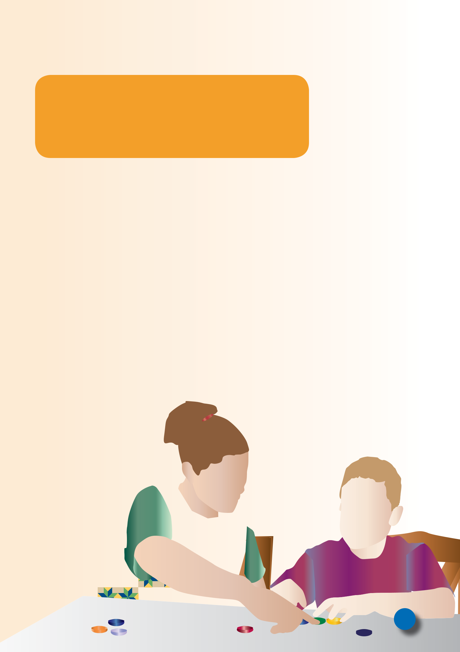
SHORT BREAKS SELF REFERRAL

When completed, please return this form to:

Short Breaks Co-ordinator,

1st Floor, Tower Hamlets Town Hall, 160 Whitechapel Road, London, E1 1BJ Tel: 020 7364 1450

Email: short.breaks@towerhamlets.gov.uk

An electronic version of the Directory of Services and Short Breaks Statement for Disabled

Children and Young People, a copy of the Self Referral Form and The Transition Directory
are available on the Tower Hamlets website:
www.towerhamlets.gov.uk/childrenwithdisabilities

The Children with Disabilities Team will use the information you have provided on the self referral form to enable fair access to and track choices made for short break services. In order to do this, the information you have provided will be shared with our short break providers.

By submitting the form requesting a short break service you are consenting to your information being shared to the short break providers listed in the Directory of services and Short Breaks Statement for Children and Young People. London Borough of Tower Hamlets is a registered ‘Data Controller’ as defined under the Data Protection Act 1998. The information you provide will be held and processed in accordance with the Data Protection Act.

If you are a young person who would like to tell us what you think about your short break, please spend a few minutes completing the survey on AMP: www.surveymonkey.com/s/RDQT9GY

11


Integrated Services for Disabled Children

Telephone: 020 7364 2724
Tower Hamlets Town Hall,
160 Whitechapel Road,
London, E1 1BJ

